PRACTICE 6
Vocabulary (15 marks)
Choose the most suitable answer and write its number in the brackets provided. (15*1=15 marks)

( ) 1. When the canoe __________, the boys swam a shore.
A. leaked B. turned C. capsized D. flipped
( ) 2. The fairy has a magic __________ that can turn naughty children into
lizards.
A. stick B. rod C. rope D. wand
( ) 3. Mr Lee gave a _________ to the child who returned his wallet.
A. reward B. money C. change D. receipt
( ) 4. Edmond has to get his parents' _________ to go to Australia.
A. permission B. request C. ask D. instruction
( ) 5. We ran for __________ when it started to drizzle.
A. protection B. shelter C. safety D. closure
( ) 6. Father was so sleepy that he ________ off as mother was talking to him.
A. dozed B. slipped C. seeped D. gushed
( ) 7. Brandon groaned in __________ when he fell down.
A. pain B. glee C. joy D. jealousy
( ) 8. Natalie records her dreams in her __________.
A. newspapers B. calendar C. journal D. register
( ) 9. Kenny owns a _________ of ship.
A. flock B. fleet C. troupe D. box
( ) 10. Mother wears _________ to the market.
A. heels B. pumps C. slippers D. boots
( ) 11. Most swimmers wear _________ when they are in the water.
A. goggles B. spectacles C. clips D. ribbons
( ) 12. We take dinner in the/at __________.
A. morning B. afternoon C. evening D. midnight
( ) 13. Elephants can be trained easily as they have good __________.
A. hearing B. memory C. eyesight D. sense
( ) 14. The _________ at the soccer match cheered loudly when their team scored
a goal.
A. audience B. people C. students D. spectators
( ) 15. Jenny has been ___________ of the crime she was accused of.
A. quit B. acquitted C. released D. relieved

Grammar (38 marks)
Underline the correct word in each of the brackets. (14*1=14 marks)

16. Tim and Joe are ( go, goes, going ) to the library together.
17. I cannot decide ( between, among, along ) buying the blue cap or the black
one.
18. Josh needs to ( put, puts, putting ) in more effort to do well.
19. I can ( smell, smells, smelling ) the fragrance mother is wearing.
20. Mr Tan told ( her, its, his ) daughter, "Don't forget your umbrella."
21. My uncle from Penang ( is, are, am ) visiting us this Friday.
22. Jamie is ( look, looks, looking ) forward to the party.
23. You have grown so much ( tall, taller, tallest ) within a month!
24. ( What, Where, Who ) are you doing, Jack?
25. The workers ( is, are, have ) building the house now.
26. My brother and sister ( is, are, has ) from this school.
27. Mrs Foo baked ( any, many, much ) cookies for her family.
28. I heard the baby ( cries, cried, crying ) just now.
29. My puppy, Rum, ( is, are, has ) very mischievous.
30. I ( is, am, are ) so happy to see you again.

Rearrange the words to form correct sentences and end each sentence with a full-stop. (5*2 = 10 marks)

31. favourite My is a toy aeroplane model
______________________________________________________________________
______________________________________________________________________
32. interesting Father every tells us stories night
______________________________________________________________________
______________________________________________________________________
33. rang and The doorbell the girls to the rushed door
______________________________________________________________________
______________________________________________________________________
34. go for They overseas a year holiday once
______________________________________________________________________
______________________________________________________________________
35. is of The child always a lot asking questions
______________________________________________________________________
______________________________________________________________________

Vocabulary Cloze (14 marks)
Fill in the blanks with the correct words from the box.

floor | open | feeling | appeared | horrible
creature | around | loneliness | dream | aimed
screamed | holding | rushed | invited

Terence felt the (36) _________ below him shake as he looked (37) _________ the empty room. (38) __________ crept into him. Suddenly the door was flung (39) __________. A strange looking (40) __________, wearing a luminous red outfit, (41) __________ at the doorway. It was (42) _________ a gun. Instead of (43) __________ frightened, Terence was happy that he had company. He (44) _________ towards the alien and (45) ___________ his new found friend into the room. The creature gave a (46) __________ laugh and (47) ___________ its gun at Terence. Terence (48) __________ and woke up from his (49) __________.

Comprehension MCQ (12 marks)
Read the passage carefully. Then choose the correct answer and write its number (A,B,C or D) in the brackets.

Cheetahs are big cats. They are often seen in small groups on the grassy plains that are their home. As they are the fastest runners of all animals, they are able to hunt in the day time. They can achieve 100 kilometers per hour to catch their prey. However, they cannot keep this speed for long. The average chase lasts for less than half a minute. Cheetahs usually hunt small antelopes or the young of some larger species. A cheetah's claws are blunt. Its method of killing is to knock the prey off balance and then strangle it. They are messy eaters and often lick the blood off each other's face after feeding. Cheetahs are now becoming very rare in many places.

( ) 50. The Cheetah is often seen ____________.
A. alone
B. with other cheetahs
C. running very fast
D. running very clumsily
( ) 51. Cheetahs are able to hunt in the day because ___________.
A. they are often in groups
B. their claws are sharp
C. they run faster than all the other animals
D. they run slowly
( ) 52. The cheetahs can keep at their speed for __________.
A. a long time
B. a short time
C. as long as they want to
D. as long as the prey is running
( ) 53. The cheetahs chase their prey for an average length of ________.
A. one minute
B. more than one minute
C. less than one minute
D. two mintues
( ) 54. Cheetahs are messy eaters because __________.
A. they strangle their prays
B. their claws are blunt
C. there is often blood on their face after eating
D. they always lick each other
( ) 55. Cheetahs live __________.
A. in the desert
B. in the countryside
C. on the grassy plains
D. in the fields

Comprehension OE (14 marks)
Read the passage carefully and answer the questions that follow.

Some houses were on fire. Several fire-engines raced to the scene. The firemen set up their equipment very quickly and fought the fiercely burning fire. As it was windy, the flames soon spread to the nearby houses. Within a short time, the thick black smoke rose and covered the neighbourhood and darkened the sky. The bright blaze was frightenig. Children screamed. The adults moved them hurriedly to safety. When the fire was put out, the houses had been completely destroyed. The firemen looked through the remains to ensure that nobody had been killed by the fire. Finally, they sprayed the entire area with water.

56. Why were there several fire-engines at the scene?
___________________________________________________________________________
57. How did the flames spread to the nearby houses?
___________________________________________________________________________
58. Why was the sky dark?
___________________________________________________________________________
59. Why did the children scream?
___________________________________________________________________________
60. What did the adults do?
___________________________________________________________________________
61. What happened when the fire was put off?
___________________________________________________________________________
62. Why did the firemen look through the remains?
___________________________________________________________________________

Guided Writing (20 marks)
Write a story based on the pictures below. You may use the words and phrases in the box.

The Pickpocket
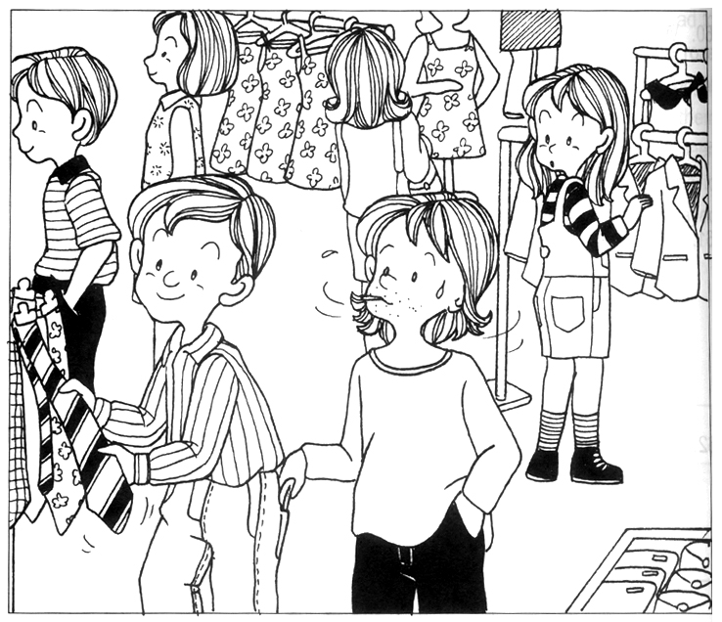

crowded | wallet | gave chase
caught | shopping complex | choosinga a tie
disappeared into the crowd | security guards

____________________________________________________________________________
____________________________________________________________________________
____________________________________________________________________________
____________________________________________________________________________
____________________________________________________________________________
____________________________________________________________________________
____________________________________________________________________________
____________________________________________________________________________
____________________________________________________________________________

ANSWERS
Primary 2 English
Practice 6
1. C | 2. D | 3. A | 4. A | 5. B
6. A | 7. A | 8. C | 9. B | 10. C
11. A | 12. C | 13. B | 14. D | 15. B

16. going | 17. between | 18. put | 19. smell | 20. his
21. is | 22. looking | 23. taller | 24. What | 25. are
26. are | 27. many | 28. crying | 29. is | 30. am

31. My favourite toy is a model aeroplane.
32. Father tells us interesting stories every night.
33. The doorbell rang and the girls rushed to the door.
34. They go overseas for holiday once a year.
35. The child is always asking a lot of questions.

36. floor | 37. around | 38. Loneliness | 39. open | 40. creature
41. appeared | 42. holding | 43. feeling | 44. rushed | 45. invited
46. horrible | 47. aimed | 48. screamed | 49. dream

50. B | 51. C | 52. B | 53. C | 54. C | 55. C

56. It was because some houses were on fire.
57. The wind helped spread the flames to the nearby houses.
58. The thick black smoke rose and darkened the sky.
59. They were frightened by the fire.
60. They moved the children to safety.
61. The houses had been completely destroyed.
62. The firemen looked through the remains to ensure that nobody had been killed
by the fire.

