二年级期终考试英语练习试卷
Class________ Name__________ No. ____Score_____
听力部分60%
在听到的单词下的括号内打“√”10%
1. | 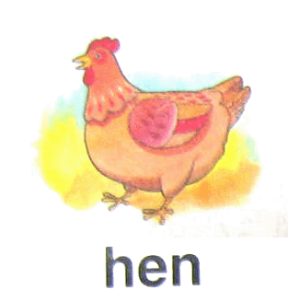  （ ） | 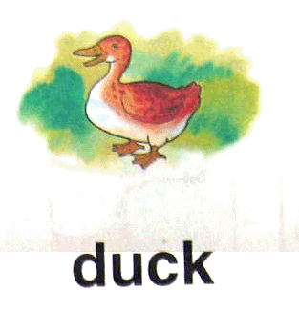  （ ） | 2. | 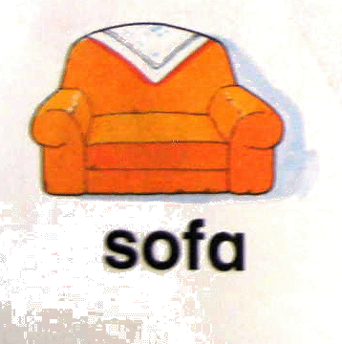  （ ） | 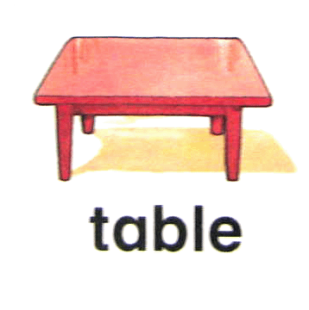  （ ）
3. | 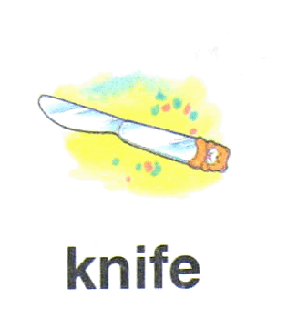  （ ） | 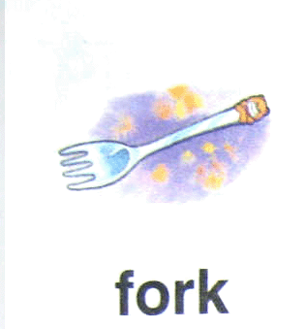  （ ） | 4. | 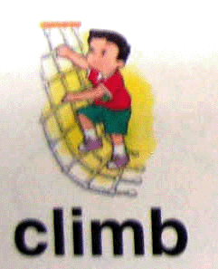  （ ） | 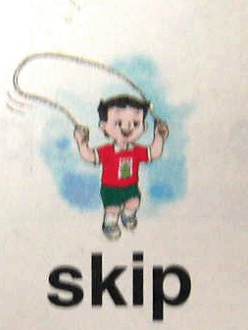  （ ）
5. | 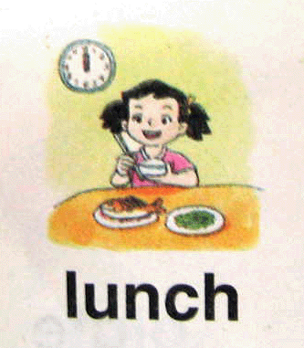  （ ） | 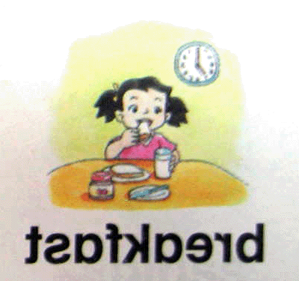  （ ） | 6. | 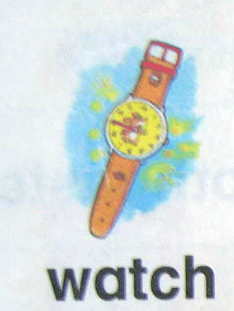  （ ） | 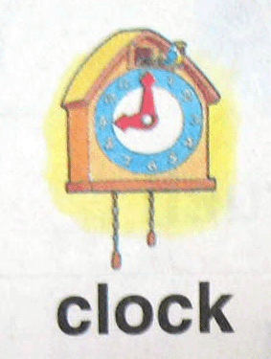  （ ）
7. | 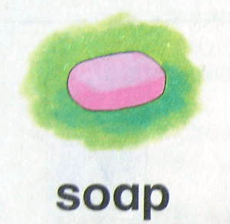  （ ） | 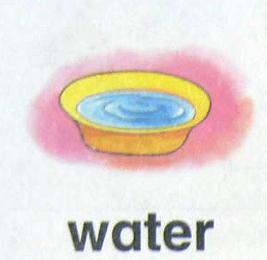  （ ） | 8. | 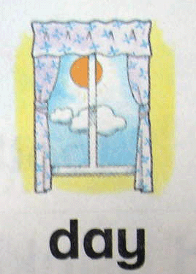  （ ） | 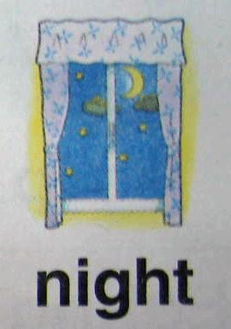  （ ）
9. |   （ ） | 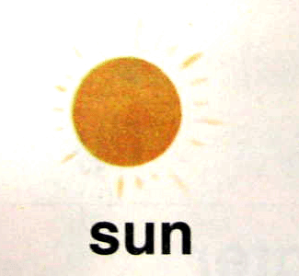  （ ） | 10. | 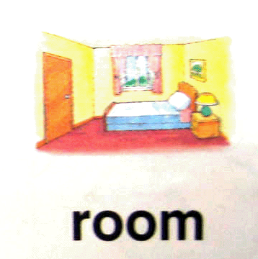  （ ） | 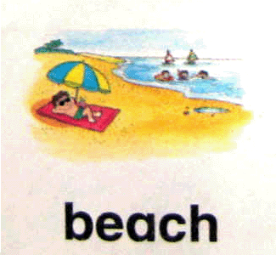  （ ）
二、听录音，圈出听到的内容。10%
1. J G 2. U W
3. mnp nmq 4. XST XSZ
5. sheep sweet 6. window yellow
7. toothbrush toothpaste 8. lamp panda
9. get up go to bed 10. walk on the grass play on the beach
三、听录音，圈出你所听到的句子的编号。6%
1. A. Spotty can write. B. Spotty can swing.
2. A. The lamp is on the floor. B. the kite is on the tree.
3. A. Don’t ride a bicycle here! B. Don’t walk on the grass!
4. A. Nine forks. B. Seven forks.
5. A. I see a cow. B. I hear a cow.
6. A. Bring me some juice. B. Give the milk to Kitty.
四、听录音编号：10%
1．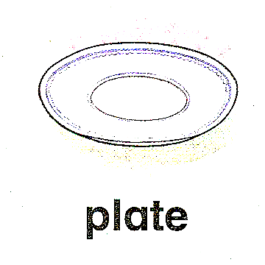  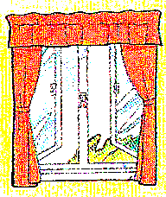 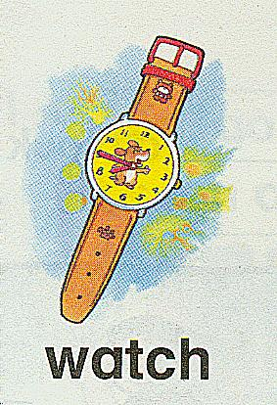 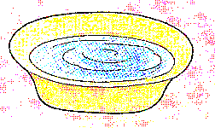
（ ） （ ） （ ） （ ） （ ）
2. chick cloud beach clock skip
（ ） （ ） （ ） （ ） （ ）
五、听录音判断（用√或×表示）。8%
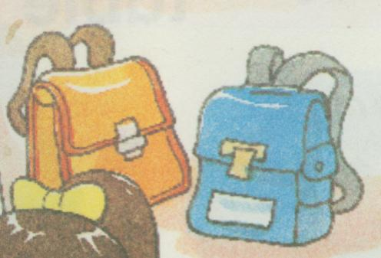
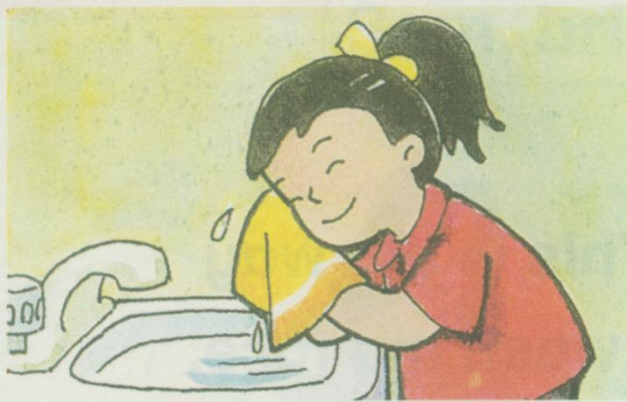
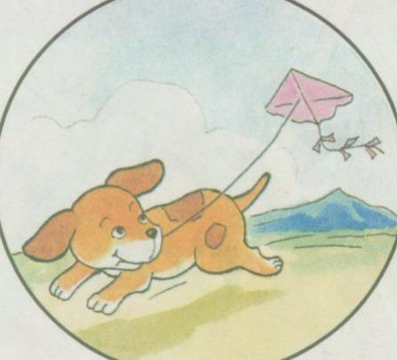
1. 2. 3.

( ) ( ) ( )
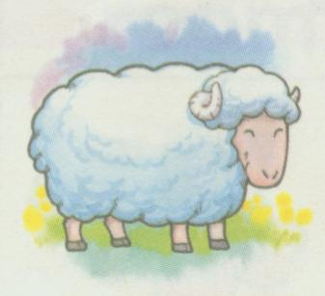
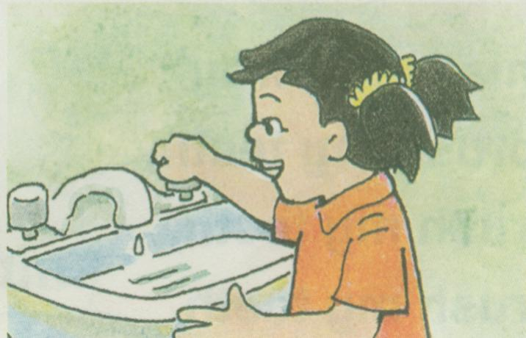
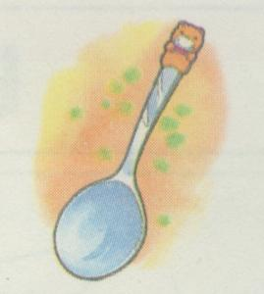
4. 5. 6.

( ) ( ) ( )
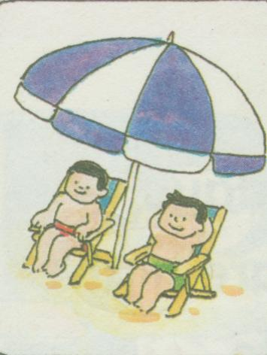
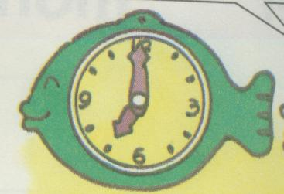
7. 8.
( ) ( )
六、听录音连线。8%
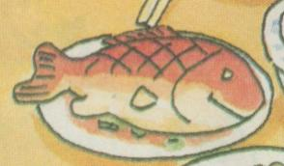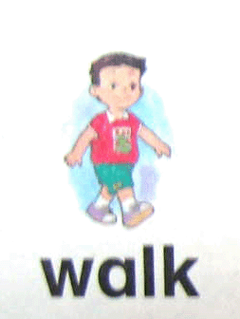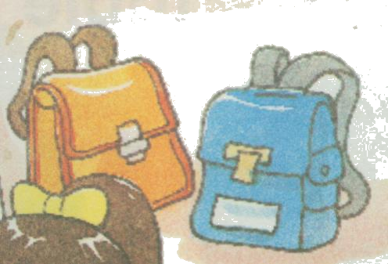

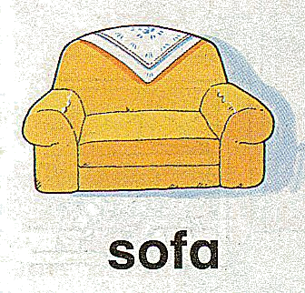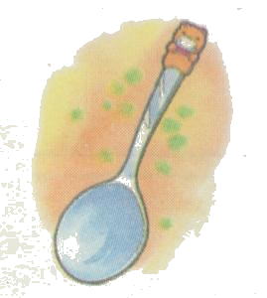

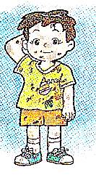

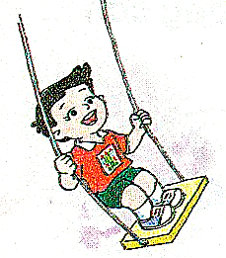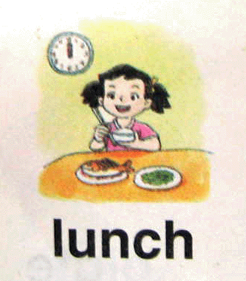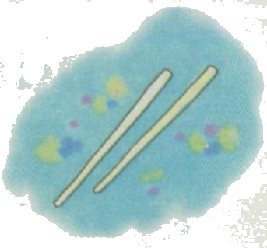

七、听录音，圈出正确的应答句编号。8%
1. a. OK. 2. a. Yes.
b. It’s OK. b. OK.
3. a. I like to swim. 4. a. OK.
b. I can swim. b. OK. Here you are.
笔试部分：40%
一、正确抄写下列字母。8%

X N w p Q s Y t

tiger summer dirty clock

二．写出下列字母的左右邻居。6%
＿＿ Q ＿＿ ＿＿ w ＿＿ ＿＿ N ＿＿
＿＿ s ＿＿ ＿＿ y ＿＿ ＿＿ O ＿＿
三、看图完成单词。8%
1． 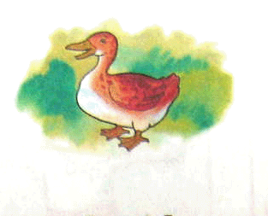 2. 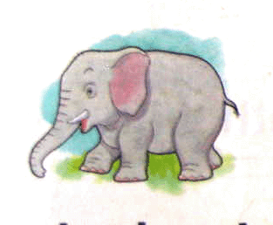 3.
d _ c _ _ l _ phant b _ _ ch
4. 5. 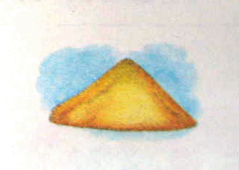 6. 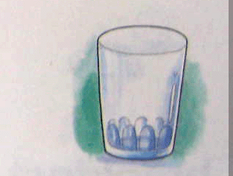
s_ _ p s _ _ d g_ as _
7．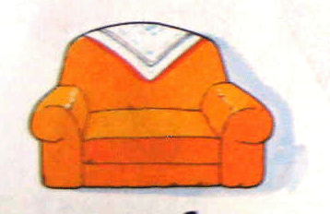 8.
s _ f _ k _ _ fe
四、圈出不同类的词。6%
1. chick pig big frog
2. glass spoon grass plate
3. skip lamp swing brush
4. soup soap towel toothbrush
5. window table monkey sofa
6. breakfast lunch dinner watch
五、看图，读句子，判断（用√或×表示）6 %
1. 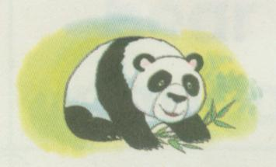 Look at the panda. It’s black and white. ( )

2. 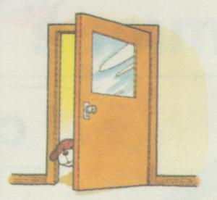 Close the window, please. ( )

3. Spotty can skip a rope. ( )

4. I wash my hands with water. ( )

5. 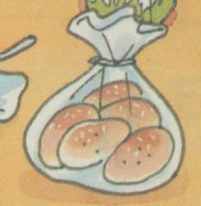 I’m thirsty. I want a Coke. ( )

6. What time is it? It’s three o’clock. ( )

六、阅读判断，正确的用“T”表示，错误的用“F”表示：6%
This is a classroom. It is big and clean. There are many desks and chairs in the classroom. There is a boy in the classroom, too. He’s Sam. He’s eleven years old. He isn’t tall. But he is very fat. He can read. Look! There are five books on his desk.
( ) 1. This is a big classroom.
( ) 2. There is a girl in the classroom.
( ) 3. Sam is seven years old.
( ) 4. He is fat.
( ) 5. Sam can read.
( ) 6. There are four books on his desk.

音带文字：
出听到单词的正确编号 10%
略。
二、听录音，圈出听到的内容。10%
1. J 2. W 3. nmq 4. XSZ 5. sweet 6. yellow
7. toothpaste 8. lamp 9. get up 10. play on the beach
三、听录音，圈出你所听到的句子的编号。6%
1. B 2. A 3. B 4. B 5. A 6. A
四、听录音编号：10%
第一组：1. shell 2. water 3. plate 4. watch 5. window
第二组：1. clock 2. chick 3. beach 4. skip 5. cloud
五、听录音判断（用√或×表示）。8%
- There are two bags on the floor.
- I brush my teeth with water.
- Spotty can ride a horse.
- Look at the rabbit. She is little and white.
- Wash your towel, please.
- What do you see? I see a bowl.
- The sun is hot. Let’s sit under the umbrella.
- What time is it? It’s one o’clock.
六、听录音连线。8%
1. Hello，I’m Sam. I’ve got two bags. They are on the sofa.
2. My name’s May. I like to drink juice and eat fish. I want chopsticks.
3. I’m Tom. I like to swing. I can see clouds in the sky.
4. Good morning, I’ m May. I have breakfast at seven o’clock.
Bring me a spoon, please.
七、听录音，圈出正确的应答句编号。8%
1. Ｉ’m sorry.
2. Let’s go to the park.
3. what can you do?
4. Bring me some milk.

