卷首语：亲爱的同学们，第一学期即将过去，在这里为期末考试练练兵，京翰教育预祝你期末考个好成绩！
小学二年级英语上册期末复习试卷(二)
Vocabulary (15 marks)
Choose the most suitable answer and write its number in the brackets provided. (15*1=15 marks)

( ) 1. The piglets loved the dirty ___________.
A. kennel B. cage C. sty D. coop
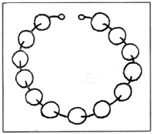 | ( ) 2. She strung the __________ into a beautiful  necklace.  A. marbles B. beads  C. balls D. counters
( ) 3. Mr Tan's __________ is driving him to his office.
A. chauffeur B. caddie C. housewife D. clerk
( ) 4. Zebras have __________ to hide from enemies.
A. dots B. stripes C. lines D. strips
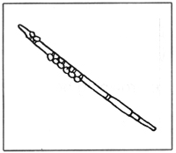 | ( ) 5. Adrian plays the ___________ very well.  A. piano B. violin  C. flute D. trumpet
( ) 6. The cake which was left in the oven was ___________.
A. ashes B. burnt C. black D. sooty
( ) 7. The girl cried __________ when she lost her pen.
A. happily B. sadly C. joyously D. curiously
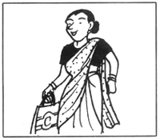 | ( ) 8. Mrs Selvi looks fabulous in her _________.  A. uniform B. sari  C. qipao D. pyjamas
A. uniform B. sari C. qipao D. pyjamas
( ) 9. The dough has to be _________ to make the bread.
A. beaten B. kneaded C. pressed D. changed
( ) 10. The __________ arrested the burglar.
A. policeman B. fireman C. chef D. officer
( ) 11. Still water is breeding grounds for ________.
A. lizards B. mosquitoes C. birds D. tadpoles
( ) 12. Charles woke up at dawn to see the _________.
A. sunrise B. sunset C. dusk D. clouds
( ) 13. Tim dived into the river to ________ the drowning boy.
A. flap B. rescue C. push D. flip
( ) 14. The ________ is especially round tonight.
A. sun B. stars C. moon D. planet
( ) 15. The frogs __________ from the rocks into the pond.
A. push B. leap C. run D. glide

Grammar (35 marks)
Underline the correct word in each of the brackets. (15*1=15 marks)

16. Reptiles ( is, are, was ) cold-blooded vertebrates.
17. ( Which, When, Who ) movie do you prefer, 'Holy Man' or 'Prince of Egypt'?
18. Mandy alerted the police when she ( see, sees, saw ) the burglar at her
neighbour's house.
19. Jackson ( is, are, was ) praised by the teacher yesterday.
20. The two boys always ( dress, dresses, dressing ) alike.
21. We should ( learn, learns, learnt ) to be independent at a young age.
22. The bait ( is, are, am ) for attracting the fish.
23. Weiming ( hear, hears, heard ) the cries of his brother and ran to the
kitchen.
24. The leaves rustle when the wind ( blow, blows, blowing ).
25. The actors put ( up, on, in ) their make-up behind the stage.
26. Irene likes the story ( onto, in, about ) the fox and the cow.
27. The culprits have not been ( arrest, arrests, arrested ) yet.
28. Would you mind ( pass, passes, passing ) me the sugar, please?
29. The baby will cry if you take his toy ( in, off, away ).
30. She went to the doctor ( as, in, on ) she was ill.

Rearrange the words to form correct sentences and end each sentence with a full-stop. (10*2 = 20marks)

31. returned have in They just from a holiday London
______________________________________________________________________
______________________________________________________________________
32. picture the Look at on wall beautiful the
______________________________________________________________________
______________________________________________________________________
33. because forgive an You should him it was mistake
unintentional
______________________________________________________________________
______________________________________________________________________
34. aching are the My bones after exercise strenuous
______________________________________________________________________
______________________________________________________________________
35. accompanied to Doreen me yesterday the bookshop
______________________________________________________________________
______________________________________________________________________
36. noodles awful plate tastes of that
______________________________________________________________________
______________________________________________________________________
37. was the Tony water bottle of he so thirsty
finished that
______________________________________________________________________
______________________________________________________________________
38. eat the to monkey bananas loves
______________________________________________________________________
______________________________________________________________________
39. lives a hard in snail shell a
______________________________________________________________________
______________________________________________________________________
40. its young kangaroo its pouch carries the in
______________________________________________________________________
______________________________________________________________________

Vocabulary Cloze (10 marks)
Fill in the blanks with the correct words from the box.

tired | slipped | upset | dark | way
twisted | avoid | broken | injured | journey

John and Mary took a big step to (41) __________ the muddy ground as they made their (42) __________ home. The sky was very (43) ___________ as it was a starless night.
'Plod!' Mary (44) __________ and fell. She suffered a (45) ___________ ankle. Suspecting that Mary might have (46) __________ her ankle, John put a bandage on her leg. Though (47) __________, John decided to carry Mary for the remaining (48) _________. When they reached home, their parents were (49) __________ to learn that Mary had (50) __________ herself.

Comprehension MCQ (10 marks)
Read the passage carefully. Then choose the correct answer and write its number (A,B,C or D) in the brackets.
I was nicknamed 'dreamer' since childhood days. Oblivious to the happenings, surroundings and people, I lived in my own small world.
'She is very quiet'. that's what my primary school teachers wrote on my report card. Indeed, I never talked in class. I always kept to myself. While my sister and brother played and skipped with other children, I dreamt of being an actress. My time was spent in acting out roles I imagined myself to be in. Sometimes my mother would see me talking to the empty air. She would stop at the door and ask, "Are you alright May?" Feeling sheepish, I would pretend to sing 'lala Iorli mama...'
My brother often laughed at my self-invented songs. "Stop that! It's horrible. Do you know what you're singsing?" he would complain and skip away.

( ) 51. The writer was nicknamed 'dreamer' because ____________.
A. she always dreamed at night
B. she always had nightmares
C. she liked dreams
D. she liked to daydream
( ) 52. In primary school, the writer ___________.
A. was noisy
B. daydreamt a lot
C. was very talkative
D. was very quiet
( ) 53. Which of the following is false?
A. The writer did not notice what happened around her.
B. The writer spent her time acting roles she imagined herself to be in.
C. The Writer sang well.
D. The writer did not play with her sister and brother.
( ) 54. The writer pretended to sing because ____________.
A. she imagined herself to be a sheep
B. she felt embarrassed
C. her mother asked her to sing
D. she liked to scare her mother
( ) 55. The writer's brother asked her to stop singing because _________.
A. he could sing better
B. she sang too softly
C. her singing was horrible
D. her singing was good

Comprehension OE (10 marks)
Read the passage carefully and answer the questions that follow.

It was Tina's birthday. Tina and her friends wanted to have a good lunch. They went to a restaurant named 'The Flintstones'. After they were given the menu by the waiter, they asked for cold water. The waiter came with the glasses, but toppled a glass as he served the group. He did not apologise for what he had done. He merely wiped the spilled water on the table with a cloth.
As he stood waiting for Tina and her friends' orders, his face was without a smile. Tina and her friends were offended by his rudeness. After a short while, the group placed their orders. They asked for fish and chips which was the cheapest on the menu. They could not afford the other delicacies on the menu. The waiter gave them a disgusted look. He then went off with the orders without a word.

56. Why did Tina and her friends go to 'The Flintstones'?
__________________________________________________________________________
57. Why should the waiter apologise to the group?
__________________________________________________________________________
58. In what way had the waiter offended Tina and her friends?
__________________________________________________________________________
59. Why did Tina and her friends order the same food?
__________________________________________________________________________
60. What was the waiter's reaction to their order of fish and chips?
__________________________________________________________________________
Guided Writing (20 marks)
Write a story based on the pictures below. You may use the words and phrases in the box.

Story-telling Competition
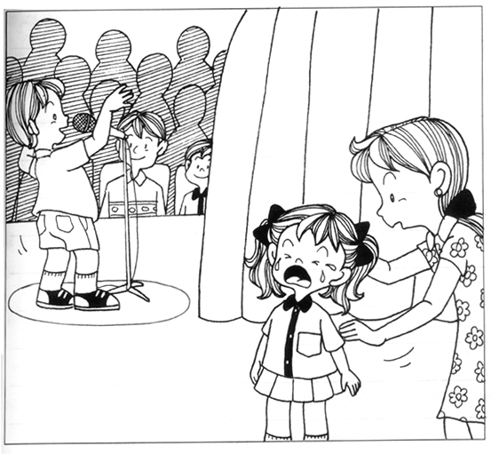

excited | practised | nervous
stage fright | audience | forgot the story
embarrassed | sad | comforted

____________________________________________________________________________
____________________________________________________________________________
____________________________________________________________________________
_______________________________________________________________________________________________________________________________________________________
____________________________________________________________________________
____________________________________________________________________________
____________________________________________________________________________
____________________________________________________________________________

ANSWERS
Primary 2 English
Practice 3

1.C | 2.B | 3.A | 4.B | 5.C
6.B | 7.B | 8.B | 9.B | 10.A
11.B | 12.A | 13.B | 14.C | 15.B

16.are | 17.Which | 18.saw | 19.was | 20.dress
21.learn | 22.is | 23.heard | 24.blows | 25.on
26.about | 27.arrested | 28.passing | 29.away | 30.as

31. They have just returned from a holiday in London.
32. Look at the beautiful picture on the wall.
33. You should forgive him because it was an unintentional mistake.
34. My bones are aching after the strenuous exercise.
35. Doreen accompanied me to the bookshop yesterday.
36. That plate of noodles tastes awful.
37. Tony was so thirsty that he finished the bottle of water.
38. The monkey loves to eat bananas.
39. A snail lives in a hard shell.
40. The kangaroo carries its young in its pouch.

41. avoid | 42. way | 43. dark | 44. slipped | 45. twisted
46. broken | 47. tired | 48. journey | 49. upset | 50. injured

51. D | 52. D | 53. C | 54. B | 55. C

56. They wanted to have a good lunch.
57. He had spilled a glass of water onto the table.
58. His rudeness offended them.
59. They ordered the same food because it was the cheapest on the menu.
60. He gave them a disgusted look and walked away with the orders without a word.

