卷首语：亲爱的同学们，第一学期即将过去，在这里为期末考试练练兵，京翰教育预祝你期末考个好成绩！
小学二年级英语上册期末复习试卷(三)

Vocabulary (12 marks)
Choose the most suitable answer and write its number in the brackets provided. (12*1=12 marks)

( ) 1. Today is Hui's birthday. Her friends are __________ it with her.
A. spoiling B. playing C. celebrating D. remembering

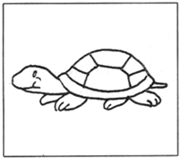 | ( ) 2. Nick's pet __________ is growing  bigger by the day.  A. snail B. terrapin  C. fish D. whale

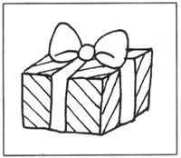 | ( ) 3. Thank you for the _________ present.  A. horrid B. awful  C. lovely D. ugly
( ) 4. During the blackout, David lit a __________.
A. torchlight B. candle C. paper D. cigarette
( ) 5. The lion is a/an __________ animal.
A. fierce B. adorable C. gentle D. friendly
( ) 6. The huge monkey _________ from tree to tree playfully.
A. flies B. flips C. swings D. sways
( ) 7. The ________ is crossing the busy road.
A. passenger B. victim C. pedestrian D. vehicle
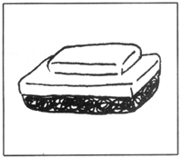 | ( ) 8. Please clean the chalkboard with a _________.  A. handkerchief B. duster  C. napkin D. cloth

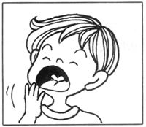 | ( ) 9. I was so tired that I kept __________.  A. yawning B. grinning  C. smiling D. eating

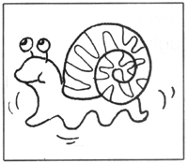 | ( ) 10. The snail is _________ slowly.  A. jogging B. walking  C. swimming D. crawling

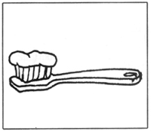 | ( ) 11. I put ________ on my toothbrush.  A. toothpaste B. flour  C. perfume D. cement
( ) 12. Please speak __________. I can't hear you.
A. softly B. quickly C. loudly D. carelessly

Grammar (38 marks)
Answer the questions in complete sentences using the words in the brackets. (4*2=8 marks)

13. What is Jasmine doing now? (reading, listening, music)
______________________________________________________________________
14. How did the monster look? (gigantic, three legs)
______________________________________________________________________
15. Why did the boys run to the telephone booth? (ambulance)
______________________________________________________________________
16. What happened when the bell rang? (pupils, returned, classrooms, orderly)
______________________________________________________________________

Underline the correct word in each of the brackets. (14*1=14 marks)

17. Fish are ( over, covers, covered ) with scales.
18. The shoplifter ( who, which, what ) was arrested by the police was a boy from
that school.
19. The stray cats are ( look, looks, looking ) for food.
20. His wallet was ( steal, steals, stolen ) by a young girl.
21. We can ( find, finds, found ) seashells on the beach.
22. Henry paid a princely sum ( for, with, on ) the mansion.
23. Ann was taking a bath when the telephone ( ring, rings, rang).
24. Rambutans ( is, are, am ) hairy fruit.
25. Desmond has ( take, takes, taken ) Helen's calculator.
26. The speeding motorcyclist was stopped ( by, with, at ) a policeman.
27. Peter and Moses plan to stay ( in, on, at ) the library for one hour.
28. Kenny has ( go, going, gone ) out for lunch.
29. They put ( in, on, out ) the fire before it spread to other houses.
30. He sat ( on, in, onto ) the beach for a long time listening to the waves.

Rearrange the words to form correct sentences and end each sentence with a full-stop. (8*2 = marks)

31. day fine It was and was a the sea calm
______________________________________________________________________
______________________________________________________________________
32. is he has sports My father that for so busy no time
______________________________________________________________________
______________________________________________________________________
33. a hole and in The dog the ground dug buried the bone
______________________________________________________________________
______________________________________________________________________
34. spent whole Janson day the drawing
______________________________________________________________________
______________________________________________________________________
35. go home that They to when decided they saw
was overcast the sky
______________________________________________________________________
______________________________________________________________________
36. the time Martha at wonderful a zoo had
______________________________________________________________________
______________________________________________________________________
37. pupils class in there this twenty are
______________________________________________________________________
______________________________________________________________________
38. likes porch her always cat at sit to the
______________________________________________________________________
______________________________________________________________________

Vocabulary Cloze (10 marks)
Fill in the blanks with the correct words from the box.

reducing | pant | advice | overeat | overweight
flight | centres | undergo | problem | examined

There are many (39) ________ people around us. A fat person tends to (40) _________ after climbing a (41) _________ of steps. However, most of them disregard this (42) _________. They continue to (43) __________. Some of them visit slimming (44) _________ in the hope of (45) _________ their weights. In schools, students are (46) _________ for obesity. They have to (47) __________ particular exercise programmes. They are also given (48) __________ on the right type of food to eat.

Comprehension MCQ (10 marks)
Read the passage carefully. Then choose the correct answer and write its number (A,B,C or D) in the brackets.

John was in a queue to board the bus. When it was his turn, a man came and squeezed up the bus. John felt angry. He looked around for a seat but could not find any seat except the one beside the rude man. John sat unwillingly beside him. He noticed that the man was very young and had an earring on his left ear. He was listening to the walkman. The music was so loud that John could hear it. John knew that he would not enjoy his bus ride beside such an inconsiderate passenger.
A while later, the young man's mobile phone rang. He answered the call and spoke so loudly that the passengers in front turned to look at him and John. Not wanting the passengers to think he was the young man's friend, John alighted at the next bus stop.

( ) 49. John felt _________ to sit beside the young man.
A. unhappy B. happy C. excited D. worried
( ) 50. John sat beside the young man because _________.
A. he wanted to talk to the young man
B. he wanted to see whether the young man was wearing any earring
C. the young man was very rude
D. there was no other empty seat
( ) 51. John thought that the young man was inconsiderate because _________.
A. the young man listened to the walkman
B. the young man talked very softly
C. the music that the young man was listening to was very loud
D. the young man's mobile phone rang
( ) 52. The passengers in front turned to look at John and the young man because
__________.
A. the young man's mobile phone rang
B. the young man listened to the walkman
C. they wanted to know who sat behind them
D. the young man was talking loudly
( ) 53. John alighted at the bus stop __________.
A. when he reached his destination
B. when he knew he missed his destination
C. beacuse the young man talked very loudly
D. beacuse he did not want the rest of the passengers to think that the
young man was his friend

Comprehension OE (10 marks)
Read the passage carefully and answer the questions that follow.
To encourage the young people in Singapore to read widely, our government builds many libraries and holds reading campaigns yearly. There are many books in the library. There are non-fiction books and fiction books, reference books and magazines. Books provide knowledge about the world we live in. Reading is a good way of knowing the happenings in the world and the people around us. We gain a better understanding of people of different cultures and their customs. It is good to cultivate the habit of reading as knowledge is power. It also enables one to speak and write better.

( ) 54. How does the government encourage the young people in Singapore to read
more books?
_______________________________________________________________________
_______________________________________________________________________
( ) 55. Name two kinds of books that you can find in libraries.
_______________________________________________________________________
_______________________________________________________________________
( ) 56. What do books provide?
_______________________________________________________________________
_______________________________________________________________________
( ) 57. Which word in the passage means 'develop'?
_______________________________________________________________________
_______________________________________________________________________
( ) 58. Why is it good to cultivate the habit of reading?
_______________________________________________________________________
_______________________________________________________________________

Guided Writing (20 marks)
Write a story based on the pictures below. You may use the words and phrases in the box.

A Filial Child
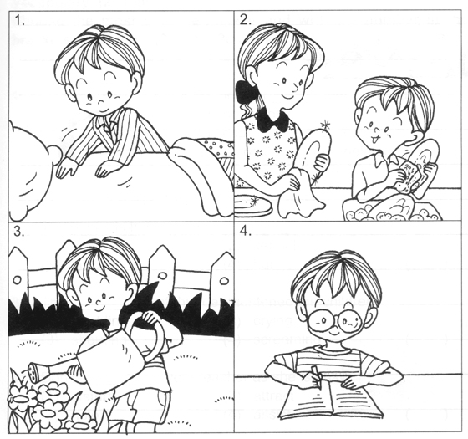

tidies his bed | household chores
washes the plates and bowls | waters the plants
listens to parents | studies diligently

____________________________________________________________________________
____________________________________________________________________________
____________________________________________________________________________
____________________________________________________________________________
____________________________________________________________________________
____________________________________________________________________________
____________________________________________________________________________
____________________________________________________________________________
____________________________________________________________________________

ANSWERS
Primary 2 English
Practice 1
1.C | 4.B | 7.C | 10.D
2.B | 5.A | 8.B | 11.A
3.C | 6.C | 9.A | 12.C
13. She is reading and listening to the music now.
14. It was gigantic and had three legs.
15. They wanted to call the ambulance.
16. The pupils returned to their classroom in an orderly manner.

17.covered | 18.who | 19.looking | 20.stolen | 21.find | 22.for | 23.rang
24.are | 25.taken | 26.by | 27.in | 28.gone | 29.out | 30.on
31. It was fine day and the sea was calm.
32. My father is so busy that he has no time for sports.
33. The dog dug a hole in the ground and buried the bone.
34. Janson spent the whole day drawing.
35. They decided to go home when they saw that the sky was overcast.
36. Martha had a wonderful time at the zoo.
37. There are twenty pupils in this class.
38. Her cat always likes to sit at the porch.

39.overweight | 40.pant | 41.flight | 42.problem | 43.overeat
44.centres | 45.reducing | 46.examined | 47.undergo | 48.advice

49.A | 50.D | 51.C | 52.D | 53.D

54. The government builds many libraries and holds reading campaigns yearly.
55. We can find fiction/non-fiction books/magazines/reference books in libraries.
56. They provide knowledge about the world we live in.
57. The word 'cultivate' means develop.
58. It is because knowledge is power and reading enables one to speak and write
better.

