卷首语：亲爱的同学们，第一学期即将过去，在这里为期末考试练练兵，京翰教育预祝你期末考个好成绩！
小学二年级英语上册期末复习试卷(一)
Vocabulary (15 marks)
Choose the most suitable answer and write its number in the brackets provided. (8*1=8 marks)

( ) 1. Jamie was _________ to Steven for his help.
A. grateful B. remorseful C. successful D. joyful
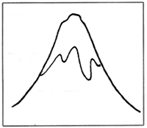 | ( ) 2. The mountain slope is ___________.  A. flat B. steep  C. pointed D. sharp
( ) 3. May and Mark built a snowman when _________ came.
A. spring B. summer C. autumn D. winter
( ) 4. ___________ are extinct.
A. Tigers B. Whales C. Dinosaurs D. Cobras
( ) 5. The bride and groom walked down the _________.
A. road B. pavement C. aisle D. isle
( ) 6. John is putting his swimming __________ on.
A. clothes B. trunks C. shirt D. trousers
( ) 7. Meiling was __________ when her beloved pet dog died.
A. upset B. glad C. happy D. sore
( ) 8. Jason ________ the secret into my ears.
A. shouted B. whispered C. screamed D. cried

Fill in the blanks with the words in the box. Use each word only once.
(7*1=7 marks)

shampoo | postman | restaurant | diligent
soap | barking | oven | honest

9. The ___________ across the road serves good food.
10. We use __________ to wash our body.
11. The __________ delivers letters and parcels to our houses.
12. Mother is barking a cake in the __________.
13. The dog is ___________ so loudly in the middle of the night.
14. The teacher praised James for being _________ in returning the lost wallet.
15. The _________ boy is studying hard for the examinations.

Grammar (25 marks)
Underline the correct word in each of the brackets. (15*1=15 marks)

16. ( These, Those, This ) toys in that box are mine.
17. My parents ( has, have, are ) bought me a new bag.
18. ( Whose, What, Whom ) toothbrush is this?
19. This fish is not fresh and it ( smell, smells, smelling ).
20. This special discount is only ( give, gave, given ) to regular customers.
21. Jack will be ( go, goes, going ) to England to further his studies soon.
22. ( Which, Whose, What ) of the pens is yours?
23. Meng is talking ( to, from, in ) Kheng now.
24. May I ( has, have, having ) some biscuits, please?
25. Both the dresses ( is, are, have ) red.
26. The puppy is busy ( play, plays, playing ) with my shoe.
27. Peter calls ( his, her, its ) kitten 'Snow White'.
28. You can get beautiful fresh flowers ( from, of, with ) that florist.
29. The class ( do, does, doing ) not like the proud boy.
30. My father was ( drive, drives, driving ) along Pasir Ris Road when he saw me
across the road.

Rearrange the words to form correct sentences and end each sentence with a full-stop. (5*2 = 10 marks)

31. is us Our teacher taking to the after zoo the test
______________________________________________________________________
______________________________________________________________________
32. to My mother to perm goes that hairdresser her hair
______________________________________________________________________
______________________________________________________________________
33. is listening John to on radio the news the
______________________________________________________________________
______________________________________________________________________
34. a mule Eileen as stubborn is as
______________________________________________________________________
______________________________________________________________________
35. very is in Anthony his work conscientious
______________________________________________________________________
______________________________________________________________________

Vocabulary Cloze (10 marks)
Fill in the blanks with the correct words from the box.

recipe | pastries | spread | watch | bookshops
baker | job | kneads | tasty | confectioneries

Jean loves to eat bread and cakes. She always takes her bread with a generous (36) ___________ of butter for breakfast. Jean likes to (37) ________ her mother when she (38) __________ dough. She enjoys looking at the delicious (39) _________ displayed in (40) __________. Sometimes, she visits (41) __________ and libraries to read (42) __________ books on pastries. Jean often dreams about becoming a (43) ___________ when she grows up. "It would be very nice if my (44) _________ is to make all those (45) __________ cakes," she told her mother.

Comprehension MCQ (14 marks)
Read the passage carefully. Then choose the correct answer and write its number (A,B,C or D) in the brackets.

A cold is a common, mild but infectious disease caused by viruses. When you catch a cold, you will probably have a sore throat, a blocked or runny nose, and perhaps a headache and a slight rise in temperature. A cold usually lasts about a week and is not serious, except in babies and people with breathing problems.
Colds are much more common among children than adults. There is no cure for a cold because it is caussed by one or more of over two hundred viruses. But you can take medicine to make you feel better, to soothe your throat or to clear your nose. Colds are spread mostly by touch rather than by coughing and sneezing, especially by rubbing your eyes after contact with the sufferer.

( ) 46. A cold is caused by ___________.
A. being in warm places
B. being in cold places
C. viruses
D. bacteria
( ) 47. 'A slight rise in temperature' means ___________.
A. having a fever
B. coughing very badly
C. having a headache
D. the person feels cold
( ) 48. A cold usually lasts for ___________.
A. a week B. a month C. a year D. a day
( ) 49. A cold is a serious disease ___________.
A. for adults
B. for children
C. for babies and people with breathing problems
D. for both adults and children
( ) 50. Colds are ___________.
A. equally common among adults and children
B. more common among adults than children
C. not common among adults and children
D. more common among children than adults
( ) 51. Which of the following is true?
A. We can cure a cold by taking medicine.
B. We can cure a cold by soothing our throat.
C. These is no cure for a cold.
D. We can cure a cold by touch.
( ) 52. Colds are spread mostly by _________.
A. shaking hands
B. by taking medicine
C. coughing and sneezing
D. touch

Comprehension OE (10 marks)
Read the passage carefully and answer the questions that follow.

A marinade is a mixture of sauce in which meat or fish is 'soaked' to absorb the flavours. Some marinades help make the meat more teacher. When marinating, the meat or fish are turned over to ensure that all sides can absorb the sauces. The longer the meat remains in the marinade, the better it is. The meat must be put in the refrigerator before it is marinated. Marinated meat is excellent for barbecuing, grilling or pan-frying.

53. What is a marinade?
_________________________________________________________________________
54. Give a word in the passage that means 'soft'.
_________________________________________________________________________
55. What do some marinades do to meat?
_________________________________________________________________________
56. Which word in the passage means 'to make sure'?
_________________________________________________________________________
57. Why do we need to turn over the fish and meat while marinating?
_________________________________________________________________________
58. How long must the meat be marinated?
_________________________________________________________________________
59. Where must the meat be put before marinating it?
_________________________________________________________________________
60. What is marinated meat good for?
_________________________________________________________________________

Guided Writing (20 marks)
Write a story based on the pictures below. You may use the words and phrases in the box.

Chicken Pox
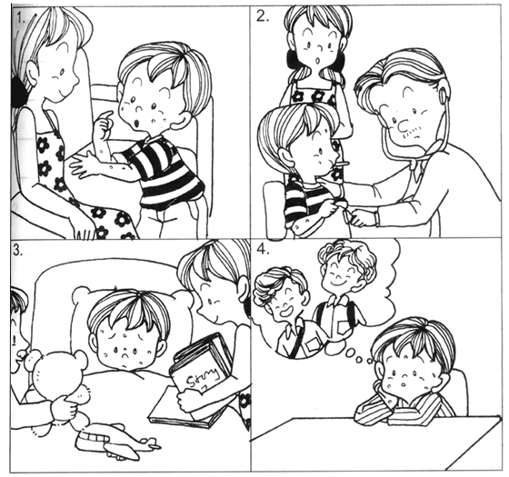

itchy | red spots | clinic
examined | thermometer | fever
indoor | bored

____________________________________________________________________________
____________________________________________________________________________
____________________________________________________________________________
____________________________________________________________________________
____________________________________________________________________________
____________________________________________________________________________
____________________________________________________________________________
____________________________________________________________________________
____________________________________________________________________________

ANSWERS
Primary 2 English
Practice 7

1. A | 2. B | 3. D | 4. C
5. C | 6. B | 7. A | 8. B

9. restaurant | 10. soap | 11. postman | 12. oven | 13. barking | 14. honest
15. diligent | 16. Those | 17. have | 18. Whose | 19. smells | 20. given
21. going | 22. Which | 23. to | 24. have | 25. are | 26. playing
27. his | 28. from | 29. does | 30. driving

31. Our teacher is taking us to the zoo after the test.
32. My mother goes to that hairdresser to perm her hair.
33. John is listening to the news on the radio.
34. Eileen is as stubborn as a mule.
35. Anthony is very conscientious in his work.

36. spread | 37. watch | 38. kneads | 39. pastries | 40. confectioneries
41. bookshops | 42. recipe | 43. baker | 44. job | 45. tasty

46. C | 47. A | 48. A | 49. C | 50. D | 51. C | 52. D

53. It is a mixture of sauce in which meat or fish is 'soaked' to absorb the
flavours.
54. The word is 'tender'.
55. They help to make meat more tender.
56. The word 'ensure' means 'to make sure'.
57. This is to ensure that all sides of the meat and fish can absorb the sauces.
58. The longer it is marinated, the better it is.
59. It must be put in the refrigerator.
60. Marinated meat is good for barbecuing, griling or pan-frying.

