2011小学二年级上学期期末测试题

第一部分 听力部分

一.听音选字母或单词

( ) 1. A. STU B.PQR C.XYZ
( ) 2. A. uvw B. mno C. fir
( ) 3. A. China B.Chinese C. England
( ) 4. A. spring B. autumn C. winter
( ) 5. A. plane B. ship C. walk

二. 听音判断
二年级上学期期末测试题（B3）

1. 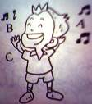 2. 3.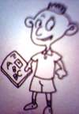 4.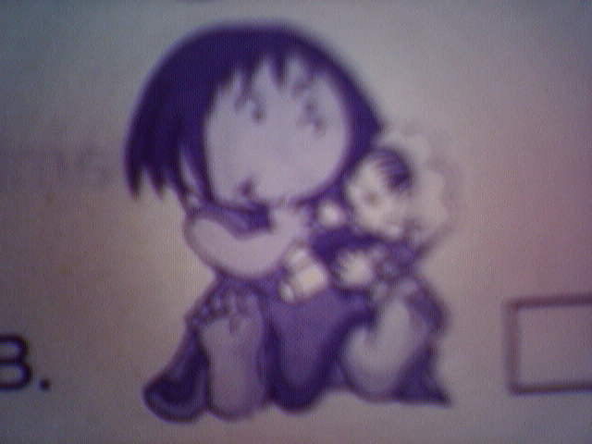 5.  ( ) ( ) ( ) ( ) ( )

6. 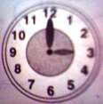 7. 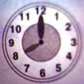 8.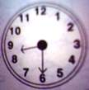 9.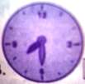 10.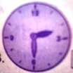
( ) ( ) ( ) ( ) ( )
三. 听音标号

1.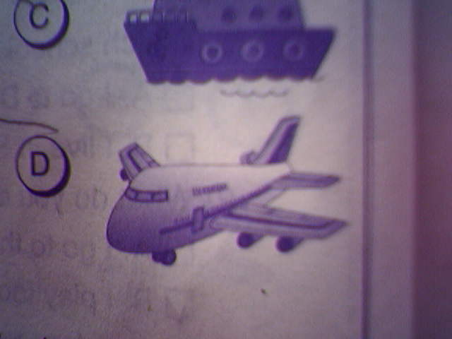 2.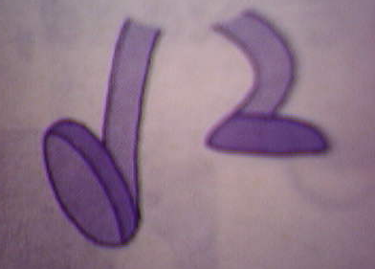 3. 4.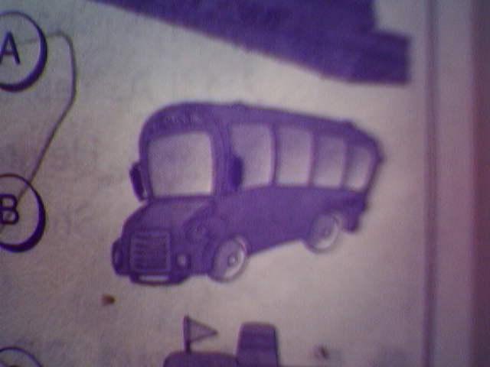 5.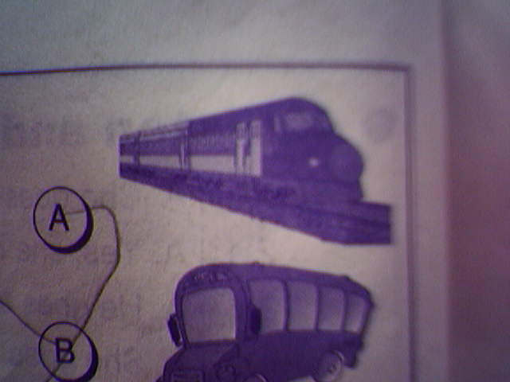
( ) ( ) ( ) ( ) ( )
四. 听音连线

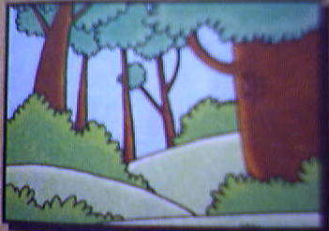 It’s cold. 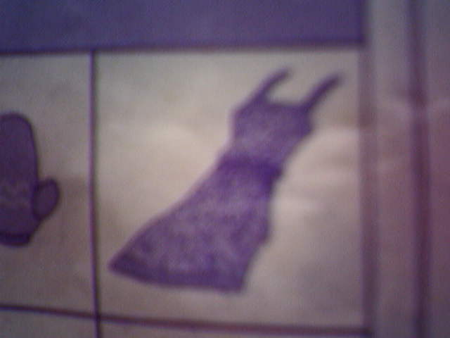

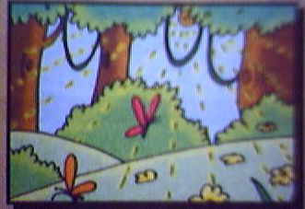 It’s cool. 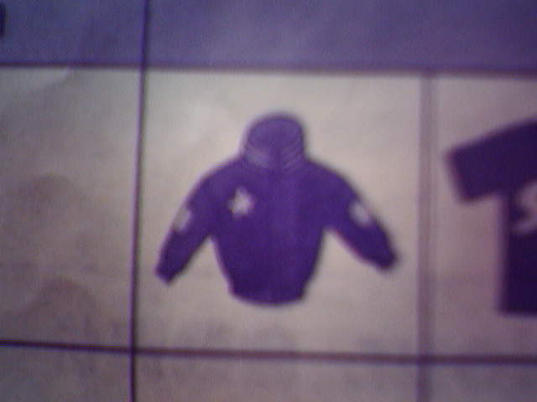

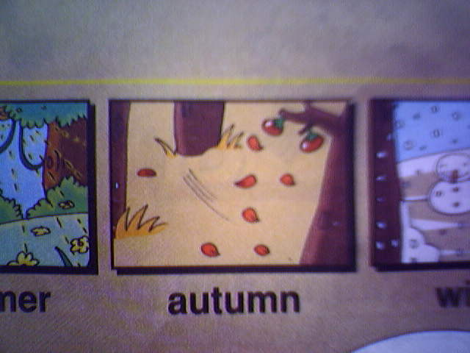 It’s hot. 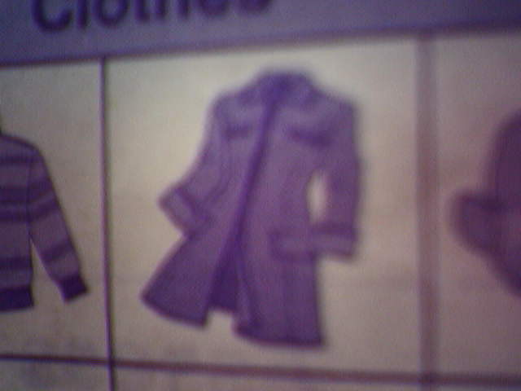

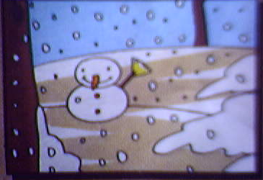 It’s warm. 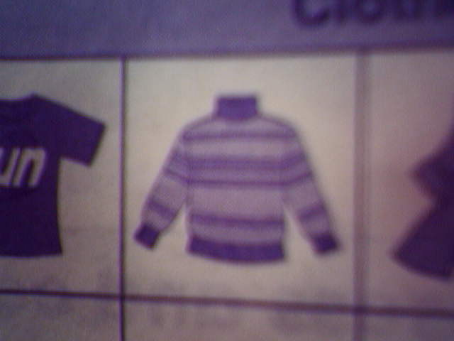

第二部分 笔答部分

五. 抄写字母、单词和句子

Q q Tt Xx Yy Uu

read want love autumn cold

We are Chinese. We love China.

Happy New Year!

六. 看图写出下列词语的首字母

1. (v w) ____indow 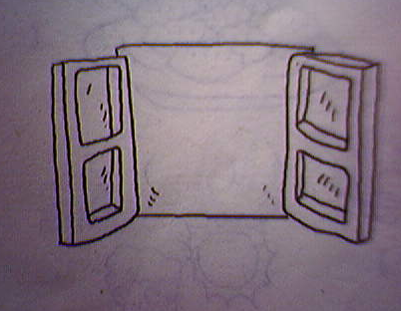 ____iolin 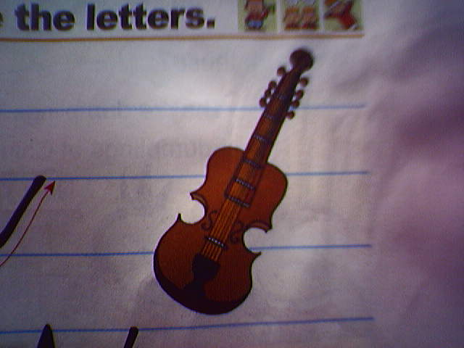

2. (s x) ____heep 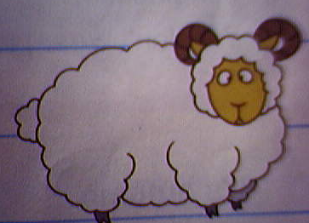 ____-ray 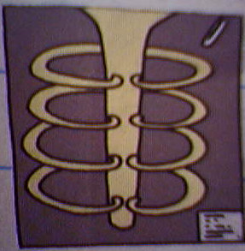

3. (p q) ____ig 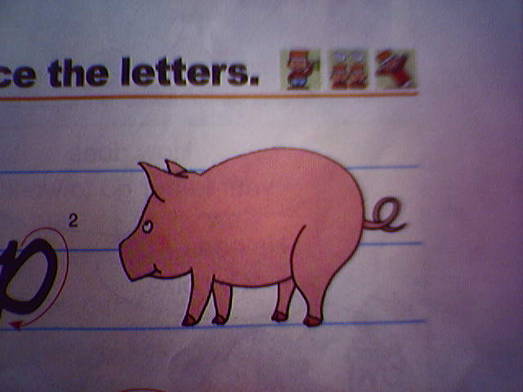 ____ueen 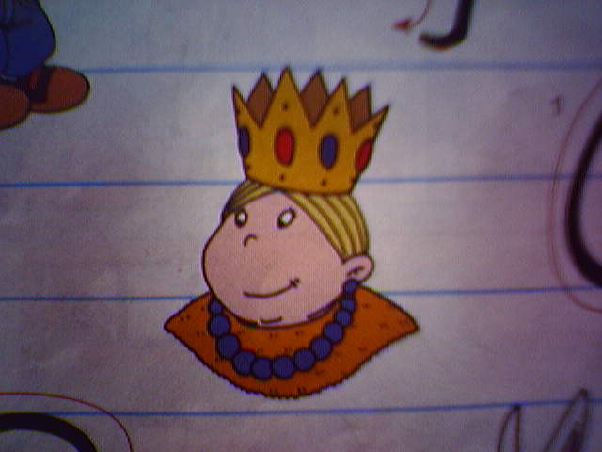

4. (y z) ____oo 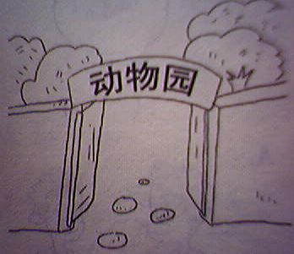 ____oyo 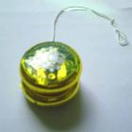

5. (t r) ____abbit 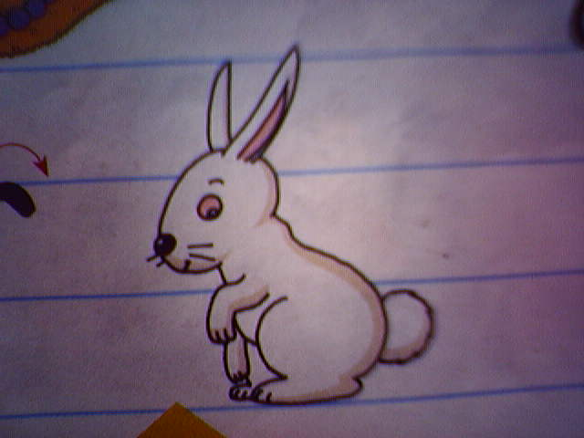 ____eddy 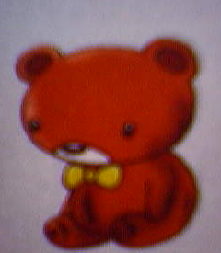

七. 读一读，勾一勾.
1. A. Christmas is in winter.
B. It’s cool in winter.
2.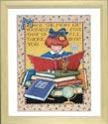 A. He reads books at ten o’clock.
B. She reads books at the weekend.
3.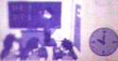 A. I have English at eleven o’clock.
B. I have Maths at ten o’clock.
4.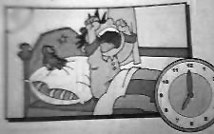 A. I get up at seven o’clock.
B. I go to bed at six o’clock.
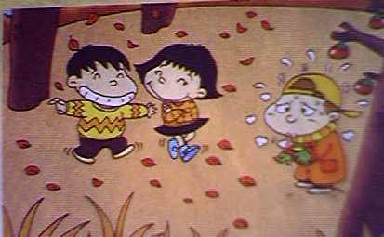
5. A. We wear shirts in winter.
B. We wear sweaters in autumn.

八. 读一读，连一连.
1. Christmas trees big dinner eat dumplings sing songs

Christmas
Chinese New Year

have firecrackers say Happy New Year Christmas presents

2. ( ) 1.What do you do at the Chinese New Year? A.I go by bus.
( ) 2.Where do you live? B. Thank you.
( ) 3. How do you go to school? C. We wear T-shirt and sunglasses.
( ) 4. A present for you. D. We eat dumplings.
( ) 5. What do you wear in summer? E. I live in Anshan.

