二年级英语第一学期期末质量测试
Class__________ Chinese Name ___________ English Name _________ Number ________
二年级英语试卷
（考核范围：Oxford English 2AU1~9; Oxford Storyland 1A）
完卷时间： 40 分钟
题号 | 听力 | 笔试 | 总分 | 等第
应得分 | 50分 | 50分 | 100分
实得分
Listening ( 50%)
- Listen and choose the correct words （听录音，选出听到的单词,将其编号填入题前括号内）10%
( ) 1. A. tree B. three
( ) 2. A. coat B. cold
( ) 3. A. tall B. tail
( ) 4. A. short B. shirt
( ) 5. A. wind B. winter
( ) 6. A. slow B. snow
( ) 7. A. bell B. belt
( ) 8. A. red B. read
( ) 9. A. Coke B. cake
( ) 10. A. sleep B. sweep

- Tick the correct picture. （听录音，勾出正确的单词） 6%
(1) 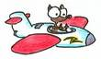 | 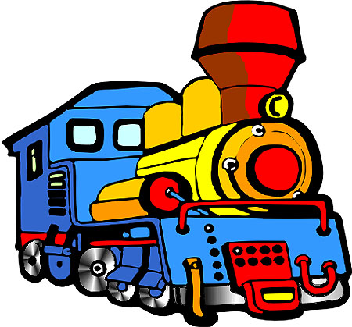 | (2) 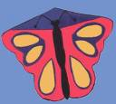 | 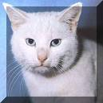
( ) | ( ) | ( ) | ( )
(3) 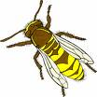 | 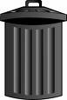 | (4) 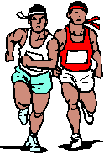 | 
( ) | ( ) | ( ) | ( )
(5) 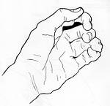 | 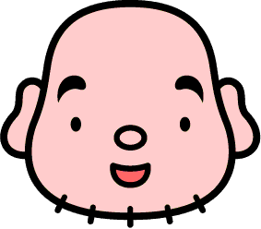 | (6) | 
( ) | ( ) | ( ) | ( )
- Listen and number （给你听到的句子编号）10%
( ) | I’m from Shanghai.
( ) | I have got a blues dress.
( ) | Christmas is coming.
( ) | I can make a snowman with my friends.
( ) | Hello, I’m Angela.
( ) | It’s short.
( ) | I live in Pudong.
( ) | Listen to the wind.
( ) | I need a new one in winter.
( ) | We are very happy.
- Listen and choose the right sentences. （听录音选出正确的句子）5%
( | ) | (1) | A. The pink rubber is very long.
 |  |  | B. The pink ruler is very long.
( | ) | (2) | A. Say “thank you” to your teacher.
 |  |  | B. Say “goodbye” to your teacher.
( | ) | (3) | A. The kitten is in the building.
 |  |  | B. The kitten is in the bin.
( | ) | (4) | A. He is reading a book in the classroom.
 |  |  | B. She is reading a book in the classroom.
( | ) | (5) | A. I can see a yellow light. Wait!
 |  |  | B. I can see a red light. Stop!
- Listen and fill in the correct words. （听录音，选择正确的词填空） 11%
(1) | Look at the ______ ______. It is very fast.
(2) | I have got ______ orange and ______ sweets.
(3) | Put on your new ______ and ______.
(4) | It is the green ______. You can ______ now.
(5) | I can see a yellow ______ on the ______. So beautiful.
(6) | Come and fly a ______ with me.
- Listen and judge. （听录音，判断下列句子与听到的句子是否一致，相同的用T，不同用表示F） 8%
1. Peter has got a ball. ( )
2. My brother has my hot dog. ( )
3. Mary lives in Shanghai. ( )
4. Sue goes to school by bicycle. ( )
5. Sam is very thirsty. ( )
6. Lily’s mother is a beautiful doctor. ( )
7. Sam has a scarf. It’s blue ( )
8. The snowman has got big eyes and a short nose. ( )

Reading: 50 %
- Write the sentence.（正确抄写下列句子） 6%
my mother needs a new dress
- Look and judge. （判断下列单词是否属于同类，相同写T, 不同写F）8 %
1. | shirt | shoe | ( ) | 2. | snow | cold | ( )
3. | swing | side | ( ) | 4. | read | red | ( )
5. | white | write | ( ) | 6. | wait | stop | ( )
7. | moon | mooncake | ( ) | 8. | cat | rabbit | ( )
- Write the correct words. （看图写单词）6%
1. |  | 2. |  | 3. | 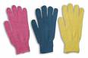
4. |  | 5. |  | 6. | 
- Choose the correct answer. （选择，将正确的代号填入前面的括号内）10%
( ) | 1. | The sun is ________ the sky.
 |  | A. | in | B. | on | C. |  | under
( ) | 2. | I can taste ________ my mouth.
 |  | A. | use | B. | with | C. |  | on
( ) | 3. | ________ you draw a dog? Yes, I can.
 |  | A. | Can | B. | Do | C. |  | Are
( ) | 4. | The apples ________ big and red.
 |  | A. | am | B. | is | C. |  | are
( ) | 5. | This is my sister. ________ is a nurse.
 |  | A. | He | B. | she | C. |  | She
( ) | 6. | I am ________. Can I have some noodles?
 |  | A. | thirsty | B. | hungry | C. |  | Full
( ) | 7. | What is ________ father? He is a teacher?
 |  | A. | you | B. | your | C. |  | you are
( ) | 8. | He likes to swim. I like to ________, too.
 |  | A. | jump | B. | swim | C. |  | Run
( ) | 9. | Eat ________ hot dog and drink ________ milk.
 |  | A. | a…a | B. | a…some | C. | Some…some
( ) | 10. | ________ the wind. It is cold.
 |  | A. | Look | B. | Look at | C. |  | Listen to

- Questions and answers. （根据实际情况回答问题） 10%
  - Where do you live? I ________ ________ Shanghai.
  - How are you? I’m ________.
  - Where is your pencil-box? It’s ________ the ________.
  - Can you fly a kite? ________, I ________.
  - How do you go to school? I go to school ________ ________..
  - What do you like to drink? I like to drink ________ .

- Readings. （阅读对话判断，与对话内容一致的用”T”表示，不一致的用”F”表示）10%
(1) Sam’s Birthday
Hello, I am Joe. I am eight. I have got a brother. He is Sam. Today is Sam’s birthday. He is three now. My mum and dad give him a new bicycle. I give Sam a blue ball. He likes the ball very much. He says, “Boys all like the ball.”
(1) | Today is Joe’s birthday. | ( )
(2) | Joe is Sam’s brother. | ( )
(3) | Joe is three years old. | ( )
(4) | Sam’s mother gives him a ball. | ( )
(5) | Sam likes the ball very much. | ( )
(2) You Are a Cat
Judy: | Here is the pet shop.
Mum: | Look, Judy! The mouse is white. The parrot’s green.
Judy: | The kittens are black and white.
Mum: | They’re very furry. The puppies are small and brown.
Judy: | Oh, I like this cat.
Kitten: | Woof! Woof!
Judy: | Say miaow! You’re a cat.
Kitten: | No, I’m a dog.
Judy: | She’s a dog. You’re a cat! She’s big and brown. You’re small and black. Her legs are long. Your legs are short.
Judy: | The dog likes sticks. She runs. She swims. She eats bones. She’s a DOG.
Judy: | You like the ball. You play. You like birds. You’re a CAT.
(1) | Here is a toy shop. | ( )
(2) | The parrot is blue. | ( )
(3) | The kittens are very furry. | ( )
(4) | The dog swims and plays with the ball. | ( )
(5) | The cat likes birds. | ( )

