PRACTICE 3
Vocabulary (30 marks)
(A) Look at the pictures and tick √ the correct boxes. (6*2 = 12 marks)

1.
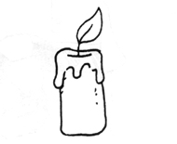
  a candle
  a torchlight
  a matchstick
  a lamp
2.
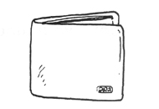
  a wrapper
  a wallet
  a bag
  a photograph
3.
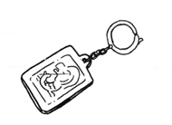
  a lollipop
  a key ring
  a bracelet
  a ring
4.
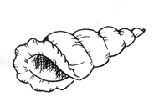
  a flute
  a balloon
  a drum
  a shell
5.
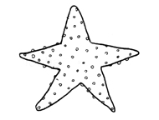
  a starfish
  a toy
  a fruit
  a sponge
6.
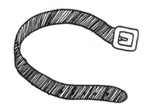
  a string
  a rope
  a belt
  a whip

(B) Match each picture to the correct word. (4*2 = 8 marks)

7.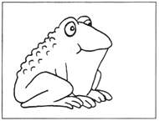* | * telephone
 | * rambutan
8.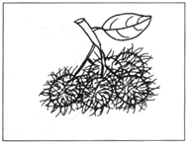* | * rambutan
 | * tadpole
 | * plug
9.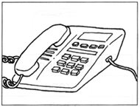* | * plug
 | * switch
 | * toad
10.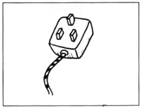* | * toad
 | * microphone

(C) Choose the most suitable answer. Write its number in the brackets
provided.(5*2 = 10 marks)

11. A/An (ship, train, aeroplane, car) flies in the sky.
12. I cover myself with a (blanket, towel, table cloth, cushion) at night.
13. Mrs Tan is writing on the white board with a (marker, crayon, pencil, brush)
14. Mother is cooking in the (storeroom, bathroom, bedroom, kitchen).
15. The little child is building (house, sandcastles, boats, shells) on the
beach.

Grammar (40 marks)
(D) Fill in the blanks with 'am', 'is' or 'are'.
(10 * 1 = 10 marks)

16. These __________ potatoes.
17. This _________ a potato.
18. Those __________ leaves.
19. That __________ a leaf.
20. These __________ Kenny's sweets.
21. She ___________ younger than me.
22. I __________ ten years old.
23. Lisa __________ angry with her brother.
24. We __________ good friends.
25. You __________ very kind to us.
26. John and David __________ in the bedroom.
27. They __________ not going to the park.
28. I __________ sure my mother will be happy to meet you.
29. They __________ sad because they cannot go to the playground.
30. His book _________ new.
31. She __________ my cousin.
32. My grandmother ___________ not feeling well.
33. The doctor __________ not here yet.
34. These __________ oranges.
35. There __________ many candles.

(E) Rearrange the words to form correct sentences and end each sentence
with a full-stop or with a question mark. (5*2=10 marks)
36. enjoys children teaching she little
_______________________________________________________________________
37. is the beach picnic my family by going for a
_______________________________________________________________________
38. rabbit vegetables she the carrots feeds and with
_______________________________________________________________________
39. not long my grandmother have a for visited time
_______________________________________________________________________
40. likes Chris is everyone friendly she because
_______________________________________________________________________

(F) Complete the sentences by using the helping words. (5*2 = 10 marks)

41.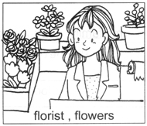 | Who is she?  __________________________.  What does she do?  __________________________.

42.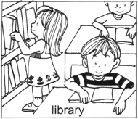 | Where are the children?  __________________________.  What are they doing?  __________________________.

43.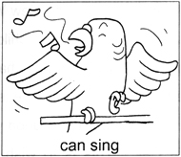 | Why does James keep a carrot?  It is because ______________________________.

44.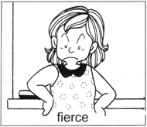 | Why are you afraid of Miss Lim?  It is because ______________________________.

45.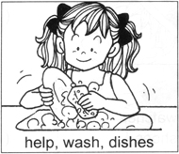 | How can Sally help her mother?  She can ____________________________________.

(G) Comprehension (5*2=10 marks)
Read the passage carefully and answer the questions that follow.

Chinese New Year is special to the Chinese. The Chinese are busy before and during this special occasion. They clean up and decorate their homes. Chinese New Year goodies are bought to be saved to the guests. Children wear new clothes and new shoes. They are most happy when the adults give them red packets. Everyone says something good like "Happy New Year", to have a good year ahead. Many say "Gong Xi Fa Cai". This is to wish one another a properous year.

( ) 46. Chinese New Year is special to the ___________.
A. Malays B. Chinese C. Indians D. Eurasians
( ) 47. The children wear ____________.
A. new watches
B. new clothes
C. new clothes and new watches
D. new clothes and new shoes
( ) 48. The children are given ___________.
A. Chinese New Year goodies
B. new books
C. red packets
D. computers
49. Why does everyone say something good?
____________________________________________________________________
50. Why do people say 'Gong Xi Fa Cai' to one another?
____________________________________________________________________

Written Expression (20 marks)
(H) Look at the picture. Underline the correct word in each brackets.
Then read the sentences.
My Bedroom
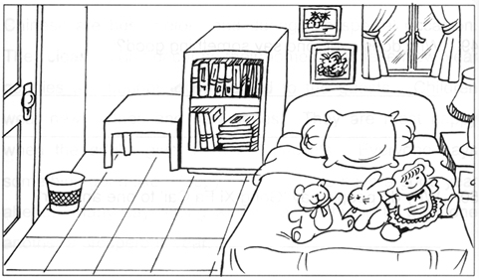
This is my (bedroom, living room). My (bed, chair) is below the (window, door). There are many (toys, books) on the (bed, table). There is a (cupboard, table) beside the (chair, shelf). There are (paintings, stickers) on the wall. I have a (basket, car) near the door. I put my (bags, books) on the (cupboard, book-shelf).

Now write out the story.
____________________________________________________________________________
____________________________________________________________________________
____________________________________________________________________________
____________________________________________________________________________
____________________________________________________________________________

ANSWERS
(Primary 1 English)
Practice 3
A.
1. a candle | 2. a wallet | 3. a key ring
4. a shell | 5. a starfish | 6. a belt
B.
7. toad | 8. rambutan | 9. telephone | 10. plug
C.
11. aeroplane | 12. blanket | 13. marker | 14. kitchen | 15. sandcastles
D.
16. are | 17. is | 18. are | 19. is | 20. are
21. is | 22. am | 23. is | 24. are | 25. are
26. are | 27. are | 28. am | 29. are | 30. is
31. is | 32. is | 33. is | 34. are | 35. are
E.
36. She enjoys teaching little children.
37. My family is going for a picnic by the beach.
38. She feeds the rabbit with vegetables and carrots.
39. I have not visited my grandmother for a long time.
40. Everyone likes Chris because she is friendly.
F.
41. She is a florist. She sells flowers.
42. They are in the library. They are reading.
43. It is because a parrot can sing.
44. It is because she is fierce.
45. She can help to wash the dishes.
G.
46. B | 47. D | 48. C
49. This is wish everyone a good year ahead.
50. This to wish one another a prosperous year.
H.
bedroom | bed | window | toys | bed | table
shelf | paintings | basket | books | book-shelf

