PRACTICE 7
Vocabulary (30 marks)
(A) Fill in the blanks with the appropriate words. (10*2=20 marks)

ribbon | trunks | windy | mountains | sunglasses
medicine | clown | thirsty | envelope | examination

1.
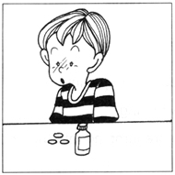 | Menghua is sick.  He has to take ____________.
2.
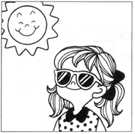 | The afternoon sun is glaring.  Mrs Lim is wearing a pair of ___________.
3.
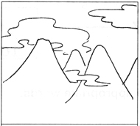 | The ___________ in China are so beautiful.
4.
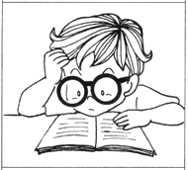 | You have to study hard for your coming _____________.
5.
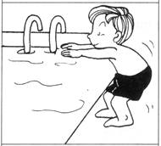 | Peter changes into his swimming ___________ before jumping into the pool.
6.
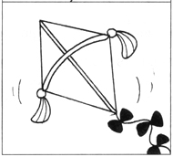 | It's a ___________ day.  Let's fly kites.
7.
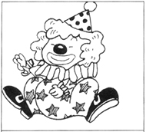 | The __________ is so funny.  He makes everyone laugh.
8.
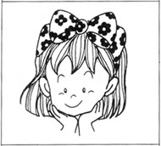 | Meimei has a pretty __________ on her hair.
9.
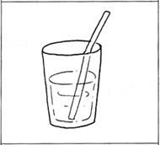 | I am feeling ___________.  Please give me a drink.
10.
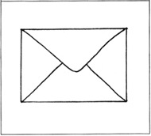 | Ivy needs an _________ for her letter.

(B) Fill in the blanks with the correct words. (10*1=10 marks)

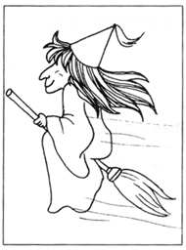 | 11. This is a _____________.  (teacher, witch, clerk)  12. She is flying on a ____________.  (dustpan, toothbrush, broom)
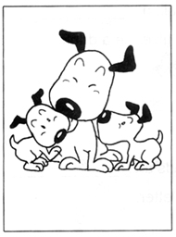 | 13. My dog has just given birth to a litter of  ____________.  (kittens, puppies, nestlings)  14. They are small and ____________.  (cute, stupid, foolish)
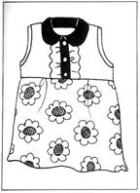 | 15. This is my new _____________.  (blouse, skirt, dress)  16. My mother ___________ it.  (sewed, slept, slapped)
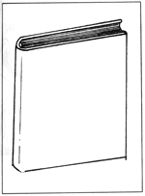 | 17. I read this book many times.  It is very ________________.  (boring, interesting, silly)  18. I borrowed it from the _____________.  (museum, library, emporium)
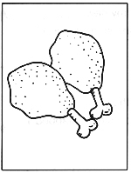 | 19. Tenzin likes to eat chicken ___________.  (drumsticks, sponges, bones)  20. They are _____________.  (bitter, delicious, tasteless)
Grammar (40 marks)
(C) Underline the correct word in each of the brackets.
(16 * 1 = 16 marks)
21. I (was, were) naughty when I was younger.
22. We (was, were) talking about you yesterday.
23. She (was, were) not in school last week.
24. The children (was, were) at the canteen at one o'clock.
25. His cats (was, were) sleeping under the table last night.
26. He (was, were) fat when he was a baby.
27. They (was, were) very quiet when their teacher scolded them.
28. You (was, were) shorter than me last year.
29. My wallet (was, were) in the cupboard yesterday.
30. The night (was, were) beautiful and we sat by the beach singing.
31. Her dog (was, were) sick last week.
32. Diana and I (was, were) classmates last year.
33. My parents (was, were) happy when I showed them my results.
34. We were thirsty and the water (was, were) not enough for us.
35. The music (was, were) good and we enjoyed it very much.
36. Susie and Janet (was, were) in the library a while ago.

(D) Rearrange the words to form correct sentences and end each sentence
with a full-stop or with a question mark. (7*2=14 marks)

37. to teacher stop the asked her students talking
______________________________________________________________________
38. bowls he rice ate was two so hungry he of that
______________________________________________________________________
39. run Thomas than can faster Jimmy
______________________________________________________________________
40. kind we and others should helpful to always be
______________________________________________________________________
41. very nobody because likes to rude is sit beside him he
______________________________________________________________________
42. takes care he pets good of his
______________________________________________________________________
43. likes to when free chess he is father play
______________________________________________________________________

(E) Complete the sentences by using the helping words. (5*2 = 10 marks)

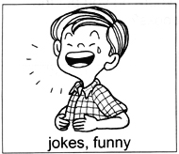 | Why is he laughing?  It is because the ______________________________.
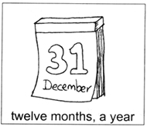 | How many months are there in a year?  There are ______________________________________.
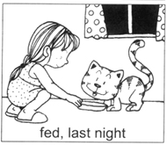 | When did you feed the cat?  I ______________________________________________.
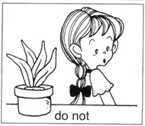 | Do you water the plants daily?  No, I __________________________________________.
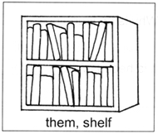 | Where do you put the books?  I ______________________________________________.

(F) Comprehension (5*2=10)
Read the passage carefully and answer the questions that follow.

Yesterday was Children's Day. Meiqing was very excited. She knew that her teacher, Miss Lee, would give them presents. She did not bring any books to school. There was no lesson. Her mother baked a mango cake for her class. Every child had to bring some food for the Children's Day party. After the feast, Miss Lee played a few games with the children. Before the party ended, each child was given a present. Meiqing got a drawing book. She was happy because she liked to draw.

49. Why was Meiqing excited on Children's Day?
_____________________________________________________________________
50. Why did Meiqing bring a mango cake to school?
_____________________________________________________________________
51. Who baked the mango cake?
_____________________________________________________________________
52. What did the children do after eating the food?
_____________________________________________________________________
53. Why was Meiqing happy to get a drawing book as a present?
_____________________________________________________________________

(G) Written Expression (20 marks)
Look at the picture and write a story about it. Use the helping
words given below.

Test

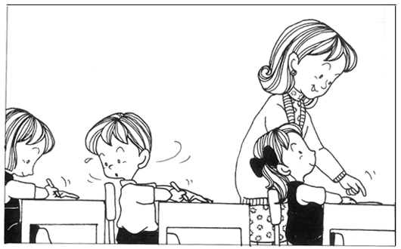

did not study | panic | copied | caught
parents | scolded | punished | studied hard
Mathematics test |  | principal's office

_________________________________________________________________________________
_________________________________________________________________________________
_________________________________________________________________________________
_________________________________________________________________________________
_________________________________________________________________________________

ANSWERS
(Primary 1 English)
Practice 7
A.
1. medicine | 2. sunglasses | 3. mountains | 4. examination | 5. trunks
6. windy | 7. clown | 8. ribbon | 9. thirsty | 10. envelope
B.
11. witch | 12. broom | 13. puppies | 14. cute | 15. dress
16. sewed | 17. interesting | 18. library | 19. interesting | 20. delicious
C.
21. was | 22. were | 23. was | 24. were | 25. were | 26. was
27. were | 28. were | 29. was | 30. was | 31. was | 32. were
33. were | 34. was | 35. was | 36. were
D.
37. The teacher asked her students to stop talking.
38. He was so hungry that he ate two bowls of rice.
39. Thomas can run faster than Jimmy.
40. We should always be kind and helpful to others.
41. Nobody likes to sit beside him because he is very rude.
42. He takes good care of his pets.
43. Father likes to play chess when he is free.
E.
44. It is because the jokes are funny.
45. There are twelve months in a year.
46. I fed it last night.
47. No, I do not water the plants daily.
48. I put them on the shelf.
F.
49. She knew that Miss Lee would give them presents.
50. Every child had to bring some food for the Children's Day party.
51. Meiqing's mother did.
52. They played a few games.
53. Meiling was happy because she liked to draw.

