牛津小学英语第一册unit1测试题
Part 1 Speaking
- Look and read. (看图，朗读下列小对话。)
Give me a book, please.
Here you are.

That’s all right.

Thank you.

- Introduce Tim for May. （为 May 介绍一下 Tim 。并把对话补充完整。）
?
Tim, this is May.

?
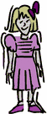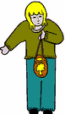
May Tim
III. Look and say. （看图，在老师的帮助下，说一说下列句子。）
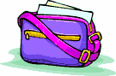
This is my . This is my .
- Count the numbers from six to one. （从六数到一）
- Read a rhyme. （朗诵一首儿歌）
Part 2 Reading and writing
- Look and tick. (在每组中找出从小到大排列的数字,在方框内打√)
  - □ five four six □ four five six
  - □ one two three □ two three one
  - □ two four one □ one two four
  - □ one three six □ six three one
  - □ five two four □ two four five
  - □ two four six □ six two four
- Read and circle. (看问答, 圈出相应数量的物品.)
  - How many books? Three books.
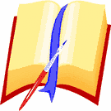
  - How many rulers? Four rulers.
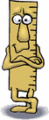
  - How many bags? One bag.
  - How many pens? Two pens.
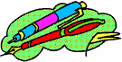
5. How many rubbers? Six rubbers.
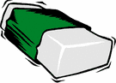

- Read and draw. (根据句子,画出相应数量的物品)
1. Give me six pencils, please.
2. Give me three rulers, please.
3. Give me four books, please.
4..It’s a tree.

