小学一年级上学期英语总复习单词测试题_试卷

- 读一读 、请给下列数字排序号
one three seven ten five

___________＜___________＜___________＜___________＜___________

- 小朋友， 你是数学小天才吗？ 请试着算一算吧。

1. seven —one=_________ 2. two + _________= six
3. ten —_________ = five 4. _________+ three = nine
- 找对子

eraser desk bear balloon bed
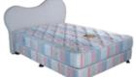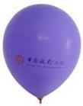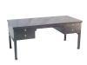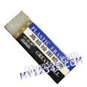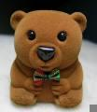

- 看图读单词，请在正确的单词下画笑脸
1. 2. 3.
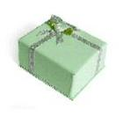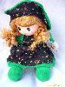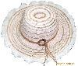

box_________
fox _________
doll_________
ball_________
hat ________
cat _____

4. 5. 6.

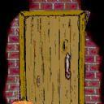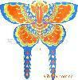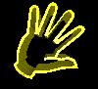

kite_________
cat ________
hand_________
head_________
dog_________
door_________

