小学五年级英语下学期第一单元自查题
班级 姓名 成绩
一、听音，选择（共10题，每小题1分）
（ ）1、A. wait B. rain C. paint
（ ）2、A. play B. today C. May
（ ）3、A. great B. green C. grass
（ ）4、A. glad B. glass C. glove
（ ）5、A. work B. walk C. talk
（ ）6、A. wash clothes B. watch TV C . what colour
（ ）7、A. eat bread B. eat breakfast C. eating bread
（ ）8、A. I have20. B. I have 12. C. I have 21.
（ ）9、A. I am 30. B. I am 13. C. I am 15.
（ ）10、A. I play sports. B. I play football. C. I play ball.
二、听音，判断对错（共10题，每小题1分）
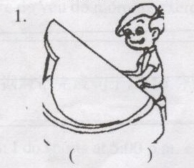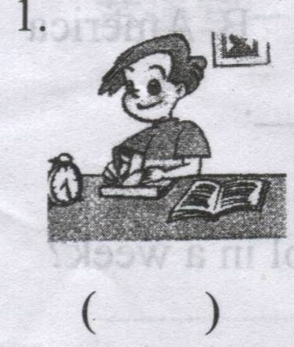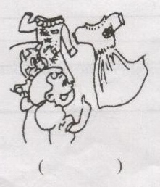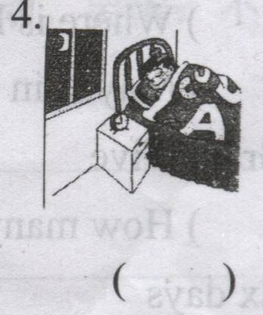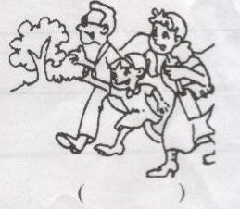
1. ( ) 2. ( ) 3.( ) 4.( ) 5.( )
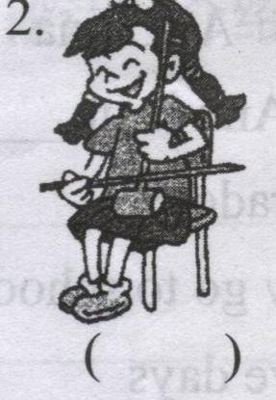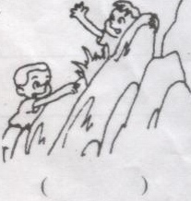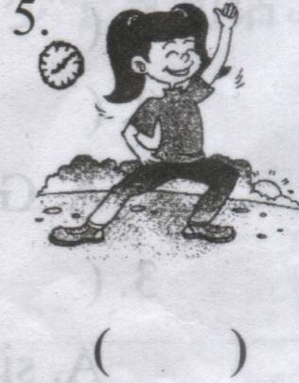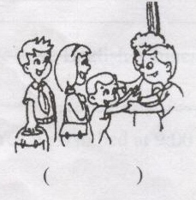
6. ( ) 7. ( ) 8.( ) 9.( ) 10.( )
三、听问题，选答句（共5小题，每小题2分）
（ ）1、A. I go to work at 8:00am. B. I usually go to work. C. I can go to work.
（ ）2、A. I often eat dinner at 7:00pm. B. Usually I climb moutains. C.Sure.
（ ）3、A. I’m a doctor. B. I go shopping. C. I’m 11.
（ ）4、A. I have noodles. B. I have Chinese and math. C. I watch TV.
（ ）5、A. Yes, I’m a teacher. B. Yes, I can. C. Sure .
四、听音，填词（共5题10空，每空1分）
1、 do you do morning exercises. 7:00a.m..
2、 do you do on the weekend? I go shopping.
3、We _______every day.
4、I often with my parents.
5、Chenjie often the on Sundays.

五、听一段对话, 判断下列五个句子的对错。（10分）
（ ）1、John likes winter best.
（ ）2、Chen jie likes spring best.
（ ）3、Mike can swim in the sea.
（ ）4、Wu yifan doesn’t like fall because it’s windy.
（ ）5、Wu yifan likes his red shirt.

笔试部分
六、选择合适的句子，补全对话（共5小题，每小题2分）
Whose is your math teacher? What do you have on Tuesdays? Who is you math teacher? Do you go to bed at 9:00 every day? When do you go to bed? When do you do sports? What do you have on Wednesday?
A: ?
B: I do sports at 5:00 p.m. every day.
A: ?
B: We have English, Chinese, math and music on Wednesday.
A: ?
B: Yes, I go to bed at 9:00 every day.
A: ____________________________?
B: I have English, Chinese, math and P.E. on Tuesdays.
A: ?
B: Our math teacher is Miss Huang.
七、阅读理解（共5小题，每小题2分）
Hello, I am Zoom. I get up at 6:00 every day in the morning. I eat breakfast at 6:30. Then I go to school at 7:00.We do morning exercises at 8:00. We have three classes in the morning and three in the afternoon. I go home at 5:00 p.m.. I play basketball at 5:30. I eat supper at 7:30. Then I do my homework. I go to bed at 9:00. This is my day. What about yours?
( )1、How many classes does Zoom have in a day?
A.five. B. six.
( )2、When does Zoom play sports in the afternoon?
A. at four. B. at five.
( )3、Where does Zoom eat breakfast?
A. at school. B. at home.
( )4、When does Zoom do his homework?
A. at nine in the morning. B. at nine in the evening.
( )5、When does Zoom go to bed?
A. at 9:00 a.m.. B. at 9:00 p.m..

八、短文选词填空（共10空，每空1分）
sports P.E. Sometimesstudent name at milk day exercises sometime date dinner
Hello.My _____ is Zhang Ming. I am a _____ at Willow School. My favourite _____ is Monday. I often get up _____ 6:30 in the morning. I have _____ and bread for breakfast. Then I go to school at 7:10. I do morning _____ at 7:40. I eat lunch at 11:45 at school. In the afternoon, we have art, computer, and _____. After school, I play _____ with my friends. In the evening, I eat _____ at 7:00. Then I do my homework. _____ I watch TV. I go to bed at 9:00. This is my day. Do you like my days?
九、根据答句问问题（共5小题，每小题2分）
1、A： ？
B：It’s 9:00 now.
2、A： ？
B：I usually go shopping on the weekend.
3、A： ？
B：Yes, she often watch TV.
4、A： ？
B：No, I go hiking.
5、A： ？
B：Yes, I am a student.
十、看图作文（10分）
这些人是谁啊？他们在周末都做了些什么啊？他们的心情怎样啊？

