小学五年级英语独立作业 2012.11

班级 姓名 等级
听力部分
一、听句子，选出你所听到的单词或短语，听两遍。
( ) 1. A. must B. mask C. ask
( ) 2. A. bike B. kite C. Mike
( ) 3. A.lesson B learn C listen
( ) 4. A.Miss B.Mrs C.Mr
( ) 5. A.puppet B.puzzle C.purse
二、听对话，根据对话内容和问题，选择正确的答句，并将其序号填在题前括号内，听两遍。
( ) 6. A. Yes, there are. B. No, there aren’t. C. There are some songbooks. .
( ) 7. A. Yes, it is. B. No, I don’t. C. Yes, I am.
( ) 8. A. He is cold. B. She is cold. C. She is hot.
( ) 9.A. Some sweets. B. Some juice. C. Some sweets and some juice.
( ) 10. A. Yes, she does. B. No, she doesn’t. C. Yes, she can.
三、听短文，根据短文内容和问题，选择正确的答句，并将其序号填在题前括号内，听三遍。
( ) 11. How old is Sam？
A. He is 7. B. He is 11. C. He is fine.
( ) 12. Where is Sam’s house?
A. Near my school. B. Near his house. C. Near his school.
( ) 13. How does Sam go to school?
A.On foot. B.By bus. C. By car.
( ) 14. Where is Sam from?
A. He is from China. B. He is from America. C. He is from England.
( ) 15. What does Sam like doing on Saturdays and Sundays?
A. He likes playing chess with me. B. He likes playing football with me.
C. He likes playing basketball with me.
笔试部分 w
四、找出与所给单词画线部分读音一致的选项。
（ ）16. book A. look B. school C. zoo
（ ）17. cake A. have B. plate C. jacket
（ ）18. desk A. them B. free C. dress
（ ）19. hot A. box B. open C. to
（ ）20. bag A. play B. basket C. happy
五、选出能填入句子横线处的最佳答案。
( )21.--What do you do ____ Saturdays?---Do the homework and listen to music.
A. in B. at C. on
( )22. ---Do you like _____? ---Yes, I _____.
A.puppets, like B. puppet, do C. puppets, do
( )23. There _____ a teacher and some students in the classroom.
A. are B. is C. am
( )24. ---How many birds _____ you see?---I _____ see any.
A. can, can B. can’t, can C. can, can’t
( )25. ____ Sundays, We can watch TV______ the evening.
A.In , on B. On, in C.At, in
( )26. ---____ on the table?--- There are many things.
A. Where’s B. Who’s C. What’s
( )27. I can play football, but I can’t play guitar.
A. the;/ B. /;the C. the;the
( )28. Don’t look ________ the window, listen ________ me, please.
A．at; to B. to; at C. for; /
( )29. I can the violin. I like the violin.
A play, playing B play, play C playing, playing
( )30. ---What are _____ jobs? ---They’re nurses.
A. they B. their C. they’re
( )31. ____that woman with big eyes?
A. Who’s B. Whose C. who’s
( )32. --- The girl over there is friend . --- name is Xiaomei .
A his, His B. my, I C. his, Herw m
( )33. Who’s the woman _____ the red dress?
A .with B. in C. on
( )34. ---What’s the mattert with your cat? ---___________
A.I’m cold B.You’re hot. C.It’s ill.
( )35. .How much the bowl of noodles?
A. am B. is C. are
六、找出下列各句中的一处错误。
( ) 36. They like playing basketball and their teachers after school.
A B C
( ) 37. We’re late to the party.
A B C
( ) 38. We all like learn English very much .
A B C
( ) 39. Can I help you? I would like buy some milk.
A B C
( ) 40. Do you like bread? No, I like pie.
A B C
( ) 41. I can’t playing the piano.新-课 -标-第 -一-网
A B C
七、根据短文内容，联系上下文，选出一个最佳答案，并将其序号填在题前的括号内。
I am Nancy Black. I___42__a brother, Mike. My father is a doctor and my mother is a bus driver. They don’t ___43____ on Saturdays and Sundays. They sweep the floor _____44___ Saturday morning. ___45_____ Mike and I like ____46__ some magazines. Sometimes we watch TV, but my father ___47_____ , he ___48__ reading a newspaper__49___my mother. ww w. xkb1.com
( )42. A. am B. have C. has
( )43. A. go to school B. work C. drive
( )44. A. in B. at C. on
( )45. A. And B. But C. Then
( )46. A. reading B. looking C. watching
( )47. A. isn’t B. don’t C. doesn’t
( )48. A. like B. likes C. can
( )49. A. with B. and C. or
八、阅读短文两篇，并根据要求选择正确的答案.
1）根据短文内容，找出能填入横线处的正确答案。
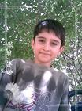


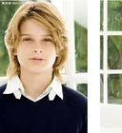

Rose
I can sing but I can’t dance. I can play the guitar and cards.Xkb1.com
Lily
I can’t sing and I can’t dance. I can play the violin and the piano.
Sam
I can’t dance, but I can sing. I can play the violin.
Tom
I can sing and dance. I can play the guitar .

（ ）50.________ can sing and play the guitar.
A. Rose B. Rose and Sam C. Rose and Tom
（ ）51. ________ can sing and dance.
A. Rose and Lily B. Tome and Sam C. Tom
（ ）52. ________ can’t dance.
A. Rose and Sam B. Rose and Lily C. Rose,Sam and Lily
（ ）53. ________ can play cards.
A. Rose B. Sam C. Tom
2）根据短文内容和提问，找出正确答案。
Look at the picture of Lily and Lucy’s bedroom. The walls are white and the windows are big. You can see a picture of their family on the wall. The desk is near the window. You can see some books and flowers on it. A clock is on it, too. There are two baseball bats under the bed. Lily’s sweater is on her bed, but Lucy’s sweater is behind her chair. Where are their hats? They are on the sofa. Oh, no, they are on the floor. What’s on the sofa? They are cats. They look like hats.
( ) 54. Where is the photo of Lily’s family？ww w. xkb1.com
A. On the desk. B. On the wall. C. Near the wall.
( ) 55.What’s on the desk?
A. Some books and flowers. B. Aclock. C. Aclock, some books and flowers.
( ) 56.Where are their hats?
A. Under the bed. B. On the floor. C. On the sofa.
( ) 57.Are there any cats on the sofa?
A. Yes, it is. B. Yes, there is. C. Yes, there are.
九、根据中文提示完成句子，每空一词。
58. 请别打开窗户。 the window, please.
59. 长着小耳朵的那个女士是我的妈妈。
The woman small is my mother.
60. 我会溜冰，我也喜欢溜冰。I can _______ and I like ________, too .
61. 玻璃杯里没有牛奶。 There’s not in the glass.
62.我们有时和朋友们一起打乒乓球。
Sometimes we ________ table tennis __________ our friends.
十、看图填空, 根据图画完成对话，每空一词。
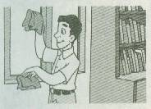
A: _________Mr Wang ?
- B: He’s in the __________.
A: _________he doing
B: He’s ________the window.

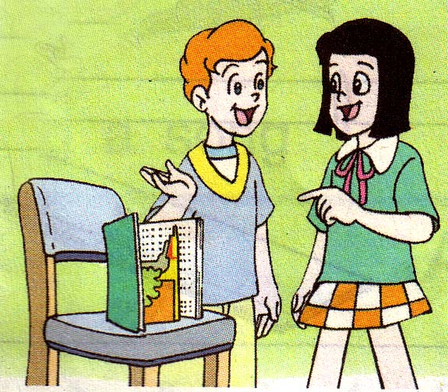
64 A: __________ on the chair?
B: __________ a stotybook.
A: _________ storybook is it?
B: Perhaps it’s Mike’s..

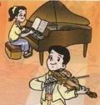
65
A: What_______ the girl do ?
B: She can play the piano. But the boy_____He can play the ________

