盐城市实验小学第一学期
四年级英语期末阶段形成性检测试卷
命题：朱银娣 审核：王咏梅
Dear children,学了一年多英语，你一定懂得了很多英语知识。现在让我们一起来检测一下自己的学习成果吧，聪明的你一定能行！
笔试部分(77’)
一．找出下列各组中不同类的单词，将序号填入括号内：5’
( ) 1. A. bookmark B. notebook C. copybook D. book
( ) 2. A. blue B. fan C. radio D. key
( ) 3. A. gloves B. cold C. socks D. shoes
( ) 4. A. he B. your C. his D. my
( ) 5. A. bed B. ill C. tired D. hot
二. 词组互译: 10’
1.画一个苹果__________________ 2. a glass of water ________________
3. 开门______________________ 4. have some cakes ______________
5. 她的钥匙 __________________ 6. whose socks___________________
7、在四点三十_________________ 8.do the puzzle ___________________
9、 一条短的围巾______________ 10. close the window _________________
三．选择填空，将正确答案的序号填入题前括号内：15’
( )1. May I have a toy car _______ David?
A, to B. for C.and
( )2. ---What ___ this? ---It is___ umbrella.
A. is; an B. are; an C. is; a
( )3. ---Do you like tigers?
---No,__________.
A. I do B. I don’t C. I can
( ) 4. Whose gloves __________?
A. is it B. are they C. they are
( ) 5. Here’s a new coat for you. --- ______________.
A. That’s OK. B. Thank you. C. That’s all right.
( ) 6. What time do you go home? --- I go home __________ five.
A. at B. in C. on
( ) 7. What’s twenty-one and thirty-five? --- It’s ____________.
A. forty-six B. fifty-six C. fivety-six
( )8. -- _______ do you have breakfast? --At 7 o’clock.
A. What time B. What’s the time C. What’s time
( )9、I’m ______ . May I have some tea?
A. thirsty B. hungry C. pretty
( )10 ---_____________shirt is this? ---__________my shirt.
A. Whose, It’s B. Who, It’s C. Who’s, Is
四. 请将下列单词排列成句子，使句意完整：10’
- now , don’t , why , to , bed , go , you ( ? )
___________________________________________________________
- is, bottle, your, where, water (?)
___________________________________________________________
3. time, watch, do, what , you, TV (?)
___________________________________________________________
4. some, and, come, cakes, have ( . )
___________________________________________________________
5. in, perhaps, umbrella, the, is , classroom, your (.)
___________________________________________________________
五．从右栏中找出与左栏相对应的答句，将序号填入题前括号内: 10’
( I )
( ) 1. What’s the time？ A. Why don’t you go to bed?
( ) 2. What’s the matter? B. It’s a doll.
( ) 3. What’s fifty minus forty? C. It’s ten.
( ) 4. What’s this on the table? D. I’m ill.
( ) 5. I’m tired. E. Five fifteen.
( II )
( ) 1. Whose sweater is this? A. Here’s a big one!
( ) 2. Is this your purse? B. Thank you!
( ) 3. Don’t eat in class, Nancy! C. All right.
( ) 4. Here’s a card for you! D. Let me see. Yes, it is.
( ) 5. My rubber is too small. E. Maybe it’s Tom’s.
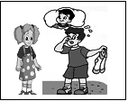
六．看图完成对话，每空一词: 15’
1. --- _____ socks _____ they?
--- _____ _____ Gao Shan’s.
--- _____ ______ Gao Shan?
--- He’s over there.

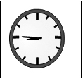
2.--- What’s the _______, Dad?
---_______ _______ forty-five.
_______we go to bed now?
---No, it’s _______ ________ watch TV.
---________ watch TV now. It’s late!
---Ok. _______ night, Dad.
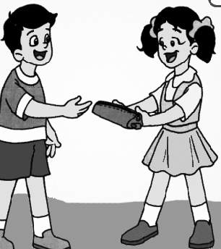
3. ---_______ I have a _______?
--- Sure. Here you _______.
--- It’s nice!
--- Thank _________!

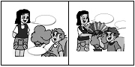
4. --- _________ the _________?
---I’m __________.
A: ________ a ________ ________ you.
B: Thanks!

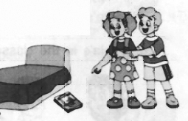
5. --- Excuse me, is this storybook?
--- No, .
---I’m sorry, but _____ my storybook?
---Look, it’s near(靠近) _______ _______.
---Thanks!

七．阅读短文,完成下列题目：12’
This is Mary’s room. It’s big and bright. We can see some kites on the front wall (前墙). On the back wall(后墙), there’s a clock. Look, it is four fifty now!
We can see a desk and bed in her room. The desk is near the window. Where are her bag and pencil-box? They’re on the desk. What’s on the bed? We can see a pair of jeans. Mary likes them, but they’re too short.
Mary and her friend Kate like this room very much! They like to play here!
(一).判断对错,正确的用“T 表示,不正确的用“F”表示.
1. ( ) We can see a clock on the back wall.
2. ( ) It’s five forty now.
3. ( ) We can see a desk and bed in her room.
4. ( ) The jeans are too short.
5. ( ) Whose room is this? It’s Kate’s room.
(二). 根据短文内容填空。
1. Mary’s room is _________ and ____________.
2. We can see some ____________ on the front wall.
3. Mary’s pencil-box is __________ the ____________.
4. We can see a ________ of jeans on the bed.
5. Mary and Kate like to ________ in the room.
教师寄语：写好了就赶快检查一下吧，不要留下遗憾哦！

