2012—2013学年英语四年级期中试卷
听力部分（五大题，共40分）
一、听录音，请选出你所听到的字母或单词。 ( 10分)
( )1. A. SXN B. FMZ C. LXS
( )2. A. hot dog B. hamburger C. hat
( )3. A. French fries B. fires C. farmer
( )4. A. science B. sports C. student
( )5. A. beef B. boy C. big
( )6. A. BGD B. EID C. DGB
( )7. A. wind B. window C. wall
( )8. A. door B. board C. floor
( )9. A. idea B. ice-water C. Good idea!
( )10.A. four B. fourteen C. forty
二、听音并圈出你所听到的单词。( 5分)
1. What’s in the( schoolbag ,pencil-case )?
2. My (classroom, computer) is very nice.
3. My friend likes ( science , math ).
4. Let me clean the (desk, chair).
5. We have 6 new (floor, fans )
三、听音并判断。 ( 5分) X|k |b| 1 . c|o |m
1.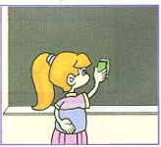2.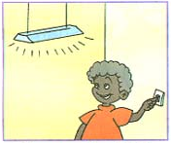3.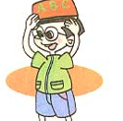4.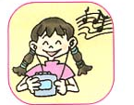5．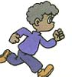
( ) ( ) ( ) ( ) ( )

四、听录音，将下面的句子按听到的顺序排序。（10分）
( )Wow! It’s nice and clean .Good job!
( ) Let me clean the board.
( )Let me clean the window.
( )Good morning. Let’s clean the classroom.
( )Let’s clean the desks and chairs.
五、听录音，选择正确的答语。 ( 10分)
( )1. A. I like blue. B. It’s blue.
( )2. A. OK. B. Thank you .
( )3. A. Sure, here you are. B. Thank you.
( )4. A. I have four math books. B. I can see fourteen story books.
( )5. A. Oh, really？ B. I like it.
笔试部分（六大题，共60分）
六、看图并写出单词。 ( 10分)
1．I have a new 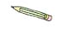
2. This is my 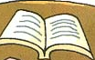
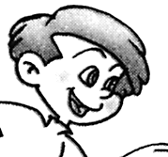
3. This is my 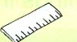
4. Mike is a
5. My 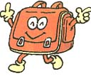 is very heavy.
七、选出不同类型的一项。 (10分)
（ ）1. A. thirty B. fifty C. four D. too
（ ）2. A. math B. English C. book D. Chinese
（ ）3. A. tall B. sports C. strong D. quiet
（ ）4. A. notebook B. floor C. wall D. door
（ ）5. A. nurse B. teacher C. student D. picture
八、根据句意，选择正确的答案。( 共10分)
( )1. What’s in your schoolbag?
A. Many books and a pencil-case. B.A heavy schoolbag.
C. Yes, it is.
( )2. How many books do you have?
A. I like bread and milk. B. I have ten books.
C. I have a big room.
( )3. Amy short. She short hair.
A. has; has B. is; has C. is; is
( )4. I a new friend.
A .have B.has C. to have
( )5. I can see English book and math book.
A. a , a B. an, an C. an, a
九、根据要求，完成题目。（10分）
1. ① look ② Let’s ③ have ④ go ⑤ a ⑥ and（连词成句，只写序号）
_______________________________________________.
2. ① do ② How ③ many ④ you ⑤ have ⑥ books（连词成句，只写序号）
_______________________________________________?
3. ① long ② has ③ My ④ hair ⑤ mother（连词成句，只写序号）
_______________________________________________.
4.I have a new schoolbag.（用book仿写句子）
_______________________________________________
5.She has short hair. She has big eyes.（用and合并句子） _______________________________________________
十、从B 栏中找出A栏相对应的答语。（10分）
A B
（ ）1、How many pencils do you have？ A、 His name is Mike.
（ ）2、Where is my seat？ B、 It is black and white.
（ ）3、What colour is this bag？ C、 Sure. Here you are.
（ ）4、What is his name？ D、 I have thirty pencils.
（ ）5、May I have a look？ E、 It is near the door.
十一、阅读短文，选择正确的答案，并将序号填在题前括号中。（10分）
I’m Miss Liu.I am your English teacher.We have a new classroom.It is very big and clean.This is my new desk. There are some new English books.They are blue and white.These new desks and chairs are for you.
( )1.Miss Liu is teacher.
A. a Chinese B. an English C. a math
( )2.They have a classroom.
A. small B. old C. new
( )3.Their English books are .
A. blue B. white C. blue and white
( )4 has a new desk?
A. Miss Liu B. Mrs Liu C. Mr Liu
( )5.The new classroom is .
A. clean B. clean and big C. big

四年级听力材料
一、 听录音，请选出你所听到的字母或单词。( 2次)
1. FMZ 2.hot dog 3.farmer 4.student 5.beef
6. EID 7.window 8.floor 9.ice-water 10.forty
二、听音并圈出你所听到的单词。( 2次)
1. What’s in the schoolbag?
2. My classroom is very nice.
3. My friend likes science.
4. Let me clean the desk.
5. We have 6 new fans.
三、听音并判断正误，对的打√，错的打×。 ( 2次)
1. Clean the board.
2. Turn on the light.
3. Put your schoolbag on your head.
4. Listen to music
5. Play computer games
四、听录音，将下面的句子按听到的顺序排序。( 2次)
1. Good morning. Let’s clean the classroom.
2. Let’s clean the desks and chairs.
3. Let me clean the board.
4. Let me clean the window.
5. Wow! It’s nice and clean .Good job!
五、听录音，选择正确的答语。 ( 2次)
1. What color is your pencil-case?
2. Let’s sweep the floor.
3. May I have a look? X k b 1 . c o m
4. How many math books do you have?
5. We have a new classroom.

