第一学期四年级英语期中检测
班级 姓名 等第
听力部分（40分）
一、听单词，选择你所听到的选项。(每小题读两遍。10分)
( )1. A. rabbit B. monkey C. bear
( ) 2. A. this B. that C. the
( ) 3. A. nice B. rice C. ice
( )4. A. what B. which C. where
( )5. A. your B. you C. my
( )6. A. a tiger B. a panda C. a dog
( )7. A. fat B. five C. four
( )8. A. Nancy B. Helen C. Mike
( )9. A. desk B. doll C. dog
( ) 10. A. think B. thank C. that
二、听录音，给下列图片标号。（每小题读两遍。12分）
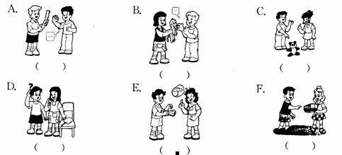
三、听录音，根据所听问句选择正确的答句。（10分）1
( ) 1. A. Yes, come in, please. B. Thank you. C. I’m sorry.
( ) 2. A. No, thank you. B. Here you are. C. No, please.
( ) 3. A. Here you are. B. No, please. C. Thank you.
( ) 4. A. Good morning. B. Good afternoon. C. Goodbye.
( ) 5. A. Thank you. B. All right. C. Here you are.

四、听录音，完成句子。（8分）
1. Here’s a __________ for you.新-课- 标-网
2. ----Can I _______ a look at ________ toy bear? ----OK.
3.—Do you like this ? –Yes. I .
4. ----_______ like this panda, please. ---- _________ you are.
笔试部分(60分)
一、单词辨音，判断下列单词划线部分读音是否相同，用“√”和“×”表示。（5分）
( ) 1. big boy ( )2. boy dog
( ) 3. cap nice ( ) 4. fat five
( )5. get orange ( )6. have hot
( )7. juice jacket ( )8. key kitchen
( )9. puppet puzzle ( )10.kite bike

二、英汉词组互译。（10分）
1. 这支铅笔 2. 那张书签 __
3. 他的钢笔 ______________________ 4. 你的玩具狮子___________________
5. 杨玲的狗 __________________ 6. 用英语 ____________________
7. have a look ____________________ 8. a lovely panda ____________________
9. over there____________________ 10. not at all______________________

三、选择填空。（共10小题；每小题1分，满分10分）新课 标 第一网
( )1. A: _______I come in? B: Come in, please.
A. Do B. May C. Am
( )2. This copybook is ________ you.
A. for B. give C. to
( )3. I like this monkey.
A. Not at all. B. Yes. C. Me, too.
( )4. Perhaps the bookmark is ________ .
A. Lily’s B. Lily’ C. Lily
( )5. Do you like this _______ ? Yes, I do. I like _____.
A. pandas; pandas B. panda; pandas C. panda; panda
( ) 6. Can I help you? ________ a toy rabbit, please.
A. I like B. I’d like C. It’s
( ) 7. Your five fat ________ on the desk.
A. dog are B. dogs is C. dogs are
( )8. The black cat is nice, __________ I like the yellow one.
A. and B. of C. but
( )9. ----Where’s my notebook? ---- It’s ___________
A. on the bed B. in the bed C. in bed
( )10. ----What’s that over there? ---- __________ it's a purse.
A. May B. perhaps C. Perhaps

四、根据句意及所给的图片，在空格内填上正确的单词。（共5小题；每小题1分，满分5分）新课 标 第一网
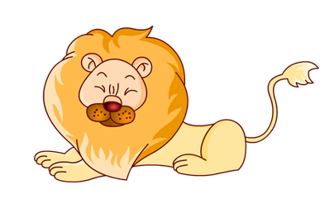
1. This is a , I think.
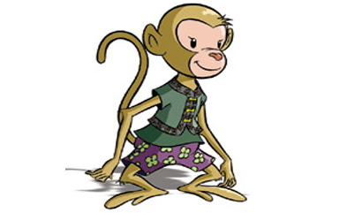
2. I’d like your .

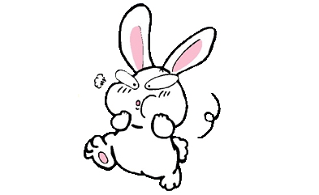
3. What a nice !

4. May I have a ?
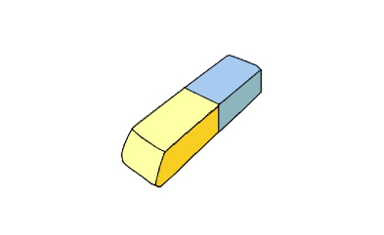
5. This is for you.

五、选择合适的回答，将其序号填在题前的括号内。（共10小题；每小题1分，满分10分）
( ) 1. What’s this? A. That’s OK.
( ) 2. Here’s a card for you. B. He’s over there.
( ) 3. I’m sorry. C. It’s a puppet.
( ) 4. I’d like this doll, please. D. Sure. Here you are.
( ) 5.Where’s the teacher? E. Here you are.
( ) 6. Do you like puzzles?. F. No, it’s Nancy’s.
( ) 7. May I have a monkey? G. Yes, I do.
( ) 8. Is this your violin? H. Thank you very much.
( ) 9. Goodbye, Miss Li. I. Me, too.
( ) 10. I like pandas. J. Goodbye.
Xkb 1.co m
六、将下列句子排列成一段通顺的对话。（共8小题；每小题0.5分，满分4分）
A
1. Can I have a look?
2. It’s a toy dog.
3. Sure. Here you are.
4. Oh, how nice!
5. What’s that in the bag?
B
1. The green box.
2. In which box?
3. What’s that in the box?
4. I like this panda.
5. Let me see. Oh, it’s a toy panda.

A. 5 ____ ____ ____ ____ B. 3 ____ ____ ____ ____

七、连词成句（共5小题，每小题1分，满分5分）
1. is that storybook a I think(, .)
_________________________________________
2. like a I’d doll please(, .)
_________________________________________
3. the perhaps pen is Yang Ling’s (.)
_________________________________________
4. in what is English that (?)
_________________________________________ k b1.co m
- me are excuse my where rubbers(，?)
_______________________________________________

八、句子翻译。（共12个空格；每空一词，每词0.5分，满分6分）
1.— 这块橡皮是给你的。— 谢谢。
— This _________ is _________ you.
— Thank you.
2. 他的故事书在哪里？
__________ __________ storybook?
3. 过来，这是你的铅笔吗？
_________ here, is this _________ pencil?
4. — 我可以要一本抄写本吗？ — 当然，给你。
— May I _________ a copybook? — Sure, here ______ are.
5. — 这个用英语怎么说? — 一个木偶。
— _______ this in ? — It’s a ________.

九、阅读理解。（共5小题；每小题1分，满分5分）
Today is Sunday. The Greens are at home. They are busy. Mrs Green is in the kitchen. She is cooking. Mr Green is sitting in the living-room. He is watching TV now. Tom is reading picture books in his study. Lily, Tom’s sister, is cleaning her new bike. They all have a happy day.
判断下列句子与短文内容是否相符，相符的用“√”表示，不相符的用“×”表示。
( )1. Today is Sunday.
( )2. Mr Green is in the kitchen. He’s cooking.
( )3. Mrs Green is reading picture books in her study.
( )4. Lily is Tom’s sister.新-课- 标-第
( )5. Lily has a new bike.

