（人教新版）三年级英语下册How old are you?
Look and match
- 将下面的字母大小写连线。
h

k
J
I
K
j

i
H

- 将每捆小棍的数量与相应的数字连线。.

每捆=10根小棍

一捆加8根小棍
一捆加6根小棍
一捆加7根小棍

twenty sixteen eighteen nineteen seventeen

2捆小棍
一捆加9根小棍

Listen and write

- 根据听到的内容写出下面事物的正确数量。
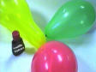 | 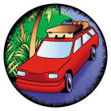 | 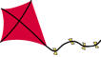 | 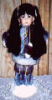 | 

- 听力内容：
- How many balloons do you have?
I have 19.
- How many dolls do you have?
I have 20.
- How many kites do you have?
I have 12.
- How many cars do you have?
I have 16.
- How many balls do you have？
I have 15.

- 教师报英文数字11－20，学生写阿拉伯数字。
_______ _______ ______ ______ _______
_______ _______ ______ ______ _______

