2012学年小学英语PEP3第四单元质量检测试卷

学 校 班级 姓名 学号

Listening part 听力部分（50%）
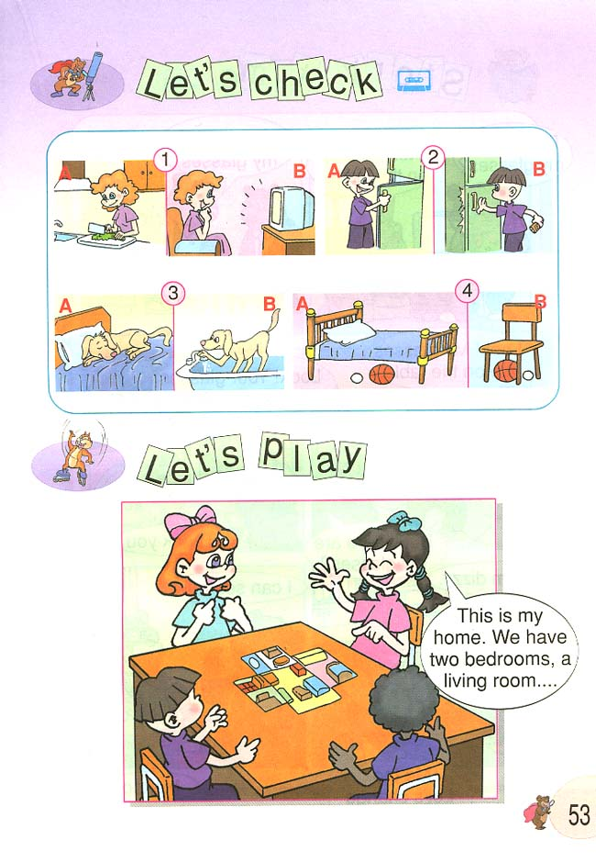
一、Listen and circle. 听音，圈出你所听到的图片序号。（12分）
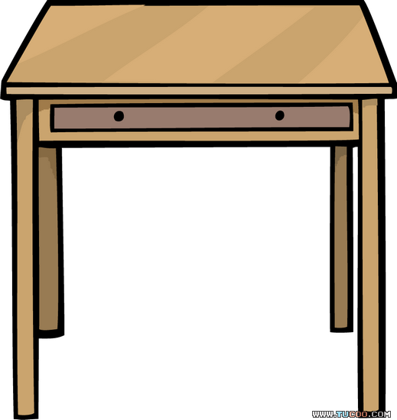
1、 2、

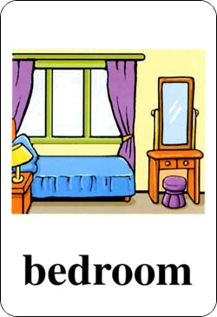
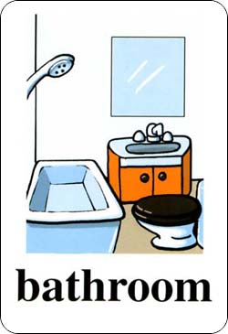
A B A B
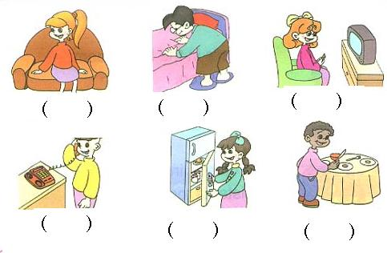
3、 4、

A B A B
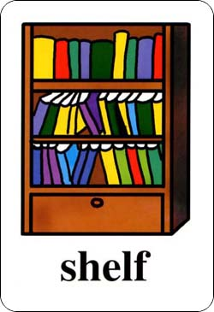
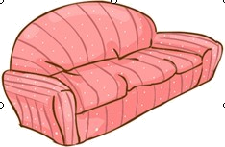
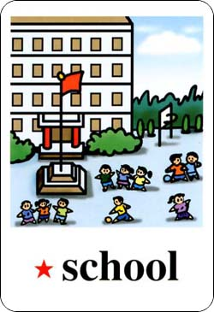
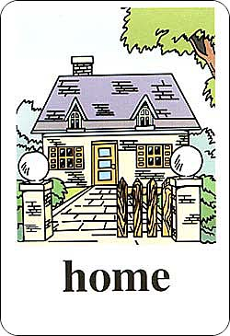
5、 6、

A B A B
二、Listen and choose. 听音，选择你所听到的单词。（12分）
（ ）1、A. fridge B. friend C. floor
（ ）2、A. please B. phone C. elephant
（ ）3、A. on B. under C. near
（ ）4、A. table B. make C. twenty
（ ）5、A. short B. shelf C. study
（ ）6、A. key B. kitchen C. chicken
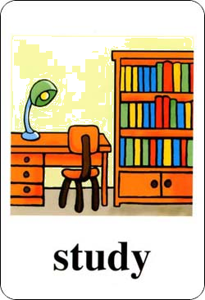
三、Listen and tick or cross. 听音，判断对（√）错（×）。（12分）
1、 2、 3、

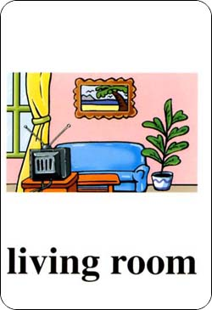
（ ） （ ） （ ）
4、 5、 6、

（ ） （ ） （ ）
四、Listen and choose. 根据你所听到的句子选择答案。（12分）
（ ）1、 A. Sure, here you are. B. Yes, he is.
（ ）2、 A. No, she isn't. B. No, they aren't.
（ ）3、 A. His name is Mike. B. He likes sports.
（ ）4、 A. Yes, they are. B. They're in the door.
（ ）5、 A. Read a book. B. Have a sleep.
（ ）6、 A. Yes, it is. B. I can see a sofa.

Reading and writing（读写部分）50％
一、Read and choose. 找出与划线单词不同类的单词。（10分）
( )1. Is this your bedroom?www .xkb 1.com
A. living room B. kitchen C. teacher
( )2. I have a story-book.Xk b1.c om
A. schoolbag B. English book C. math book
( )3. Where is the phone?
A. table B. music C. Sofa
( )4. Look! It's on the bed.
A. picture B. in C. under
( )5. Your room is very nice.
A. classroom B. study C. key
- Read and choose 单项选择。（10分）
- Is he in the study?
A. Yes,they are. B.Yes, he is. C.No, they aren't.
- Is this your bedroom? No, .www. xkb 1.com
A. he isn't. B.she isn't C. it isn't.
- Go ___ the living room. Watch TV.
A. to B.at C.near
- I have ___ new eraser.
A. the B.an C.a
5、 My father is ______ the living room.新-课-标 -第 -一-网
A. in B. under C. on
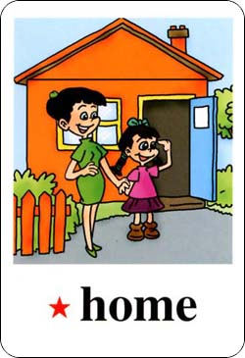
三、Read and write. 看图填空，完成短文内容。（10分）
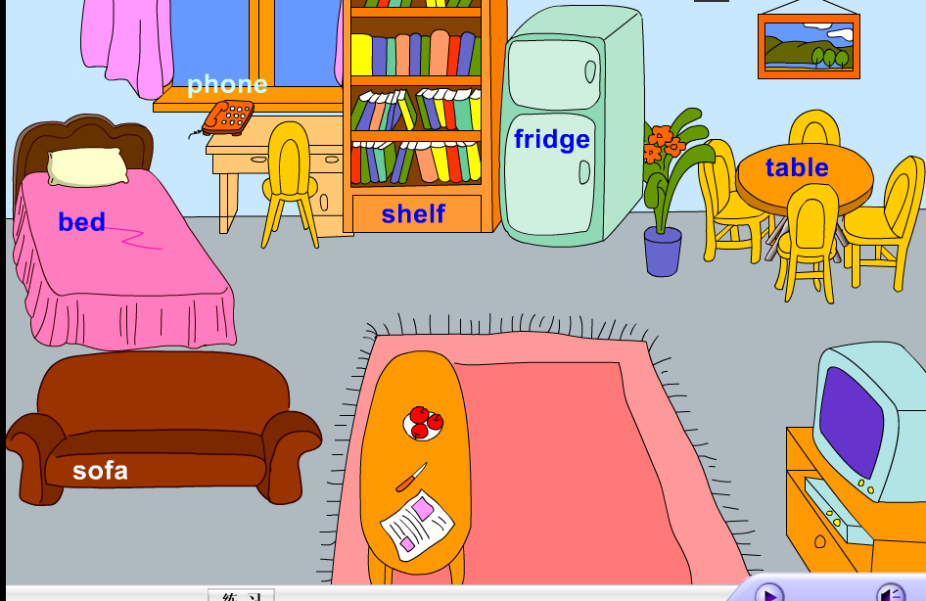
Hello! My name is Lisa. Welcome to my (家).
This is my (房间). You can see a TV, a shelf,
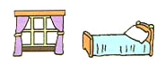
a , a and a
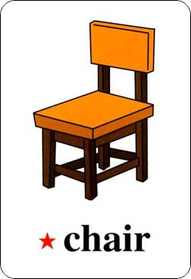
. It's a nice room. I like it.新课|标 第| 一|网
- Read and choose. 根据问句，选择合适的答语。（10分）
( ) How many rulers do you have? A、I can see a door.
( ) What can you see? B、No, they aren't.
( ) Is she in the bedroom? C、Yes, she is.
( ) Are they on the table? D、I have 13 rulers.
( ) Where are the books? E、They're in the desk.
五、Read and tick or cross. 阅读短文，判断对错。（10分）
Welcome to my home. Mom is in the kitchen. Dad is in th study. My sister is in the living room. Look, this is my bedroom. My bedroom is small, but it's very nice. You can see a bed, a desk, and two chairs. You can see many books. They're on the shelf. I have a computer. It's on the desk.新-课-标 -第 -一-网
( )1. Mom is in the kitchen.
( )2. Dad is in the living room.
( )3. My bedroom is very big.
( )4. You can see a picture on the desk.
( )5. Many books are on the shelf.

