新世纪小学二年级英语期末试卷
（书写2分）
姓名 成绩
一、看图片，选择正确的单词。（3’* 6=18’）
A.sofa B.telephone C.photo D.lamp E.mat F.fridge
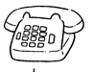( ) | 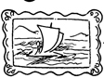 ( ) | 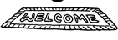( )
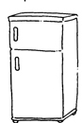 ( ) | 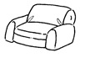( ) | 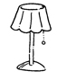 ( )
二、读一读，给下列图片配对。（4’*5=20’）
1.My name is John Chan.  2.Peter is not here.  3.Mary Lee is seven years old.  4.I have a sofa in my flat.  5.The baby is sleeping.  6.Tom is at school. | A.He is absent.  B.Please keep quiet.  C.I am your new teacher.  D.She is in P2.  E.He is present.  F.It is red
三、读一读，给下面图片标序号。（1.5’* 8=12’）
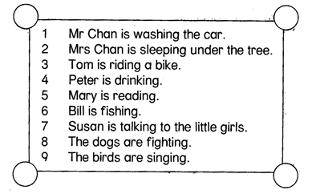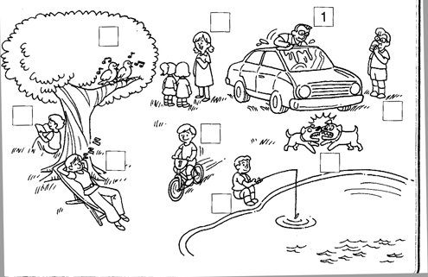

四、选择正确的单词填空。（3’* 5=15’）
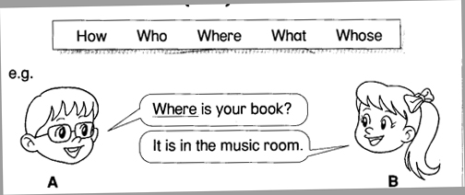
1、A： colour is the cupboard?
B:It is black and white.
2、A： jacket is it?
B:It is Peter’s.
3、A： does Betty have in her home?
B:She has a very big TV.
4、A： is that funny man?
B:He is Charlie’s father.
5、A： many toys does Charlie have?
B:He has eight toys.

五、把句子按正确的顺序排起来。（8’*2=16’）
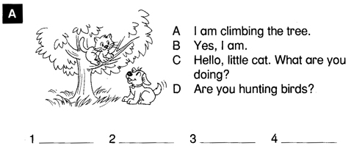
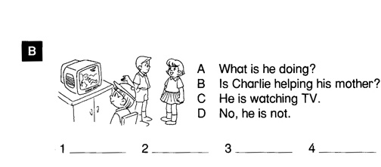
六、选词填空。（2’* 5=10’）
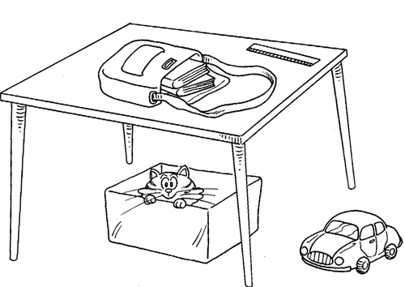
A.in B.on C.under
1.The books are the bag.
2.The bag is the table.
3.The box is the table.
4.The box is the floor.
5.The cat is the box.
七、选择合适的词，填在横线上。（1’*7=7’）