2012年二年级英语暑期作业
Unit 1-4
一 Write(正确写出下列单词的英文或中文意思．)

1. 苹果 2. 15 3. 猫

4.headmaster 5. teddy bear 6.picture book
———— ————— ________
二． Read and circle(圈出于例词同类的单词。)
1. fifty ( five fine for )
2. fly ( book blue bee )
3. pen ( ruler bus cat )
4. bread ( pizza milk water )
5. red ( purple play pig )
6. swim ( rabbit fox sleep )
三． Read and circle the correct word(看图，勾出正确的单词．)
１
seventy seventeen

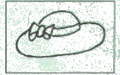
2.
cat hat

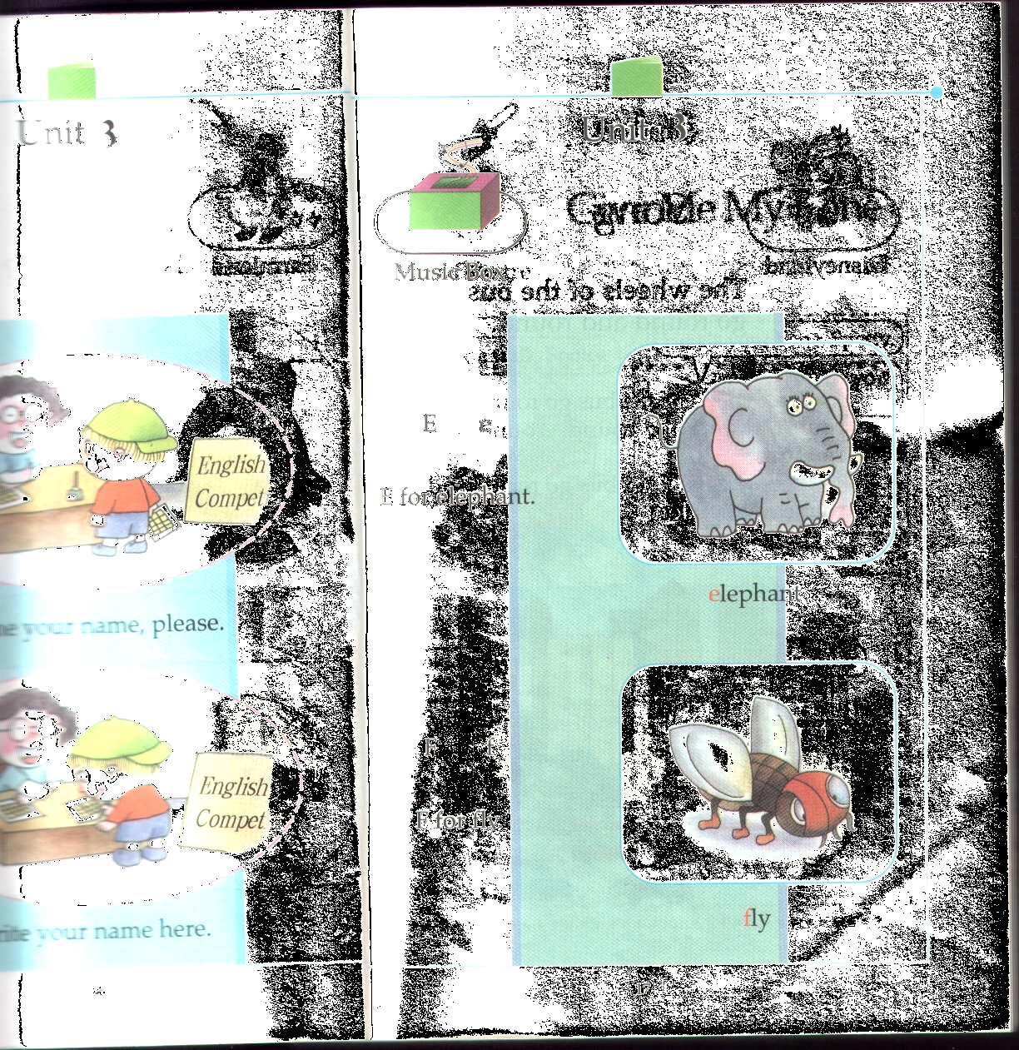
3. butterfly fly

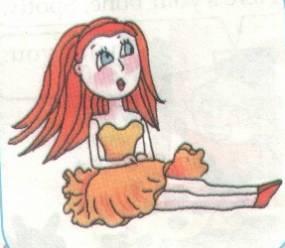
4.
jigsaw Barbie Doll

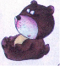
5.

panda bear

四． Read and circle the correct sentences(看图，勾出正确的句子．)
１．
（ ） I’ve got a Barbie doll .
（ ） I’ve got a picture book.


2
( ) Give me the bones..
( ) Give me the chicken.

3.

( ) It’s twenty-five eleven.
( ) It’s eleven twenty-five.

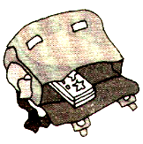
4

( ) It’s in the bag.
( ) It’s on the bag.


5.
( ) Let’s go skating.
( ) Let’s go cycling.

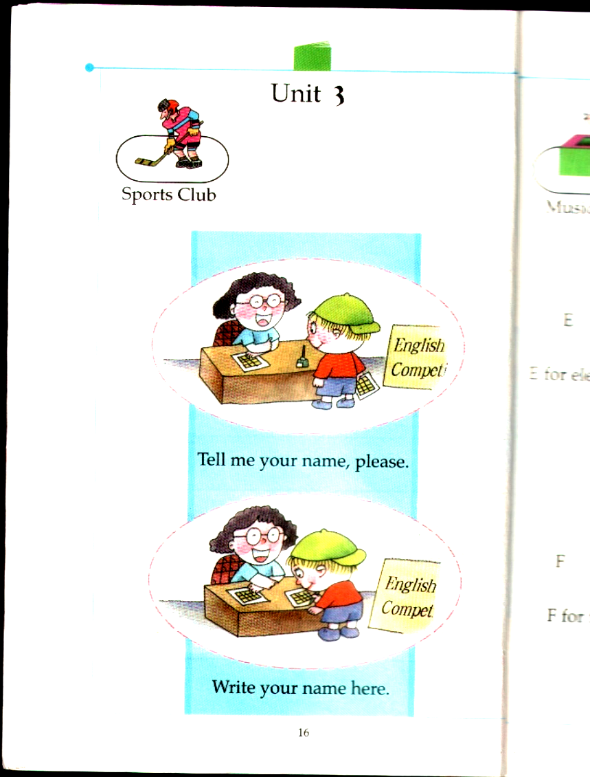
6.
( ) Tell me your name, please.
( ) Write your name here.

五． Read and choose.（根据问题，选择正确的答案）
( ) 1 What time is it? _____
A I’m nine. B It’s seven thirty.
( ) 2 How much is twenty plus one? _____
A Nineteen. B Twenty-one.
( ) 3 Give me an apple, please. _______
A Thank you. B O.k. Here you are.
( ) 4 Is she your class teacher? _______
A Yes, she is. B Yes, he is.
( ) 5 Where are you from? ______
A I love Pudong. B I’m from Pudong.
( ) 6 A: Let’s take a walk. B: _________.
A Great B Bye-bye.
( ) 7 May I speak _____ your mother?
A on B to
六． Read and choose. (阅读下列短文，选择正确的答案)
This is Tom. He is my friend. He is tall. He is fat. He is nine years old.
He can draw and write. He likes apples.
( ) 1Tom is my _________.
A. father B. friend C. mother
( ) 2 Tom is a __________.
A. boy B. girl C. teacher ww w.x kb1.com
( ) 3 Tom is ___________.
A. short and fat B. tall and thin C. tall and fat
( ) 4 Tom can __________.
A. draw B. dance C. sing
( ) 5 He likes to eat __________.
A. apples B. lemons C. oranges

