吴江市实验小学二年级英语学科期末
班级 姓名 学号 成绩
听力部分 （50分）
- 听录音，选出你所听到的单词、词组和句子。（24分）
( )1.A.bottle | B.blouse | ( )2.A.puzzle | B.puppet
( )3.A.bed | B.box | ( )4.A.seven | B.shirt
( )5.A.jacket | B.jeep | ( )6.A.monkey | B.bear
( )7.A.Music | B.Maths | ( )8.A.boat | B.plane
( )9.A.go home |  | B. go to bed
( )10.a. There is a can. B. There is a box.
( )11.A. I’d like a coat. |  | B.I can see a fox.
( )12.A.It’s on the sofa |  | B. It’s in the sofa
- 听录音，圈出你所听到的内容相符的图片。（14分）
1. | 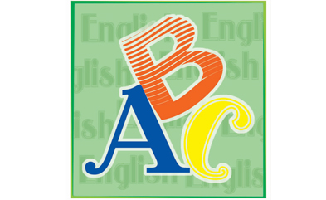 | 
2. |  | 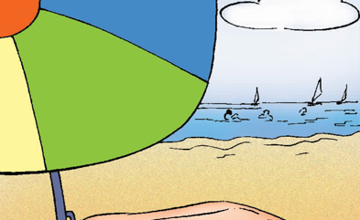
3. | 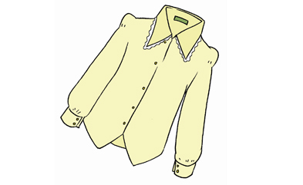 | 
4. | 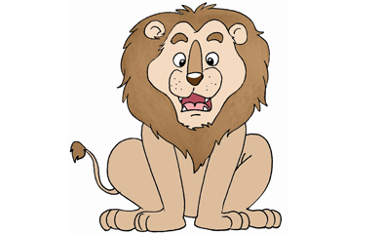 | 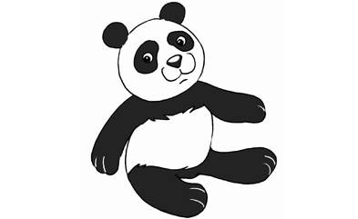
5. | 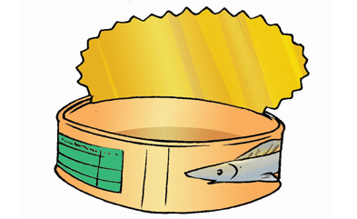 | 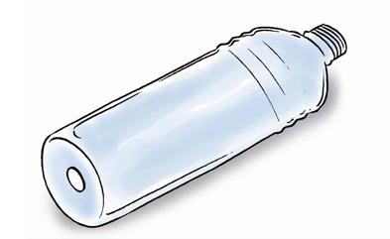
6. | 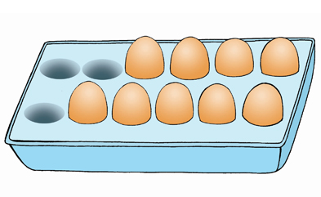 | 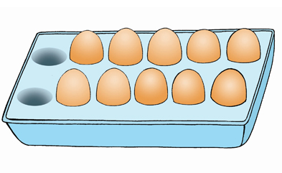
7. | 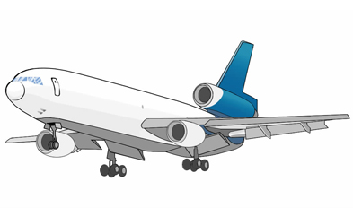 | 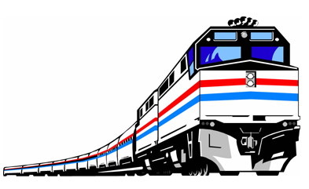
- 听录音判断，画笑脸或哭脸。（12分）www. xkb1 .co m
1. 2.
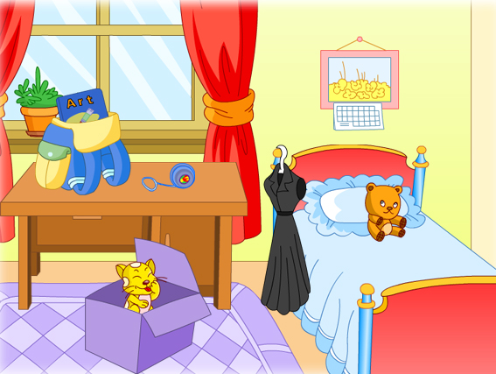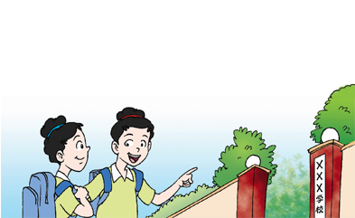
- 4.
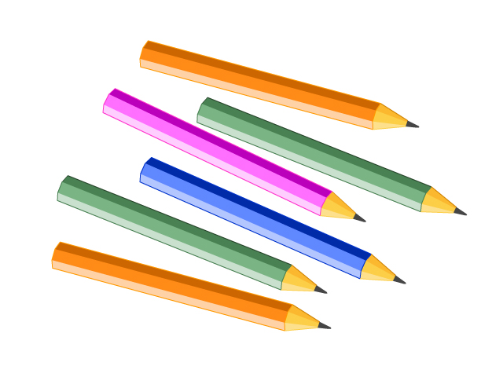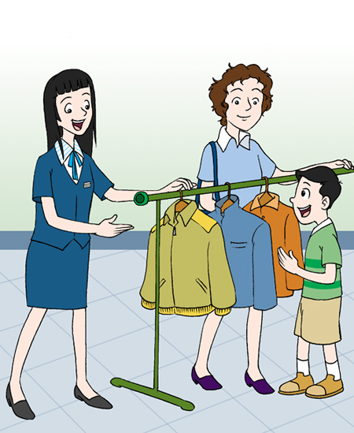
5. 6.
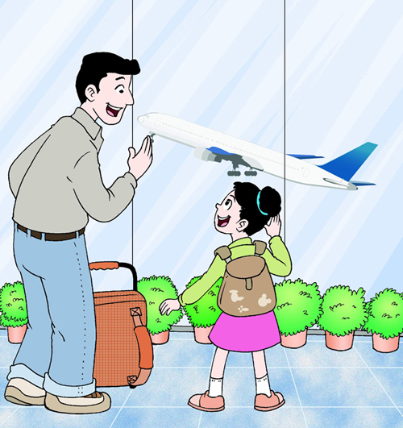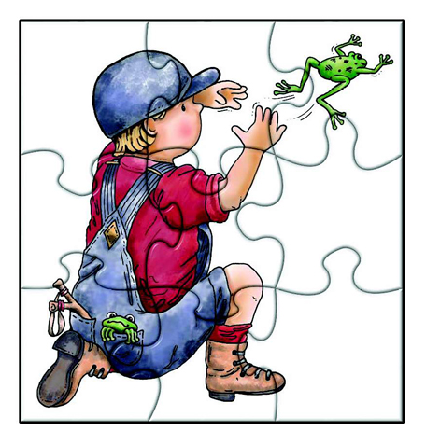
笔试部分（50 分）
- 写出所给字母的邻居。（12分）
1. ___ Ee ___ | 2. Nn | 3. Kk
4. ___ Ii ___ | 5. Pp | 6. Cc
- 根据图片在四线三格中写出单词。（6分）
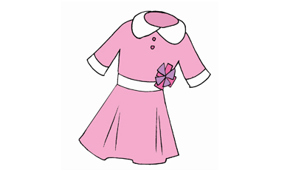
1. 2. 3.
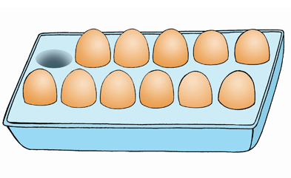


----------------------------------------------------------------------------------------------------------------------------------------------------------------------------------------------------------------------------------------------------------------------------------------------------------------------------------------------------------------------------------------------------------------
4. 5. 6.
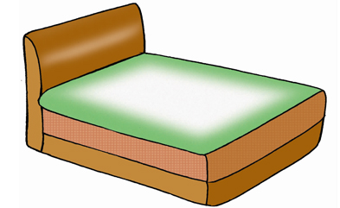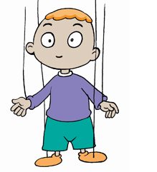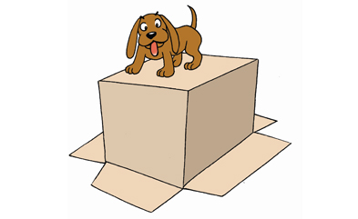
----------------------------------------------------------------------------------------------------------------------------------------------------------------------------------------------------------------------------------------------------------------------------------------------------------------------------------------------------------------------------------------------------------------
- 选择正确的答案。（20分）新课 标第一网
（ ）1. Do you like spring ? Yes, I _______.
A. can | B. do
（ ）2. Can I help you ? -----________
A. I’d like a coat. | B. I like tigers.
（ ）3. Where’s the car?-----________
A.OK. | B. It’s on the sofa.
（ ）4.What can you see ? -----________
A.I can jump. | B. I can see a train.
（ ）5.What do you have ? -----________
A.I have a doll. | B. I like dolls.
（ ）6.What lessons do you have ?-----________
A.We have PE and Art. | B. I have a yo-yo.
（ ）7.It’s time to go to bed. -----________
A. Goodbye . | B. Good night.
（ ）8.Let’s count the -----________
A. jeep | B. jeeps
（ ）9.Let’s keep the water clean.的中文是什么？
A.我想要一杯水。 | B.让我们保持水源的干净。
（ ）10.It’s time to go home.的中文是什么？
A. 是上学的时间了。 | B. 是回家的时候了。X kb 1.c o m
- 选出各组中不同类的单词，并将其序号写在题前的括号内。（6分）
( ) 1. | A.bee | B.lion | C.fox | D.bed
( ) 2. | A.jacket | B.shirt | C.school | D.coat
( ) 3. | A.plane | B.winter | C.train | D.boat
( ) 4. | A.two | B.twelve | C.seven | D.PE
( ) 5.  ( ) 6. | A.English  A.can | B.Art  B.spring | C.Chinese  C.autumn | D.box  D.summer

- 在四线三格中正确抄写下列句子。（6分）
- In the school bag ?
----------------------------------------------------------------------------------------------------------------------------------------------------------------------------------------------------------------------------------------------------------------------------------------------------------------------------------------------------------------------------------------------------------------
- It’s on the table.
----------------------------------------------------------------------------------------------------------------------------------------------------------------------------------------------------------------------------------------------------------------------------------------------------------------------------------------------------------------------------------------------------------------
- I can see a wolf.
----------------------------------------------------------------------------------------------------------------------------------------------------------------------------------------------------------------------------------------------------------------------------------------------------------------------------------------------------------------------------------------------------------------

吴江市实验小学二年级上学期英语学科期末考试卷
听力稿
听录音，选出你所听到的单词、词组和句子。（24分）
1.bottle | 2.puppet | 3.bed
4.seven | 5.jeep | 6.bear
7.Maths | 8.plane | 9.go home
10.There is a can. | 11. I’d like a coat.
12. It’s in the sofa.
二、听录音，圈出你所听到的内容相符的图片。（14分）
1. Art 2.. Winter 3. skirt 4. panda 5. bottle 6. ten 7. plane
听录音判断，画笑脸或哭脸。（12分）
1.A:Where’s the cat?  B:It’s in the box. | 2.A:It’s time to go to bed.  B:Good night.
3.A:Let’s count the pencils. How many?  B:Ten. | 4.A:Can I help you ?  B:I ‘d like a dress.
5.A:What can you see ?  B:I can see a boat. | 6.A:What do you have ?  B:I have a puzzle.

新课 标第 一网

