一年级英语期中试卷无答案
Part B 笔试

Ⅰ、抄单词。（1’x9）
rabbit panda circle milk queen
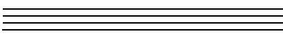
chicken octopus triangle french fries
Ⅱ、看一看，查一查，选一选。（2’x4）
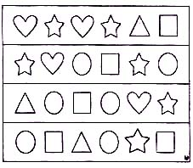
①（ ）How many stars can you see?
A、Four B、Five C、Six
②（ ）How many hearts can you see?
A、Two B、Four C、Three
③（ ）How many circles can you see?
A、Six B、Five C、Four
④（ ）How many squares can you see?
A、Five B、Three C、Two
Ⅲ、连线。（① 2’x8 ② 3’x7）

① 果汁 hamburgers ￤ 机器人 quilt
汉堡 peacock ￤ 被褥 ostrich
孔雀 juice ￤ 鸵鸟 rabbit
正方形 square ￤ 兔子 robot

②
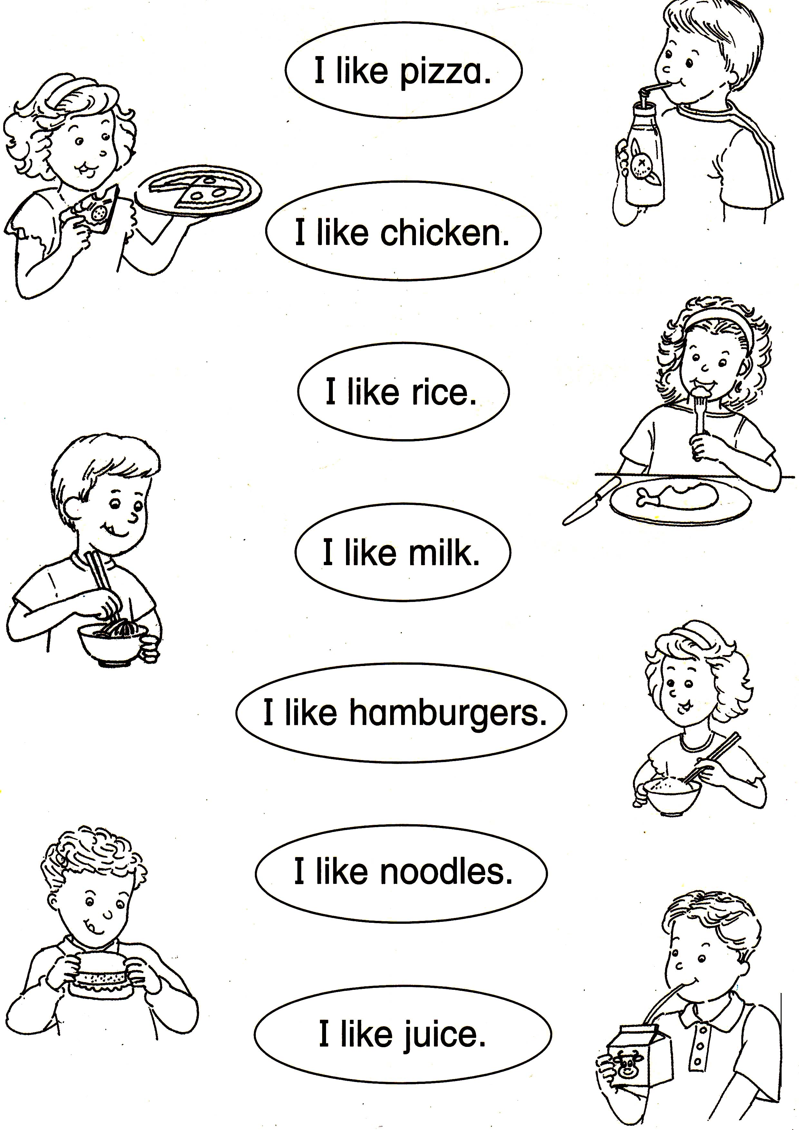
Ⅳ、选择。（5’x6）
①（ ）—What’s this? —It’s a 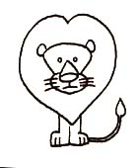.
A、 tiger B、 lion
C、 fish D、monkey
②（ ）Point to the 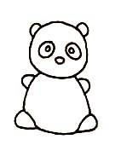 , please.
A、 panda B、 monkey
C、 dog D、 bird
③（ ）—What shape is it?
—It’s a 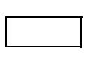 .
A、 star B、 reatangle
C、 square D、heart
④（ ）How many triangles can you see? 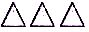
A、 One B、Two
C、Three D、Four
⑤（ ）—I like chicken,What do you like?
—I like 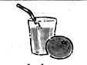.
A、 juice B、rice
C、noodle D、milk
⑥（ ）Eat ＿＿ ice cream,please.
A、 a B、an
C、\

