PRACTICE 4
Vocabulary (30 marks)
(A) Look at the pictures and underline the appropriate word in each of
the bracket. (6*2 = 12 marks)
1.
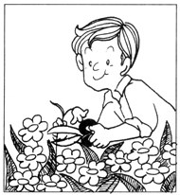 | The (barber, hawker, pilot, gardener) is tending to the flowers.
2.
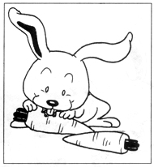 | The rabbit is eating the (cabbage, lettuce, carrots, turnips).
3.
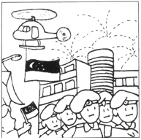 | The (firework, bomb, gun, flame) display on National Day is gorgeous!
4.
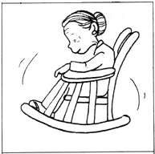 | Grandmother is sitting on the (skates, rocking chair, rocket, sofa).
5.
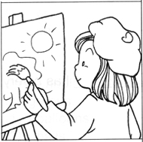 | Maisy is a/an (engineer, artist, lawyer, singer).
6.
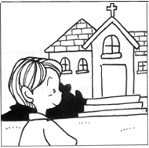 | Andy goes to the (temple, mosque, church, library) every Sunday.

(B) Fill in the blanks with the correct words. (4*2 = 8 marks)
cheeks | chicks | dinosaur
giraffe | piglets | vegetables

7.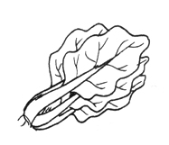 | Mother bought some ____________ from the market.

8. 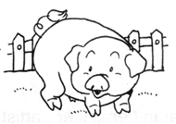 | There are many ____________ in the farm.

9. 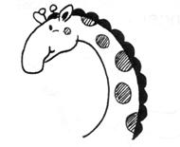 | The ____________ has a very long neck.

10. 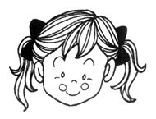 | My sister has rosy _____________.

(C) Choose the most suitable answer. Write its number in the brackets
provided.(5*2 = 10 marks)

( ) 11. Doris is ___________ but her sister is thin.
A. fat B. short C. tall D. round
( ) 12. Mother bought Sean a __________ for his birthday.
A. peanut B. cake C. biscuit D. bread
( ) 13. Father is washing his new __________.
A. pen B. book C. car D. television
( ) 14. We should not play with __________ as it is dangerous.
A. balloons B. fire C. balls D. toys
( ) 15. Look at the beautiful fish in the __________.
A. zoo B. garden C. museum D. aquarium

Grammar (40 marks)
(D) Underline the correct word in each of the brackets.
(18 * 1 = 18 marks)

16. I like to eat grapes.
My sister is buying (me, her) a bunch of grapes.
17. My brother and I love to draw.
My mother likes (our, their) drawing.
18. John gives me the bookmarks.
They are (my, their) bookmarks.
19. Lisa wears a new watch.
She likes (her, it) watch very much.
20. You have a nice toy.
I wish I can have (your, it) toy.
21. Mr Sim gives Meiling and Doreen a doll.
This is (their, our) doll.
22. He has two younger sisters.
He takes care of (his, her) sisters.
23. My uncle has a red car.
This is (his, her) car.
24. We have not eaten.
We are going to have (our, their) dinner now.
25. John is hardworking.
He studies hard for (his, her) examinations.
26. They do not want the toy car.
They are throwing away (their, his) toy car.
27. The cat sleeps in that basket.
That is (its, his) basket.
28. This bear does not belong to you.
It is not (your, its) bear.
29. I have a sister.
Jenny is (my, our) sister.
30. We have a big room.
This is (our, their) room.
31. Mary and Meihua like to collect stamps.
This is (their, our) collection.
32. Joe and I are going to the movies.
These are (their, our) tickets.
33. Lionel likes to play ball games.
This is (his, her) ball.

(E) Rearrange the words to form correct sentences and end each sentence
with a full-stop or with a question mark. (6*2=10 marks)

34. book pen is a and is a this that
_______________________________________________________________________
35. always eats she before prays she
_______________________________________________________________________
36. happy examinations because Jason passes is his he
_______________________________________________________________________
37. like David do together brother to his and things
_______________________________________________________________________
38. rainbow this saw the window I looked out morning
of a when I
_______________________________________________________________________
39. plays she is Hazel whenever the piano free
_______________________________________________________________________

(F) Complete the sentences with the helping words. (10*2 = 20 marks)

40. 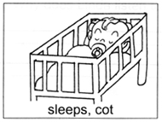 | Where does the baby sleep?  The baby ____________.

41. 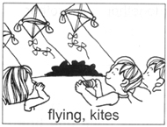 | What are the children doing?  They _____________.

42. 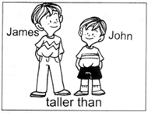 | Who is taller?  _______________________________________  _______________________________________

43. 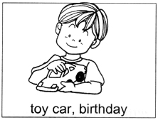 | What did you get for your birthday?  I got _____________________________.

44. 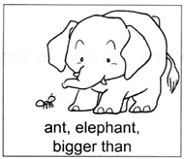 | Which is bigger?  ___________________________________  ___________________________________

(G) Comprehension (5*2=10 marks)
Read the passge carefully and answer the questions that follow.

Linda loves music. It keeps her company when she is alone. It makes her happy when she is sad. He brothers like to listen to music too. They always spend their Saturdays listening to the radio programmes together. Sometimes, their mother will scold them for not spending more time in their studies. Linda likes English songs more than she likes Chinese songs. Her brothers like Chinese songs better. They have a Karaoke set in the living room. They are only allowed to use it during special occasions because their mother does not want them to spend all their time singing.

45. Why does Linda listen to music when she is sad?
____________________________________________________________
46. What does Linda do when she is alone?
____________________________________________________________
47. Who does Linda listen to music with on Saturdays?
____________________________________________________________
48. Does Linda like Chinese songs?
____________________________________________________________
49. Why are Linda and her brothers only allowed to use the Karaoke set on special
occasions?
____________________________________________________________

(H) Written Expression (20 marks)
Look at the pictures and write a story about the pictures.

Picnic
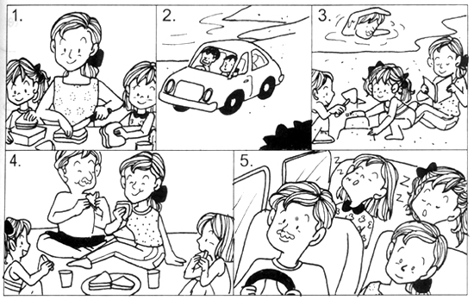

Last Sunday, my parents brought us for a picnic at the beach. In the morning,
_____________________________________________________________________________
_____________________________________________________________________________
_____________________________________________________________________________
_____________________________________________________________________________
_____________________________________________________________________________

ANSWERS
(Primary 1 English)
Practice 4
A.
1. gardener | 2. carrots | 3. firework
4. rocking chair | 5. artist | 6. church
B.
7. vegetables | 8. piglets | 9. giraffe | 10. cheeks
C.
11. A | 12. B | 13. C | 14. B | 15. D
D.
16. me | 17. our | 18. my | 19. her | 20. your | 21. their
22. his | 23. his | 24. our | 25. his | 26. their | 27. its
28. your | 29. my | 30. our | 31. their | 32. our | 33. his
E.
34. This is a book and that is a pen. / This is a pen and that is a book.
35. She always prays before she eats.
36. Jason is happy because he passes his examinations.
37. David and his brother like to do things together.
38. I saw a rainbow when I looked out of the window this morning.
39. Hazel plays the piano whenever she is free.
F.
40. The baby sleeps in a cot.
41. They are flying kites.
42. James is taller than John.
43. I got a toy car for my birthday.
44. The elephant is bigger than the ant.
G.
45. Music makes her happy when she is sad.
46. She listens to music.
47. Linda listens to music with her brothers on Saturdays.
48. Yes, Linda likes Chinese songs.
49. It is because their mother does not want them to spend all their time singing.

