PRACTICE 1
Vocabulary (30 marks)
(A) Look at the pictures and tick √ the correct boxes. (6*2 = 12 marks)
1.
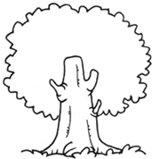
  a plant
  a tree
  a flower
  a shrub
2.
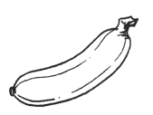
  a pineapple
  a pear
  a banana
  a guava
3.
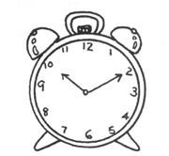
  a watch
  a kettle
  a clock
  a bowl
4.
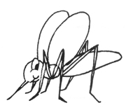
  a butterfly
  a caterpillar
  a mosquito
  a bird
5.
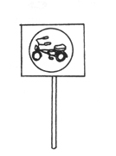
  a roadsign
  a poster
  a card
  a signal
6.
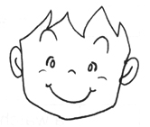
  a squint
  a yawn
  a frown
  a smile

(B) Match each picture to the correct word. (4*2 = 8 marks)
7.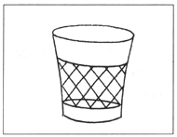* | 7.* | *straw
 |  | *basket
8.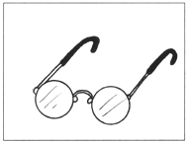* | 8.* | *basket
 |  | *newspapers
9.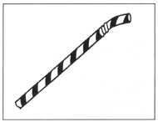* | 9.* | *book
 |  | *spectacles
10.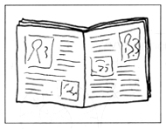* | 10.* | *spectacles
 |  | *umbrella

(C) Choose the most suitable answer. Write its number in the brackets
provided.(5*2 = 10 marks)
( ) 11. Mother went to the __________ to buy some fish.
A. market B. bookshop C. toilet D. clinic
( ) 12. I like Jenny because she is __________.
A. fierce B. kind C. loud D. angry
( ) 13. Peter drinks soup with his ___________.
A. fork B. spoon C. hands D. toothpick
( ) 14. She has just taken a meal. She feels ________ now.
A. full B. hungry C. sad D. gentle
( ) 15. The sponge is _________.
A. hard B. heavy C. soft D. rough

Grammar (40 marks)
(D) Underline the correct word in each of the brackets.
(10 * 1 = 10 marks)

16. This (is/are) Peter's bag.
17. That (is/are) my school.
18. These (is/are) my friends.
19. This painting (is/are) beautiful.
20. Those (is/are) chairs.
21. These (is/are) my father's books.
22. That (is/are) a cup of coffee.
23. This (is/are) a horse.
24. Those (is/are) big boxes.
25. This (is/are) honey.

(E) Rearrange the words to form correct sentences and end each sentence
with a full-stop or with a question mark. (5*2=10 marks)
26. like drink he does to what
_______________________________________________________________
27. cap he a wearing is
_______________________________________________________________
28. very the is sharp knife
_______________________________________________________________
29. to he bicycle wants a buy
_______________________________________________________________
30. difficult are questions too the
_______________________________________________________________

(F) Complete the sentences with the helping words. (10*2 = 20 marks)

31.
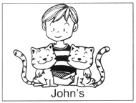 |  | Whose cats are those?  Those are __________.
32.
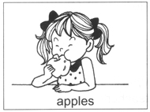 |  | What does Mary like to eat?  She _________________.
33.
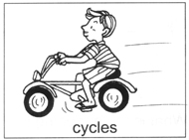 |  | What does your father do on Sunday?  My ___________________.
34.
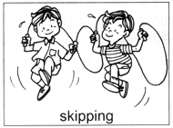 |  | What are they doing?  They ________________.
35.
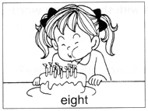 |  | How old is your sister?  She is _______________.
36.
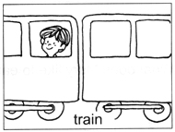 |  | Where is William?  He is _________________.
37.
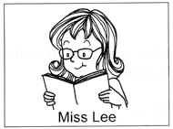 |  | Who is your favourite teacher?  My _____________________.
38.
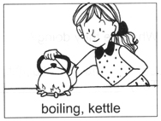 |  | What is mother doing?  She is _________________.
39.
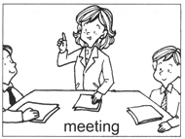 |  | Where is Aunt Yeo?  She is _________________.
40.
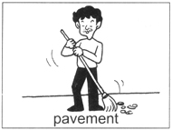 |  | What does a sweeper do?  He __________________.

(G) Comprehension (5*2=10 marks)
Read the passage carefully. Choose the correct answer and write its
number in the brackets.

Sylvia has a big family. She has five older sisters and one older brother. Sylvia's parents love Sylvia the most because Sylvia is very obedient. Sylvia's sisters help her with her studies. Her brother teachers her how to draw. Sylvia is close to her sisters and brother. They play badminton on Saturday afternoons and basketball on Sunday mornings. They go to the beach for a picnic once a month. Her parents take them to other countries for holidays every year.

( ) 41. There are _________ people in Sylvia's family.
A. six B. seven C. eight D. nine
( ) 42. Sylvia's parents love her because she ___________.
A. is sweet
B. is close to her sisters and brothers
C. obeys them
D. takes care of them
( ) 43. Parents are one's ____________.
A. grandfather
B. father and mother
C. mother
D. grandmother
( ) 44. Sylvia's family go for a picnic ___________.
A. once a month
B. two times in a month
C. four times a month
D. one time in seven days
( ) 45. It is true that _____________.
A. Sylvia's sisters can draw very well
B. Sylvia's brother is an artist
C. Sylvia's learns how to draw from her brother
D. Sylvia's brother likes to draw

(H) Written Expression (20 marks)
Look at the picture. Read the sentences.

My sister/Brother
I have a younger sister.
She is very cute.
I love her very much.
She likes to laugh.
She likes to eat chocolates and cakes.
My sister can draw well.
She can sing very well too.

Now write six or more sentences about your sister or brother.
______________________________________________________________
______________________________________________________________
______________________________________________________________
______________________________________________________________
______________________________________________________________

ANSWERS
(Primary 1 English)
Practice 1
A.
1. a tree | 2. a banana | 3. a clock
4. a mosquito | 5. a roadsign | 6. a smile
B.
basket; spectacles; straw; newspapers
C.
11. A | 12. B | 13. B | 14. A | 15. C
D.
16. is | 17. is | 18. are | 19. is | 20. are
21. are | 22. is | 23. is | 24. are | 25. is
E.
26. What does he like to drink?
27. He is wearing a cap.
28. The knife is very sharp.
29. He wants to buy a bicycle.
30. The questions are too difficult.
F.
31. Those are John's cats.
32. She likes to eat apples.
33. My father cycles on Sunday.
34. They are skipping.
35. She is eight years old.
36. He is on/in the train.
37. My favourite teacher is Miss Lee.
38. She is boiling a kettle of water.
39. She is in a meeting.
40. He sweeps the pavement.
G.
41. D | 42. C | 43. B | 44. A | 45. C

