上海牛津版一年级英语暑假作业题2 Name__________
- 给下列单词编号
- big small new old
( ) ( ) ( ) ( )
2. f ace ears eyes head nose
( ) ( ) ( ) ( ) ( )
- a big nose small head two small eyes two big ears
( ) ( ) ( ） （ ）
- a new doll an old yo-yo a big plane a small car
( ) ( ) ( ) ( )

- 圈出听到的单词
- Look at the doll. She's got two( big, small ) ears.
- I'v got a round ( face, nose ).
- Which apple do you like? I like the ( big,bag ) one. It's red.
- Superkid has got ( a big head, a small head ).

- 圈出不同类的单词
- small big new bag
- face ears pencil haed
- Shanghai Zoo small eyes The Bund Grand Theatre
- ears eyes nose hands

- 勾出正确的句子
1.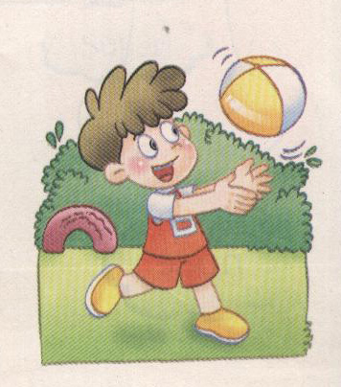 （ ）This is Norman. He’s got a ball.
( ) This is Norman. He’s got a plane.
2.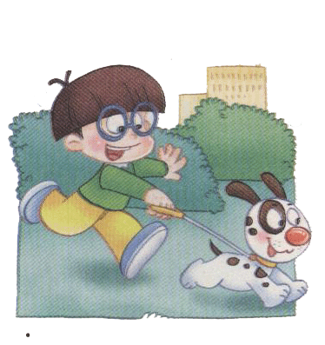（ ）Look at YangMingming.He’s got a yo-yo.
( ) Look at YangMingming. He’s got a dog.
3.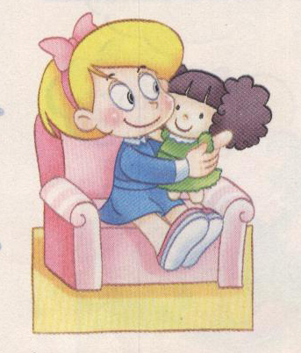 ( )Carol has got a new doll.
( )Alice has got a new doll.
4. 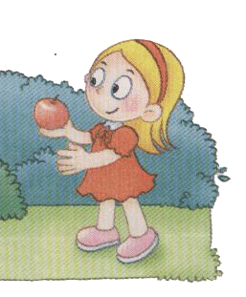( )Sue has got a big apple.She’s so happy.
( ) Sue has got a small apple.She’s so happy.
- 根据课文内容编号
( ) A big head?
( ) A boy?
( ) That is a boy.
( ) He's got a big head
( ) Norman?
( ) Who's he?
( ) No, he is Superkid.

