暑假作业练习 一 Name__________
按照课文内容排序Name_________

1. ( ) What's this?
( ) Sandy.
( ) Open it.
( ) Yes?
( ) This is my New Year;s gift.
( ) Wow! Nicky!

- ( ) Sorry,Sandy.
( ) I'm not Tommy.
( ) Hello,Tommy.
( ) That's OK.
( ) Wow,you've got a new bag!It's so nice.
( ) Thank you.

3. ( ) That is the Huangpu River.
( ) Look, the Bund.
( ) So many ships.
( ) Wow,how beautiful!

4. ( ) A big head?
( ) A boy?
( ) That is a boy.
( ) He's got a big head
( ) Norman?
( ) Who's he?
( ) No, he is Superkid.

暑假作业练习二
一．圈出不同类的单词
1. face small ear nose
2. panada mouse mouth monkey
3. long big short hair
4. crayon peach pear banana
5. teacher nose nurse doctor
6. father aunt postman grandma
7. nurse uncle father mother
8. pencil book eraser elephant
9. snake mouse knife monkey
10. apple peach orange new
11. yo-yo crayon ball pen sharpener
12. small cat mouse dog
13. see smell taste car
14. cookies sweets apples meat
15. green yellow white tall
16. fat long small metro
17. Shanghai Zoo Grand Theatre Nanpu Bridge knife
18. car ship plane yo-yo
19. boy he she it
20. I you he am
二．选择正确的答案
( )1. You’v got a new bag! It’s so nice!
A: Yes,it is. B: Thank you!
( )2. Hello ! Are you Sandy?
A:No, I’m Sandy! B:Yes ,I’m Sandy!
( )3. What’s this ?
A: I’m not Sun. B: It’s a bag.
( )4 .Tom has got a _________
A: big ears B: big head
( )5.She ______ a red pencil-box.
A: have got B: has got
( )6. I can ______ the car
A: smell B: see

三.圈出与例题单词同类的单词
1. small A: big B: face C: ears D: eyes
2. pencil A: tall B: big C : head D: knife
3. nose A: face B:fat C: thin D: mouse
4. girl A: Sandy B: Norman C: Alice D: Tom
5. is A: you B: I C: he D: am
6. apple A: sweets B: cookie C: bone D: orange

暑假作业练习2 Name__________
- 给下列单词编号
- big small new old
( ) ( ) ( ) ( )
2. f ace ears eyes head nose
( ) ( ) ( ) ( ) ( )
- a big nose small head two small eyes two big ears
( ) ( ) ( ） （ ）
- a new doll an old yo-yo a big plane a small car
( ) ( ) ( ) ( )

- 圈出听到的单词
- Look at the doll. She's got two( big, small ) ears.
- I'v got a round ( face, nose ).
- Which apple do you like? I like the ( big,bag ) one. It's red.
- Superkid has got ( a big head, a small head ).

- 圈出不同类的单词
- small big new bag
- face ears pencil haed
- Shanghai Zoo small eyes The Bund Grand Theatre
- ears eyes nose hands

- 勾出正确的句子
1.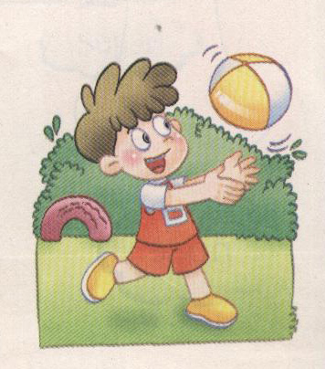 （ ）This is Norman. He’s got a ball.
( ) This is Norman. He’s got a plane.
2.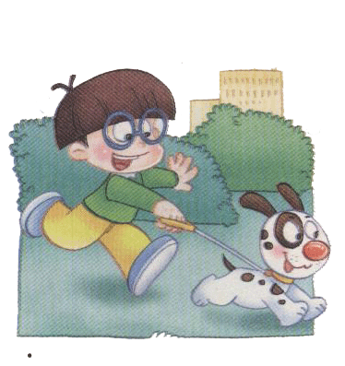（ ）Look at YangMingming.He’s got a yo-yo.
( ) Look at YangMingming. He’s got a dog.
3.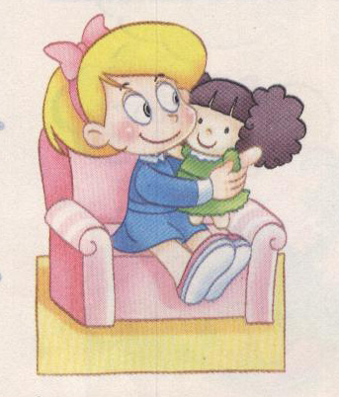 ( )Carol has got a new doll.
( )Alice has got a new doll.
4. 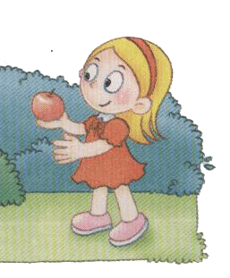( )Sue has got a big apple.She’s so happy.
( ) Sue has got a small apple.She’s so happy.
- 根据课文内容编号
( ) A big head?
( ) A boy?
( ) That is a boy.
( ) He's got a big head
( ) Norman?
( ) Who's he?
( ) No, he is Superkid.

测试意图：检查学生对基础知识的了解很认识，练习学生的做题应答能力。

