PRACTICE 5
Vocabulary (30 marks)
(A) Look at the pictures and underline the appropriate word in each of
the brackets. (6*2 = 12 marks)

1.
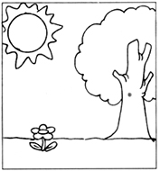 | It is a (cloudy, rainy, sunny) day today.
2.
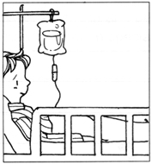 | Mr Tan is in the (hospital, theatre, airport) due to a bad fall.
3.
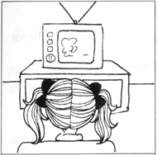 | Kailing has been watching the (cinema, television, radio) programme since this morning.
4.
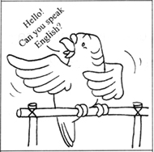 | Junguang has a (chicken, hamster, parrot) that speaks English.
5.
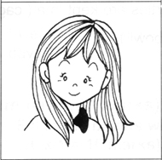 | Lingmei is as pretty as a (fairy, ghost, witch).
6.
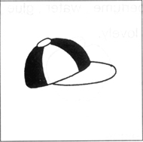 | Have you seen my (hat, cup, cap)?
7.
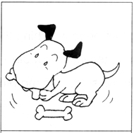 | My dog loves to eat (sticks, rods, bones).
8.
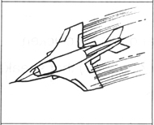 | John's uncle is an airforce (teacher, pilot, cook).
9.
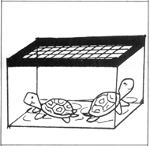 | The turtles are kept in a (cage, tank, bowl).
10.
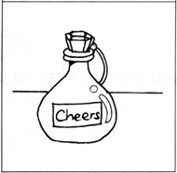 | The (perfume, water, glue) smells lovely.

(B) Underline the correct word in each of the brankets. (5*2= 10 marks)

11. Ali is very (sad, happy, angry) as he scored full marks in his test.
12. A (rabbit, spider, kitten) has long ears.
13. The (pillow, rainbow, rain) in the sky looks so beautiful.
14. Johnson went to the (barber, chef, hawker) to cut his hair.
15. I wear clean (slippers, shoes, heels) to school every day.

Grammar (40 marks)
(C) Fill in the blanks with 'a' or 'an'. (16*1=16 marks)

16. 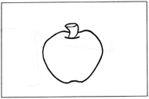  _____________ apple | 17. 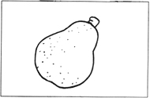  ____________ pear

18. 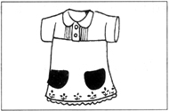  ___________ dress | 19. 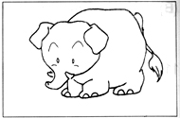  ___________ elephant

20. 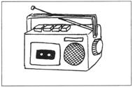  ___________ radio | 21. 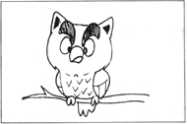  ____________ owl
22. 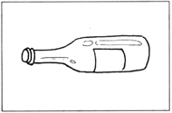  ___________ bottle | 23. 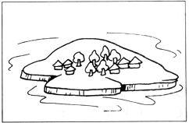  ____________ island
24. 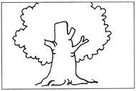  ___________ tree | 25. 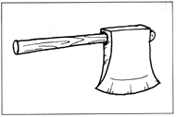  ____________ axe
26. 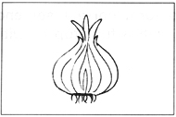  ___________ onion | 27. 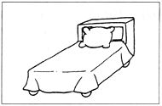  ___________ bed
28. 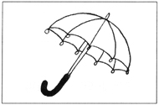  ___________ umbrella | 29. 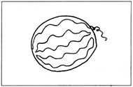  ___________ watermelon
30. 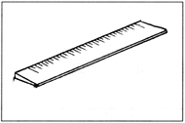  ___________ ruler | 31.   __________ computer

(D) Rearrange the words to form correct sentences and end each sentence
with a full-stop or with a question mark. (7*2=14 marks)

32. was enormous Jane elephant when saw frightened she an
__________________________________________________________________________
33. fat eats is a because he lot so he
__________________________________________________________________________
34. pencils those pens are or
__________________________________________________________________________
35. clean please classroom keep the
__________________________________________________________________________
36. flowers the garden red are in pink the or
__________________________________________________________________________
37. his mother shopping cart the push helping he is to
__________________________________________________________________________
38. just been feeling she is because scolded very sad she has
__________________________________________________________________________

(E) Complete the sentences with the helping words. (5*2 = 10 marks)

39. 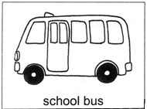 | How does Ali go to school?  He _______________________.
40. 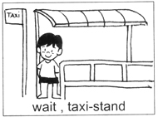 | Where can I get a cab?  You can ___________________.
41. 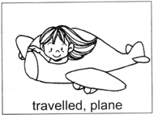 | How did Sally get to Japan?  She _______________________.
42. 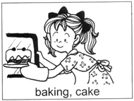 | What is Katie doing?  She _______________________.
43. 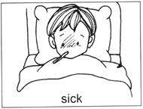 | Why is John not in school today?  It is because _____________.

(F) Comprehension (5*2 = 10 marks)
Read the passage carefully and answer the questions that follow.

Inline-skating is fun. But not everyone likes it. There are people who are afraid to fall. There are people who like other sports better. You need to be able to balance yourself when you skate. When you are able to do so, you can go faster and farther. There are few places in Singapore where inline skates can be rented. One of these places is the East Coast Park. It feels good to skate and enjoy the sea breeze at the same time. It is better for those who are learning to skate to visit the East Coast Park on weekdays. There are fewer cyclists and skaters on the track on weekdays.

44. Give one reason why some people do not want to skate?
_____________________________________________________________________
45. When can one skate faster and farther?
_____________________________________________________________________
46. Name one place that rents out skates.
_____________________________________________________________________
47. What can one enjoy in the East Coast Park while skating?
_____________________________________________________________________
48. When is a good time for people who are beginners in skating to visit
the East Coast Park?
_____________________________________________________________________

(G) Written Expression (20 marks)
Look at the pictures and write a story about the pictures.

My Birthday Party
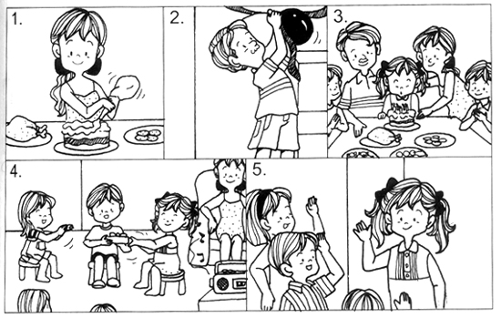

I had a birthday party last Wednesday. My mother baked a birthday cake for me. ___________________________________________________________________________
_______________________________________________________________________________
_______________________________________________________________________________
_______________________________________________________________________________
_______________________________________________________________________________

ANSWERS
(Primary 1 English)
Practice 5
A.
1. sunny | 2. hospital | 3. television | 4. parrot | 5. fairy
6. cap | 7. bones | 8. pilot | 9. tank | 10. perfume
B.
11. happy | 12. rabbit | 13. rainbow | 14. barber | 15. shoes
C.
16. an | 17. a | 18. a | 19. an | 20. a | 21. an
22. a | 23. an | 24. a | 25. an | 26. an | 27. a
28. an | 29. a | 30. a | 31. a
D.
32. Jane was frightened when she saw an enormous elephant.
33. He is so fat because he eats a lot.
34. Are those pens or pencils?/ Are those pencils or pens?
35. Please keep the classroom clean.
36. Are the flowers in the garden red or pink?
37. He is helping his mother to push the shopping cart.
38. She is feeling very sad because she has just been scolded.
E.
39. He takes a school bus.
40. You can wait at the taxi-stand.
41. She travelled to Japan by plane.
42. She is baking a cake.
43. It is because he is sick.
F.
44. Some people are afraid to fall. / Some people like other sports better.
45. When one is able to balance, one can skate faster and farther.
46. One place that rents out skates is the East Coast Park.
47. One can enjoy the sea breeze while skating in the East Coast Park.
48. It is better for them to visit the East Coast Park on weekdays.

