小学英语六年级上册第六单元教案

第四课时
B let’s learn Number and say Good to know
Ⅰ.Teaching aims:
能够掌握B部分的Let’s learn中的四会单词，做到会听、说、读、写。
Ⅱ.Teaching importance and difficult:
To be able to say the following words: engineer , accountant , policeman salesperson, cleaner
Ⅲ.Teaching tools: Teacher cards
Ⅳ. Teaching Steps:
Step1 warm up
Let’s sing a song .Little Water Drop
Let’s chant .
Review
T: Where does the rain come frome ?
Where does the cloud come from ?
Where does the vapour come from ?
How can the water become vapour ?
Step 2. Presentation
Do you want to know how to plant ? Today I will tell you .
T take out a seed and say : seed
T point the soil say : soil
T take out a picture : sprout
（1）I am a drawer.
让同学们画一画各式各样的seeds, plants等等，可以是看见过的，也可以是想象中的，在自己的感受中理解并学会。
（2 Guess Guess
通过描述或谜语猜测其名称或特异功能。
（3）Story: The King and the Seeds 国王与种子关于诚实的故事，将课文单词串联起来。
（4）Grow up

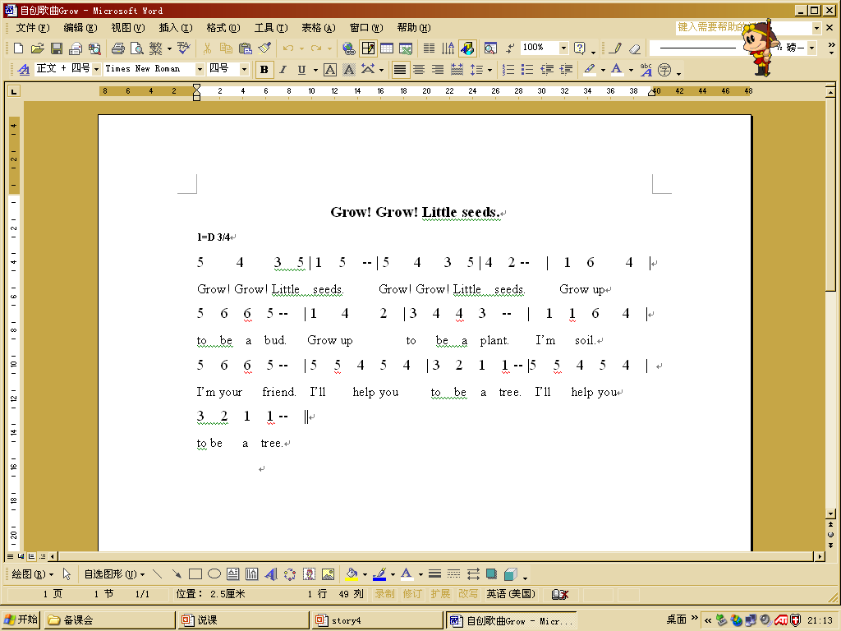

- Number and say
Step 3.Do listening exercises.
Ss listen to the tape and do exercises in the activity book.
Step 4.Homework
教学反思：

