Unit 9 By the time l got outside, the bus had already left.

学习目标

1.通过本单元的学习，掌握过去完成时态的用法，特别是与一般过去时态和现在完成时态的区别。
2.合理安排自己的学习和生活，守时守信。

难点解析
1. By the time I got outside, the bus had already left.
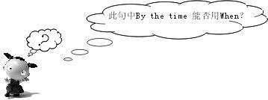
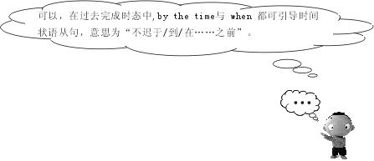
完成下列两题：
（1）________ he woke up this morning, the sun had risen high.
（2）_________ the doctors arrived, the man had already died.
By the time 与When均可。
2. (1) I’ve never been late for school.
(2) By the time she got to class, the teacher had already started teaching.
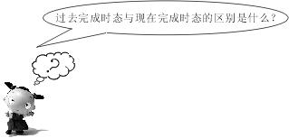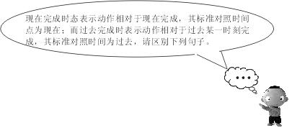
1. It seems that he has known the news.
2. It seemed that he had_______.
3. It is said that he has been to the moon.
4. It was said that ________ had __________.
其中1、3 表示到现在为止已发生的事情，而2、4表示到过去某一时刻为止发生的事情。

典型例题
1. By the time I got there, the train _________ already _______. (gone)
解析：当一个动作发生的时候，另外一个动作已经完成，即“过去的过去”，应用过去完成时态，had, gone.
2. When I got to school, I realized I had left my backpack at home. （对划线部分提问）
解析：其答案为What did you realize when you got to school?划线部分是过去完成时态，是realized的宾语从句，应用what提问。
3. By the time we arrived at the cinema, the film had______ for 10 minutes.
A. begun B. been on C. started
解析：当我们到达电影院时，电影已经开始十分钟了（一段时间），应用过去完成时态，选延续性动词，故答案为B。

单元练习
I．根据汉语及首字母写出单词
1. When I began to sing，he laughed and made me very e_________(尴尬的)．
2. After a long trip to Europe，1 felt very e________(精疲力竭的)．
3. a_______：to make known publicly
4. d________：to give an account of in speech or writing
5. a_________：one that is invested with this power，especially a government or government officials.
6. Last night a friend of mine invited me to a c_______ party (化装舞会)．
II．用所给词的正确形式填空
1. ——Did Jim watch the football march?
——He told me that he ________ (watch)it．
2. He asked Lin Tao why he __________ (not join) their team yesterday．
3. I didn't know whether Mother________ (take) me to Beijing next month．
4. Our teacher told us if it_______ (not snow) we would visit the Science Museum the next day．
5. When they_______ (reach) the station，the train_________(1eave)．
6. By the end 0f last term，We________ (1earn) over two thousand new words．
III．完形填空
Many years ago there lived two brothers in London. They were both very rich. They had 1
Ideas about money. They were quarrelling（争吵）about what would happen if a poor fellow could 2 a million pound note. One thought that anyone with such a 3 would have 4 he wanted; the other thought that it would be 5 for him to get anything with the note（钞票）.They couldn’t agree with each other. So they 6 to make a bet (打赌).
It happened that a young man named Henry was 7 through the street that day, who had come to Britain only chance. 8 home and job, he looked pale（苍白的）and 9 . Suddenly he saw an apple 10 away by a child. The man was so hungry that he was thinking of 11 it up to eat. Just as he was 12 out his hand, he heard a 13 calling him. He looked up and saw the two 14 . They gave him an envelope. They told him not to open it 15 two o’clock. They said, “Nothing but money in it.” Then they left…
1. A. two B. more C. different D. the same
2. A. get B. make C. find D. give
3. A. idea B. note C. way D. chance
4. A. what B. whatever C. that D. which
5. A. nice B. possible C. impossible D. certain
6. A. decided B. had C. wished D. wait
7. A. going B. wandering C. walking D. running
8. A. With B. Without C. Not D. No
9. A. strong B. happy C. hungry D. shy
10. A. thrown B. left C. picked D. found
11. A. eating B. picking C. looking D. collecting
12.A. reaching B. putting C. holding D. raising
13.A. noise B. sound C. voice D. shout
14. A. apples B. letters C. gentlemen(绅士) D. fellows
15. A. after B. until C. since D. for
IV. 阅读理解
English is spoken as a first language by most people in the USA, Britain, Australia, New Zealand, Ireland and Canada. However, English is spoken all over the world. It is the main language in over 60 countries, including India, Singapore and many of the Caribbean and Pacific islands. In these places English is often a second language.
English is also an international language in many other countries, like China and Japan. People in these countries use it for business, and travelers to these countries use English when they get there to communicate. Other people may learn English because they enjoy reading books in English, listening to British or American music or watching American films.
English has changed a lot over the years and still goes on changing. It is no longer right to talk about British English or American English if the speakers come or don't come from those countries. People in Japan and Korea, for example, may use the American spelling but may not sound like Americans.
English will probably be the most widely used language in the world by the end of the 21st century. This language no longer belongs to British, American or Australian speakers. It be- longs to anyone in the world. So, as a middle school student of English today, think about how you can use this language. After you leave school, you will almost certainly need it.
根据短文内容选择最佳答案
1. In how many countries is English spoken as a first language?
A. Five. B. Four. C. Three. D. Six.
2. In which other countries is English spoken as a main language?
A. Britain, the USA, Australia.
B. India, Singapore and many of the Caribbean and Pacific islands.
C. China ,Japan.
D. Over 60 countries.
3.People from other countries learn English for~
A. passing exams
B. business and traveling
C. reading English books, enjoying English music or films
D. both B and C
4.Even if people in Japan and Korea use American spelling they ~
A. will speak the same as Americans
B. may not sound like Americans
C. will speak British English
D. will speak English much better
5. Which answer best describes the passage?
A. A First Language in the World
B. A Second Language in the World
C. English Around the World
D. A Useful Language
V．写作
根据所给图画内容和英文提示，写一篇短文。
要求：1.词数在100个左右。2．把图中所示内容表达完整，用上所有词语，条理清晰，意思连贯，语句通顺，标点正确。3．短文第一句已给出．
提示：football match，excited, bed，until，twelve，too late for, get to school，still，in bed,
begin, 1esson，get angry, feel guilty(惭愧)，have a test，fail，English test
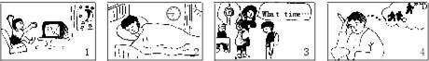
It was late last Monday, but Tom was still watching TV in his room.

参考答案
I. 1. embarrassed 2. exhausted 3. announce 4. describe 5. authority 6. costume
II. 1. had watched 2. didn't join 3. would take 4. didn't snow 5. reached, had left 6. had learned
III. 1~5 CABBC 6~10 ABBCA 11 ~ 15 BACCB
IV. 1~5 DBDBC
V. It was late last Monday, but Tom was still watching TV in his room. There was a wonderful football match on TV. How excited he was! That night he didn't go to bed until twelve o'clock.
The next morning, it was a quarter to eight when he woke up. It was too late for Tom to get to school on time.
When Tom reached school, it was eight. The teacher was already beginning her lesson. When Tom came into the classroom, she got angry and said, "What time is it now, Tom? "Tom felt guilty and could say nothing.
In English class, he had a test. He couldn't remember the lessons at all, all he was thinking of was the foot- ball match. So, Tom failed his English test.

