小学三年级英语Unit1单元测试题

（时间：40分钟）Listening Part （50分）
一、听音，写出你所听到的大写或小写字母。（5分）

二、听音，选出句子中所含有的单词。（5分）
( )1. A. for B. from C. friend ( )2. A. nine B. fine C. nice
( )3. A. go B. no C. oh ( )4. A. blue B. brown C. black
( )5. A. China B. Canada C. America
三、听音，判断下列各图是否与听到的内容一致，是的画，否则画。（12分）
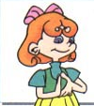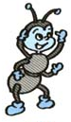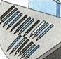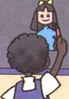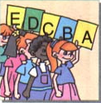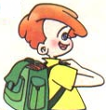
() () () () () ()
四、听音，按照你所听到的顺序给下面的图标号。（12分）
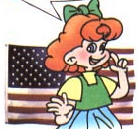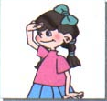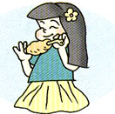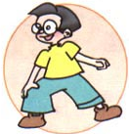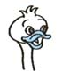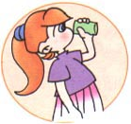
( ) ( ) ( ) ( ) ( ) ( )
五、听音，根据你所听到的问句，选择正确答语。（8分）
( )1. A. My name is Amy. B. Hello, Amy. C. I'm from China.
( )2. A. I'm from America. B. This is Mike. C. This is a boy.
( )3. A. Good morning! B. Good afternoon! C. Goodbye!
( )4. A. That's right. B. No, thanks. C. Sure, here you are.
六、听音，给下列句子标上正确的序号。（8分）
( ) I'm from Canada.
( ) This is my friend, Tutu.
( ) Nice to meet you.
( ) Where are you from?
Writing Part （50分）
一、按字母表的顺序给下列字母标上正确的序号。（5分）
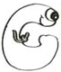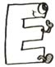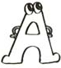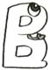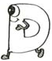
( ) ( ) ( ) ( ) ( )
二、把相应的大小写字母连起来。（5分）
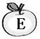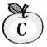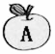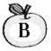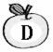

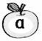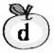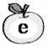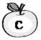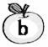
三、看图，将相对应的单词和图片连线。（12分）
apple dog student Coke elephant girl

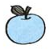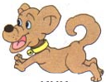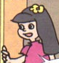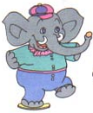
四、看图，选出合适的句子。（10分）
( )1.A. I'm from China. B. I'm from Canada. C. I'm from America.
( )2.A. Goodbye, Mike! B. Hello, I'm Mike. C. A A A, say “OK”!
( )3.A. This is a ball. B. This is a balloon. C. Bounce the ball.
( )4.A. This is a girl. B. This is a boy. C. This is a teacher.
( )5.A. Act like a cat. B. Act like a duck. C. Act like a dog.
1.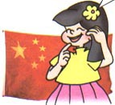 2.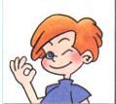 3.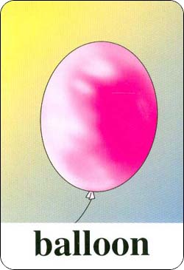 4. 5.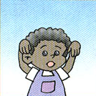
五、 根据<A>栏中的问句，在<B>栏中选出正确答语。（8分）
<A> <B>
( )1.How old are you? A. Thank you.
( )2.Happy birthday! B. One cake.
( )3.How many cakes? C. I'm fine, thanks.
( )4.How are you? D. I'm nine.
六、根据所给的情景，选择正确答案。（10分）
( )1. 别人跟你说“I'm sorry.”你应该回答：
A. Come in. B. Oh, no. C. It's OK.
( )2. 你想说“我是从中国来的。”应该这么说：
A. I'm China. B. I'm from China. C. My name is China.
( )3. 你想提醒对方当心，应该说：
A. Look at me. B. Watch out. C. Thank you.
( )4. 你想知道对方是哪里人，你可以问：
A. How are you? B. What's your name? C. Where are you from?
( )5. 你想跟对方借东西来看一下，应该说：
- May I have a look? B. Have some chicken. C. Can I have some chicken?
PEP小学英语三年级下册单元测试题
Unit 2 My Family
学校 姓名 班级 评分
（时间：40分钟）
Listening Part （50分）
一、听音，选出句子中所含有的字母或单词。（10分）
( )1. A. BEC B. BDC C. DBC
( )2. A. efi B. ife C. ifg
( )3. A. father B. brother C. mother
( )4. A. family B. funny C. really
( )5. A. come in B. come on C. welcome
( )6. A. dad B. dog C. duck
( )7. A. mom B. man C. me
( )8. A. grandpa B. grandma C. grandmother
( )9. A. great B. green C. grandpa
( )10.A. she B. he C. we
二、听音，按照录音所读的顺序，用大写字母 给下面的图标号。（10分）
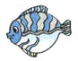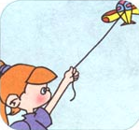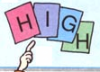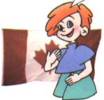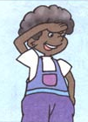
( ) ( ) ( ) ( ) ( )
三、听音，判断下列各图是否与听到的内容一致，是的画，否则画。（12分）
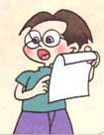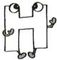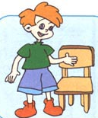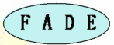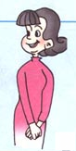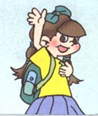
() () () () () ()
四、听音，根据你所听到的问句，选择正确答语。（8分）
( )1. A. She's my mother. B. She's my sister. C. He's my brother.
( )2. A. He's my brother. B. She's my mother. C. She's my sister.
( )3. A. Good morning! B. Good afternoon! C. See you!
( )4. A. I'm Amy. B. I'm from America. C. My name's Amy.
五、听音，按照录音所读的顺序，用大写字母 给下列句子标号。（10分）
( ) What a big fish!
( ) This is my family!
( ) Who's that girl?
( ) He's my father.
( ) I'm from Canada.
Writing Part （50分）
一、找出下列单词中不同类的一项，并将序号填在( )内。（10分）
( )1. A. grandma B. grandpa C. ice-cream
( )2. A. water B. hot dog C. hamburger
( )3. A. dad B. teacher C. mom
( )4. A. boy B. girl C. student
( )5. A. and B. elephant C. squirrel
二、判断下列字母是不是相应的大小写字母，是的打“√”，否则打“×”。（5分）
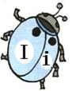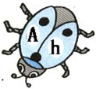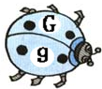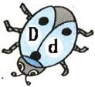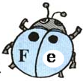
( ) ( ) ( ) ( ) ( )
三、补充写出下列大、小写字母的左邻右舍。（5分）
Model: A B C a b c
1. C F G

2.e ɡ h

四、根据<A>栏中的问句，在<B>栏中选出正确答语。（10分）
<A> <B>
( )1. What's your name? A. Sure. Here you are.
( )2. Where are you from? B. Great!
( )3. Who's that man? C. My name is Tutu.
( )4. May I have a look? D. I'm from China.
( )5. Let's watch TV! E. He's my grandpa.
五、看图，选择下面的句子，把对话补充完整，将序号填在( )内。（8分）
( )1. A. I'm four. B. Four. C. I'm fine, thank you.
( )2. A. She's my mother. B. He's my father. C. He's my brother.
( )3. A. Nice to meet you. B. Good morning. C. Good afternoon.
( )4. A. He's my father. B. She's my sister. C. He's my brother.
1.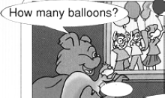2.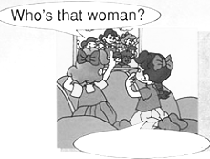3.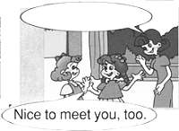4.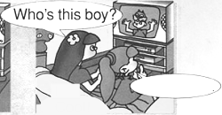
六、这是Ann的家谱树，请帮她把相对应的人物名称的序号填在( )内。（12分）
A. brother B. sister C. father D. mother E. grandmother F. grandfather
