小学四年级第二学期英语期中试卷
听力部分
- 听音，给单词排序。
today ( ) breakfast ( ) morning ( )
1. yesterday ( ) 2. supper ( ) 3. evening ( )
tomorrow ( ) lunch ( ) afternoon ( )
what ( ) reading ( ) twenty ( )
4. when ( ) 5. writing ( ) 6. twelve ( )
Where ( ) playing ( ) thirty ( )
- 听句子，选出你所听到的一个单词。
( ) 1. A. glad B. nice C. how
( ) 2. A. cool B. call C. cold
( ) 3. A. friend B. teacher C. father
( ) 4. A. markers B. pencils C. pens
( ) 5. A. green B. purple C. yellow
( ) 6. A. under B. below C. beside
( ) 7. A. desks B. chalk C. books
( ) 8. A. cloudy B. windy C. snowy
( ) 9. A. October B. January C. September
( ) 10. A. ninth B. twentieth C. first
- 听上句，选择正确的下句。
( )1. A. October first B. May fourth C. November fifth
( ) 2. A. June second B. May first C. August first
( )3.A. September tenth B. February first C. January first
( ) 4. A. September tenth B. July first C. June first
- 听音写出日期。
_______ _______ _______ _______ _______
_______ _______ _______ _______ _______
- 听音，选择正确答案。
( ) 1. I have super at ______ in the evening.
A. 6:30 B. 6:00 C. 6:35
( ) 2. _______ is lunch?
A. When B. What C. Where
( ) 3. Today is Monday, ________.
A. June 13 B. June 14 C. June 15
( ) 4. ______ is the fifth day of the week.
A.Sunday B. Thursday C. Tuesday
( ) 5. How’s the ______ today?
A. cloudy B. weather C. windy
( ) 6. Is this a ______ day?
A. sunny B. rainy C. snowy
( ) 7. The rain is ______.
A. above B. under C. below
( ) 8. Spring Festival is in _______.
A. January or February B. March or April
C. May or June
( ) 9. The boy in red shorts is the_______.
A. third B. second C. first
( ) 10. Are you ready for _______class?
A. Chinese B. English C. math

笔试部分
- 画出相应的时间。
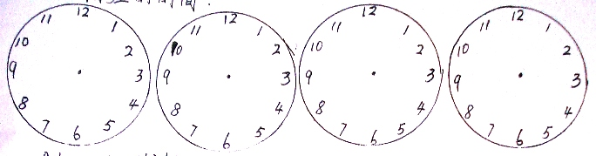

At seven thirty At six At ten twenty At five fifteen
- 将单词填写完整并标号。
a. J__nuary b. m__ __ ch c. M__ __
F__bruary A__ __il J__ __e

d. J__ly e. S__ __tember f. N__vember
A__gust O__ __tober D__cember

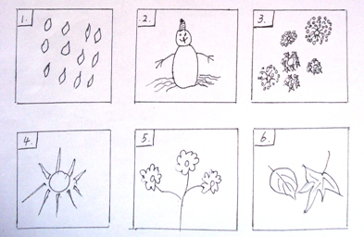
- 连词成句。
- is, what, ?, it, day
________________________________________
- Wednesday, June, ., It’s, twenth
________________________________________
- day, ?, tomorrow, What, is
________________________________________
- the, today, ?, weather, What’s
________________________________________
- cloudy, Is, ?, it
________________________________________
- 句子搭配。
( ) 1. When is Children’s Day? A. August 7th.
( ) 2. How are you? B. Sunday
( ) 3. What’s the weather like? C. June 1st.
( ) 4. What day is it? D. In the classroom.
( ) 5. What day is the first day? E. Fine, thanks.
( ) 6. What day is the last day? F. 15.
( ) 7. What’s the date? G. A chair.
( ) 8. Where is Mr. Wood? H. Saturday.
( ) 9. How many books do you have? I. It’s snowy.
( ) 10. What’s this? J. Thursday.

