小学英语四年级上册Unit2单元测试题
听力部分
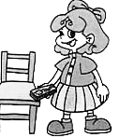
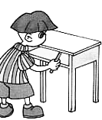
- 听录音, 圈出所听到的图片的序号. (10分)
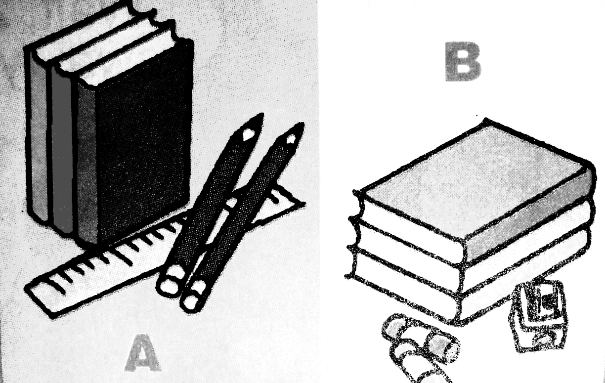
1. 2.

A B A B
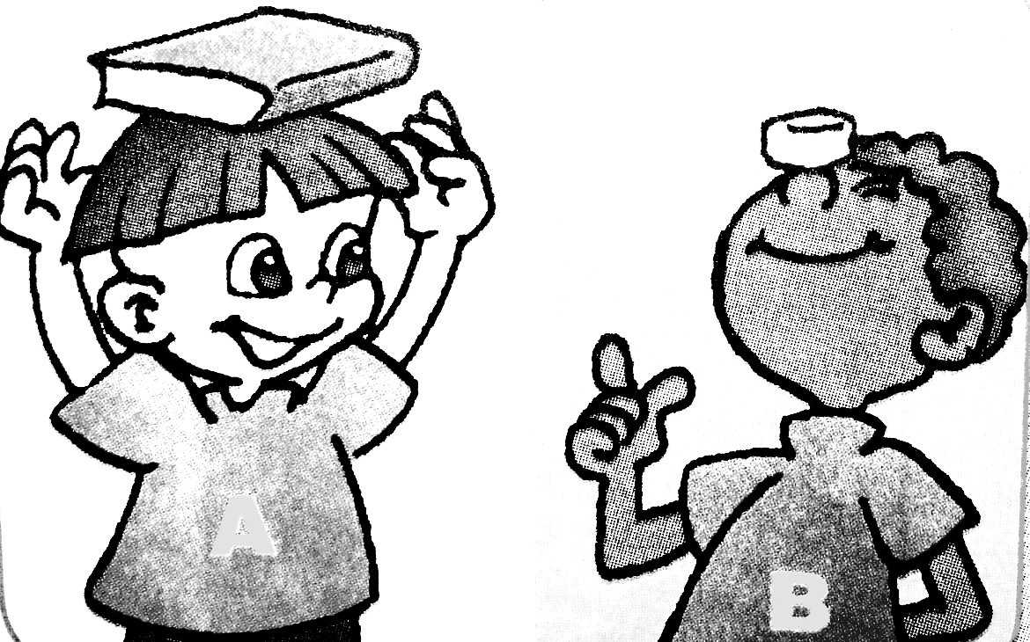
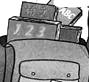
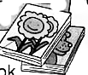
3. 4.

A B A B
- 听录音, 判断图片的对错, 用“√”或“×”表示. （10分）
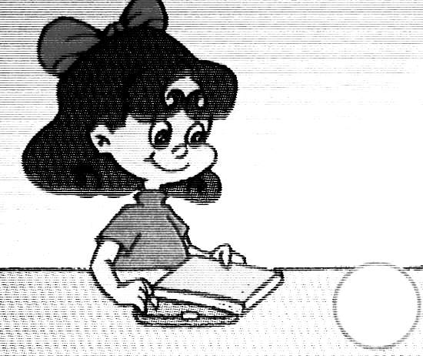
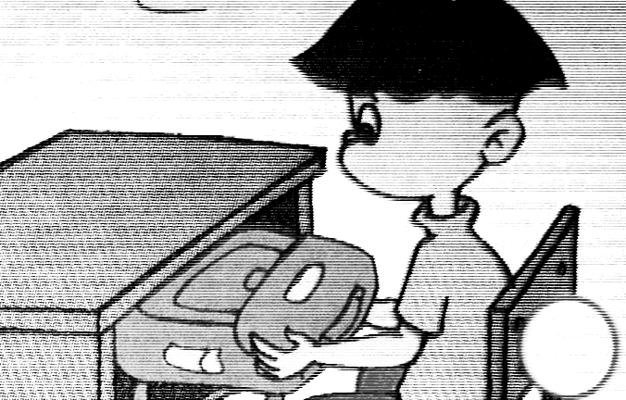
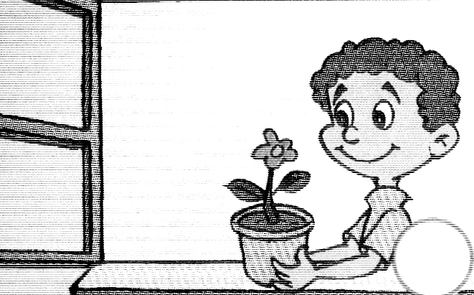
1. 2. 3.

( ) ( ) ( )
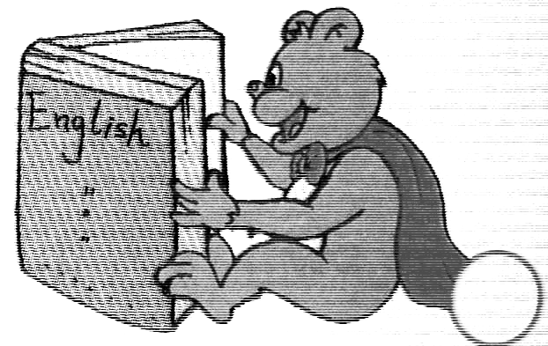
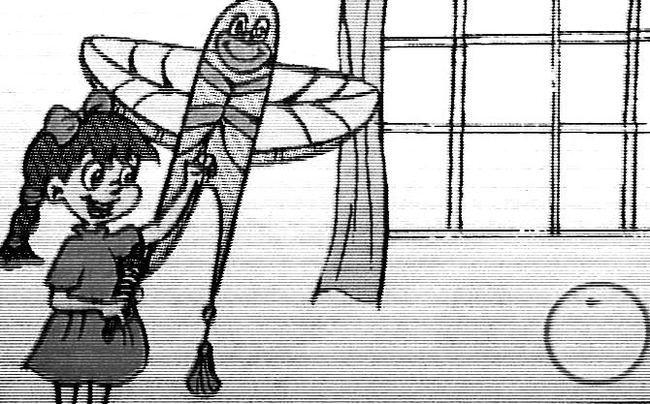
4. 5.

( ) ( )
- 听录音, 填上所缺的单词或数字. （20分）
- A: Look! I have a new __________.
B: It’s very nice.
- A: How many ___________ can you see?
B: I can see _________.
- A: What’s in your ___________?
B: There are 4 ___________.
- A: What color is your __________?
B: It’s yellow.
- A: What’s in your ____________?
B: ______ crayons, _______ erasers and _________ picture books.
- 听录音, 选择最佳的答语. （10分）
( ) 1. A. It’s blue and white. B. The door is green.
C. It’s under the desk.
( ) 2. A. Thank you. B. Sure. Here you are.
C. Great!
( ) 3. A. I can see 28 desks. B. I can see 5 pens.
C. I have 30 chairs.
( ) 4. A. My pen is very long. B. My seat is near the door.
C. My pen is on the chair.
( ) 5. A. My schoolbag is under the chair.
B. My schoolbag is blue.
C. Look! 1 English book and many notebooks.
- 听录音, 用阿拉伯数字完成下面的表格. （10分）
book  name | English  book | Chinese  book | math  book | note-  book | story-  book | picture-  book
Zhang
Peng
Sarah
Chen
Jie

笔试部分
- 根据图片, 填上所缺的字母. （10分）
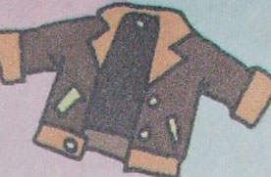
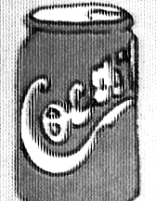
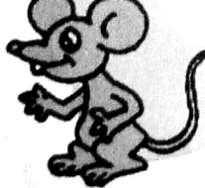
- __acket 2. __oke 3. __ouse

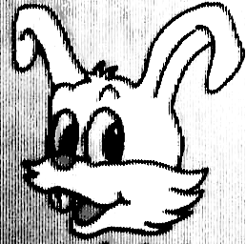
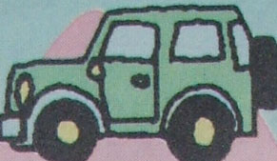
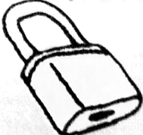
4. , __abbit 5. __eep 6. __ock
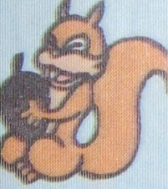
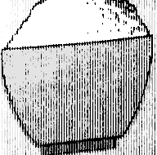
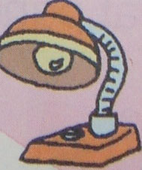
7. s__uirrel 8. __ice 9. __amp

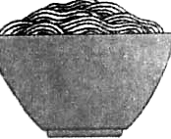
10. __oodles

- 将下列单词填入空格, 把对话补充完整. （10分）
have green eleven wall classroom
big nice too near like

Sarah: Mike, we have a new __________.
Mike: Really? Let’s go and _______ a look.
Sarah: OK.
Mike: Wow! It’s so ______!
Sarah: We have ______ lights.
Mike: Look! The ______ is white. The floor is _______.
Sarah: Look at the picture.
Mike: It’s very _______. Where is my seat?
Sarah: It’s ______ the door.
Mike: I ______ our new classroom.
Sarah: Me ______.
八. 选句补充对话,将正确的句子的编号填在横线上. （10分）
- How many picture books do you have?
- What color is it?
- How nice!
- What’s in it?
- May I have a look?
Amy: Hi, Chen Jie. I have a new schoolbag.
Chen Jie: Really? ________________________
Amy: It’s black and white. Look! It’ s so heavy.
Chen Jie: _____________________
Amy: Some English books, some story-books, and many picture books.
Chen Jie: __________________________
Amy: Let me count. 1, 2, 3, 4…15. I have 15 picture books.
Chen Jie: _______________________________
Amy: Sure. Here you are.
Chen Jie: Wow! A fat panda! ___________

九 阅读短文, 判断对错.`（10分）
Amy: Look at our new classroom.
John: Wow! So many books.
Amy: How many Chinese books can you see?
John: I can see twelve.
Amy: How many desks and chairs can you see?
John: I can see thirty-five.
Amy: Oh, my schoolbag is heavy.
John: What’s in it?
Amy: Ten story-books and fifty picture books.
John: Oh, so many.

( ) 1. There are many books in the classroom.
( ) 2. I can see twenty Chinese books.
( ) 3. I can see thirty-five desks.
( ) 4. Amy’s schoolbag is heavy.
( ) 5. There are ten story-books and fifty picture books in the schoolbag.

