PEP小学英语四年级上册第一学期综合试题
听力部分
- 听读音，选出正确的图画，并在括号里打“√”。（10分）
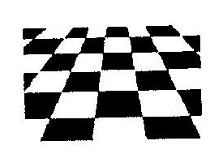
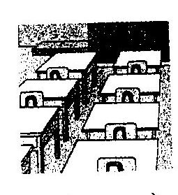
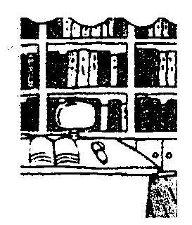
1. 2.
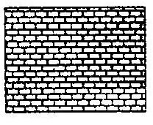

（ ） （ ） （ ） （ ）
3. 4.
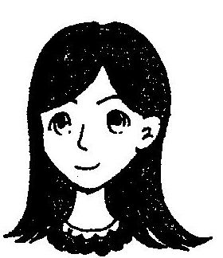
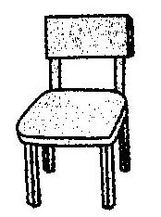
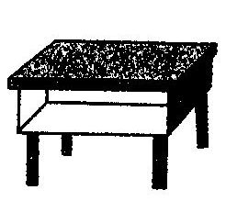
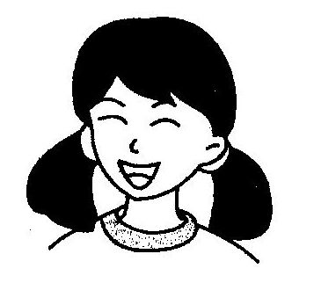
、

（ ） （ ） （ ） （ ）
5.
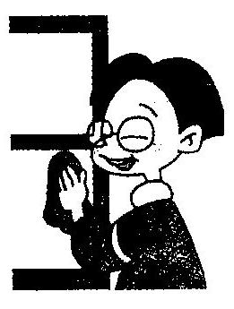
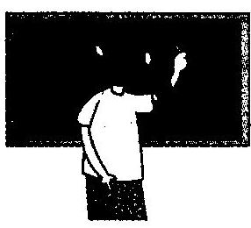

（ ） （ ）
二．听读音，判断图画是否与读音相符，相符的请打“√”，否则打“×”。（10分）
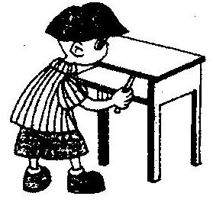
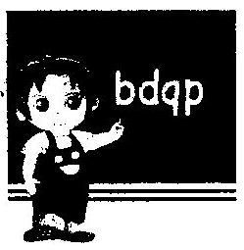
1. 2.

（ ） （ ）
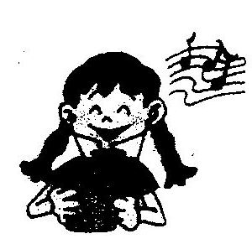
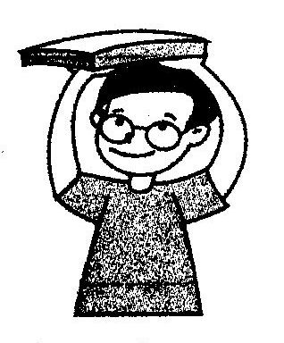
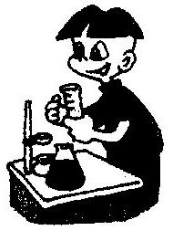
3. 4. 5.

（ ） （ ） ( )
- 听读音，用“√”勾出下列人物喜欢的食物。（10分）
Food  Name | rice | noodles | soup | egg | hamburger | fish | chicken | juice
Amy
Mike
John
Sarah

- 听读音，给下列图画标上正确的数字序号。（10分）
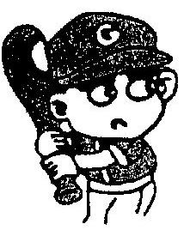
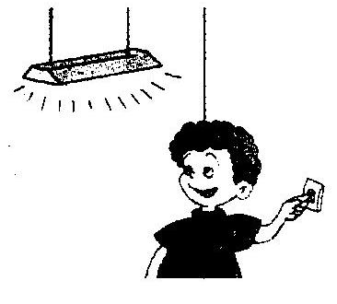
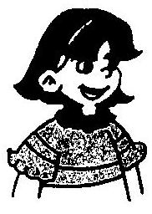
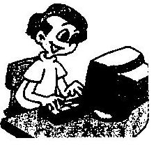
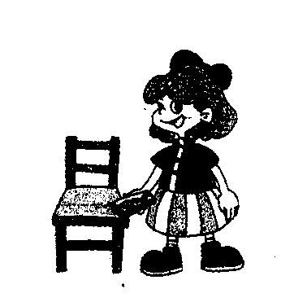

（ ） （ ） （ ） （ ） （ ）

五．听读音，选出你所听到的单词或数字。（10分）
( ) 1. A. plate B. play C. paint
( ) 2. A. chicken B. kitchen C. three
( ) 3. A. four B. tall C. fork
( ) 4. A. nice B. knife C, nine
( ) 5. A. school B. spoon C. soup
( ) 6. A. mouse B. music C. milk
( ) 7. A. black B. bread C. breakfast
( ) 8. A. home B. room C. phone
( ) 9. A. 18 B. 58 C. 88
( ) 10. A. 45 B. 37 C. 63
六．根据你所听到的句子，找出每题中正确的答句。（10分）
( ) 1. A. It’s on the book. B. It’s in the desk.
C. It’s near the window.
( ) 2. A. They’re my parents and me. B. There are four.
C. My parents and me.
( ) 3. A. My father is a doctor. B. She’s a doctor.
. C. My mother likes music.
( ) 4. A. No, they aren’t. B. Yes, he is.
C. No, you’re right.
( ) 5. A. He’s a driver. B. He’s my brother.
C. He looks strong.

七．根据读音，完成下列句子，每空一词。（10分）
1. Welcome to my .

2. Amy’s is a .

3. I have an uncle. He’s a .

4. My parents are s .
笔试部分
八．根据上下文和图画，填上句子所缺的单词，使句子完整。（10分）
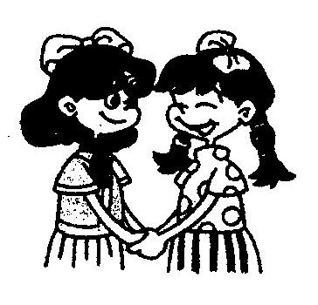
1. We are .

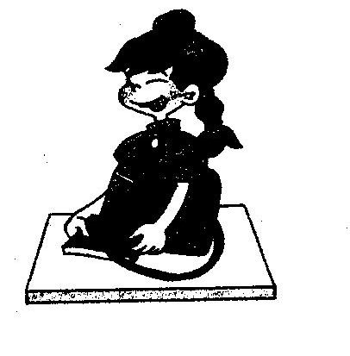
2. Chen Jie is a . She’s quiet.

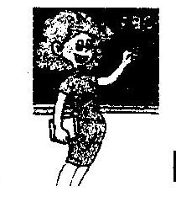
3. This is my English . Her name is Miss White.

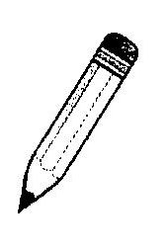
4. The is in the desk.

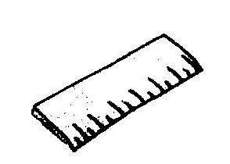
5. Look, I have a long .

九.找出下列句子正确的答句，并将其编号填在题前的括号里。（10分）
A. Yes. Pass me a spoon, please.
B. It’s ¥15.
C. Good idea.
D. I’d like some hot dogs.
E. Thank you very much!
( ) 1. What would you like for breakfast?
( ) 2. Can I help you?
( ) 3. Everything’s ready.
( ) 4. How much is the plate?
( ) 5. Let’s clean the classroom.

十.阅读短文，判断对错。（10分）
Look, this is a photo of my family. I put it on the desk in my bedroom. Look! They are my grandparents. They are not very old. My dad is strong. My mom is thin. Oh, this is my sister. She’s quiet. She’s 10. She’s a good student. She likes English and sports. The boy is me. I like music and books.

( ) 1. I am a girl. I like music and books.
( ) 2. My grandpa and grandma are very old.
( ) 3. My sister is 10. She’s a good teacher.
( ) 4. My sister likes English and sports.
( ) 5. There are 6 members in my family.
听力材料
- 听读音，选出正确的图画，并在括号里打“√”。
- Look, the floor is clean.
- ---What’s in the classroom? ---Many desks and chairs.
- This is my good friend. She has long hair, small eyes and a mouths.
- Looks, this is my new chair.
- Let me clean the board.
- 听读音，判断图画是否与读音相符，相符的请打“√”，否则打“×”。
- Put the schoolbag in the desk.
- Write down small letters bdpq, please.
- The girl likes listening to music.
- Put the book on your head.
- Zhang peng is my new friend. He likes painting.
- 听读音，用“√”勾出下列人物喜欢的食物。
- ---Hello. Sarah. What would you like? ---I’d like som,e noodles and two eggs.
- I’m Amy. I’d like some rice, fish and soup.
- Give Mike some soup, 3 hamburgers and some chicken. What about you, Johen? I’d like some chicken and some juice.
- 听读音，给下列图画标上正确的数字序号。
- The boy is my brother. He likes playing computer games.
- Put the pencil-case on the chair.
- The girl is my friend. She has short hair, big eyes and mouth.
- Turn on the lights, please.
- My friend has big eyes and small mouth. He likes sports.
- 听读音，选出你所听到的单词或数字。
1. ahgk 2. RIYL 3. 35 4. 72 5. eleven
6. who 7.nice 8. math 9. board 10. bed
六. 根据你所听到的句子，找出每题中正确的答句。
1. Where’s your seat?
2. How many people are there in your family?
3. What’s your mother?
4. Are they nurses?
5. Who’s that man?
七. 根据读音，完成下列句子，每空一词。
1. Welcome to my home. 2. Amy’s brother is a doctor.
3. I have an uncle. He’s a farmer. 4. My parents are teachers.

答案
一.
1. 2.

（ √ ） （ ） （ √ ） （ ）
3. 4.
、

（ ） （ √ ） （ √ ） （ ）
5.

（ ） （ √ ）
二.
1.× 2.× 3.√ 4.√ 5.×
三.
Food  Name | rice | noodles | soup | egg | hamburger | fish | chicken | juice
Amy | √ |  | √ |  |  | √
Mike |  |  | √ |  | √ |  | √
John |  |  |  |  |  |  | √ | √
Sarah |  | √ |  | √
四.
5 2 4 3 1
五.
1. B 2. B 3. A 4. C 5. C
6.B 7. A 8.A 9. C 10. A
六.
1. C 2. B 3. B 4. A 5. B
七.
1. home 2. brother doctor 3. farmer 4. teacher
八．
1. friends 2. student 3. teacher 4. pencil 5. ruler
九.
1. D 2. A 3. E 4. B 5. C
十.
1.× 2.× 3.× 4.√ 5.√

