牛津小学英语4B 期末试卷
口试部分 （30%）
听力部分 （30%）
一、找出句中所提到的人或物，填序号 (听两遍，可多选) (每小题2分, 共10分)




( ) 1. A. B. C. D.





( ) 2. A. B. C. D.




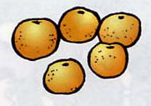
( ) 3. A. B. C. D.

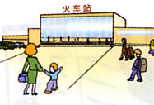

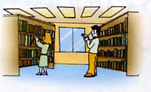
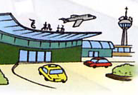
) 4. A. B. C. D.
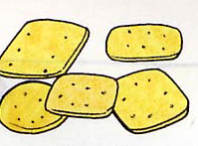
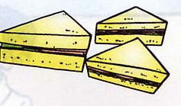
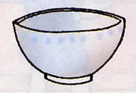
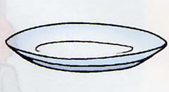
( ) 5. A. B. C. D.

二、判断所听内容是否与图相符，用√或╳表示 (听两遍) (每小题1分, 共8分)
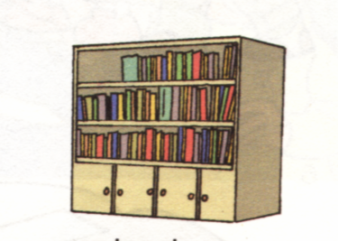
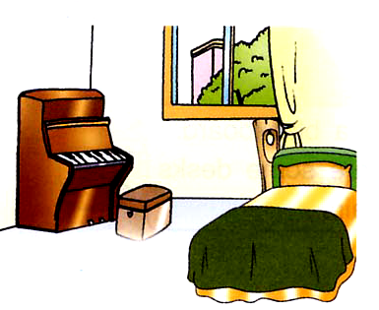
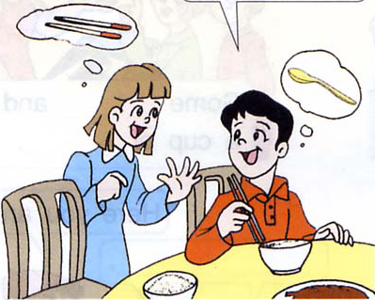

1 2 3 4

( ) ( ) ( ) ( )
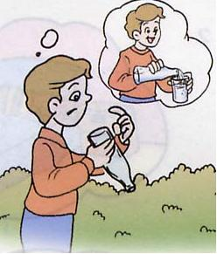
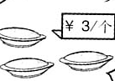
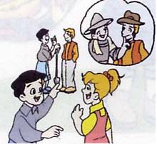

5 6 7 8

( ) ( ) ( ) ( )
三、听录音，根据所给情景找句子(听两遍) (每小题1分, 共6分)

( ) 1. A. Let’s play football at the school. B. Shall we play football?
C. Where do we play football?
( ) 2. A. Is this bus for Baima Park? B. Is bus No.2 for Baima Park?
C. Is this No.2 bus?
( ) 3. A. There are some computers in our school.
B. There is a computer in our school.
C. There are many computers in our school.
( ) 4. A. I’ve got some nice pictures. B. Look at my nice pictures.
C. This is my nice picture.
( ) 5. A. Come here, please. B. Have some apple juice, please.
C. Come and drink some orange juice, please.
( ) 6. A. What would you like? B. How about you？
C. What do you like?
四、听短文，判断所给句子是否正确，用√或×表示 (听两遍) (每小题1分, 共6分)
( ) 1. This is Ben’s classroom.
( ) 2. The classroom is big and bright.
( ) 3. There is a TV near the window.
( ) 4. There are twenty-nine students in Ben’s class.
( ) 5. There are some books and copybooks in the bookcase.
( ) 6. Miss Wang is a good teacher.
笔试部分（40%）
五、找答句，填序号 (每小题1分, 共10分)
( ) 1. Welcome to our school. A. Let’s hurry.
( ) 2. We’re late for the party. B. Yes, sir.
( ) 3. How do we go there? C. Yes, it is.
( ) 4. Don’t climb trees again. D. Thank you.
( ) 5. Something to drink? E. No, I can’t.
( ) 6. What can you see？ F. Yes, she is.
( ) 7. Can you read it? G. A cup of tea, please.
( ) 8. What’s for breakfast? H. Noodles and milk.
( ) 9. Is that woman a nurse? I. I can see a train.
( )10. Is this bus for the station? J. By bike.
六、根据图意，找句子组成对话，按对话顺序填序号 (每小题2分, 共8分)
- Shall we go to the library by bike? B. They are watermelons.
- Who’s the boy with big nose? D. I’m thirsty.
E. He’s my student, Tim. F. What are those?
G. Here’s some apple juice. H. All right.

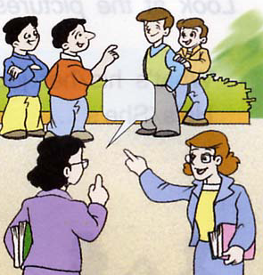
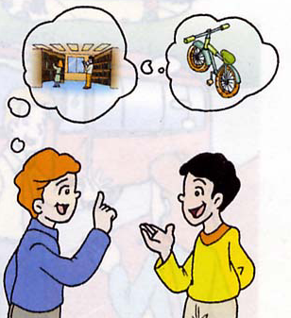
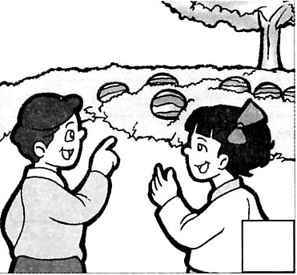
1. 2. . 3. 4.
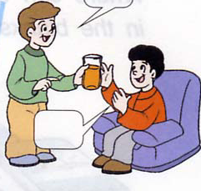

( ) ( ) ( ) ( ) ( ) ( ) ( ) ( )
七、根据实际情况回答问题 (每小题1分, 共6分)
1. What’s your name? ___________________
2. How old are you? ___________________
3. How do you go to school in the morning? ______________________
4. Can you use chopsticks? ________________________________
5. What do you want to be? _______________________________
6. Do you love your teachers? _______________________________
八、看图完成对话 (每小题2分, 共8分)

1. A: _______that ________?
B: Which boy?
A: _________ _________ in the shirt.
B: Sorry, I don’t know.
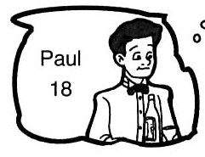
2. A: What’s __________ job?
B: He’s a ______________.
A: How old is he?
B: ___________ ___________.

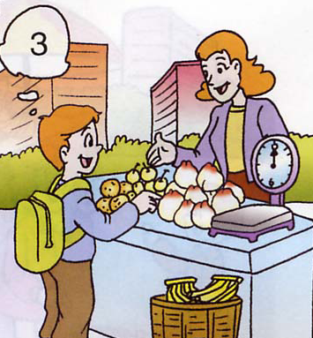
3. A: Can I help you?
B: I’d like some peaches.
A: _________ __________ kilos?
B: Three kilos, please.
_________ _________ are they?
A: Six yuan.

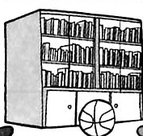
4. A: What’s in the bookcase?
B: _________ __________ some books.
A: ________ is the football?
B: It’s _________ the bookcase.
九、阅读对话，回答问题 (每小题2分, 共8分)
A: It’s four o’clock; let’s go home, Su Hai.
B: I’m not so good, Su Yang.
A: What’s the matter？
B: I’m ill, I think.
A: Let’s go to see the doctor.
B: OK, but how do we go to the hospital?
A: Shall we go there by bus?
B: Which bus is for the hospital?
A: I don’t know. Er, let’s go by taxi.
B: All right.

1. What’s the time?
______________________________________________________
2. How about Su Hai?
______________________________________________________
3. Do they go to the hospital?
______________________________________________________
4. How do they go to the hospital?
______________________________________________________

听力内容
一、找出句中所提到的人或物，填序号 (听两遍，可多选) (每小题2分, 共10分)
1. A: Who’s that student? B: She’s Helen. Her father is a doctor.
2. A: Mum, this is my friend, Mike. B: Nice to meet you, Mike.
A: Nice to meet you.
3. A: What are those? B: They’re peaches and oranges.
A: I’d like some grapes. B: Oh, here they are.
4. A: Are you free, now? B: Yes.
A: Let’s go to the library. B: OK.
5. Here are no biscuits on the plate.
二、判断所听内容是否与图相符，用√或×表示 (听两遍) (每小题1分, 共8分)
1. —What’s in the bookcase?
—There are some books.
2. —Where’s the piano?
—It’s in the bedroom.
3. —I can’t use the fork.
—You can use a spoon.
4. —I’m hungry.
—Here’s some bread for you.
5. I’d like some water. There’s no water in the bottle.
6. —What would you like?
—I’d like three pies. How much are they?
—Six yuan, please.
7. —What are their jobs?
—They’re doctors.
8. There is a map on David’s T-shirt. He likes it very much.
三、听录音，根据所给情景找句子(听两遍) (每小题1分, 共6分)
1. 放学后，你向同学建议在学校踢足球。
2. 你想问2路车是否到白马公园。
3. 你告诉别人你们学校有很多电脑。
4. 你告诉别人自己有一些漂亮的图画。
5. 叫别人过来喝些桔子汁。
6. 问别人喜欢什么?

四、听短文，判断所给句子是否正确 (听两遍) (每小题1分, 共6分)
I’m Ben. This is my classroom. It’s not big but bright. There are two blackboards in it. You can see a TV near the big blackboard. A bookcase near the window. There are some books and our copybooks in the bookcase. There are twenty- five students in our class. Miss Wang is our English teacher. She is a good teacher. We love her.
参考答案
一、1. AB 2. CD 3. ABD 4. C 5. BD
二、1. √ 2. √ 3. × 4. √ 5. √ 6. × 7. × 8. √
三、1. A 2. B 3. C 4. A 5. C 6. C
四、1. √ 2. × 3. × 4.× 5. √ 6. √
五、1. D 2. A 3. J 4. B 5. G 6. I 7. E 8. H 9. F 10. C
六、1. CE 2. FB 3. AH 4. DG
七、略
八、1. Who’s, boy, The one/ boy
2. his, waiter, He’s, eighteen
3. How many, How much
4. There are, where, near
九、1. It’s four o’clock.
2. She’s ill.
3. Yes, they do.
4. They go to the hospital by taxi./ By taxi.

