牛津小学英语4A期末试题
听力部分 (30%)
笔试部分 (70%)
六、看图选词完成句子 (7%)
sweater, seven ten, bedroom, rubber, storybook, pen

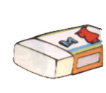
1．—May I have this white ?
—Sure. Here you are.
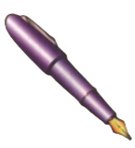
2. —I’d like this , please.
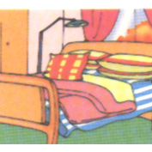
—OK. Here you are.
- —Where’s Yang Ling?
—She’s in the .
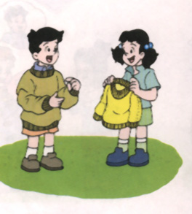
4. —Look at this new .
—How nice!
- —What’s the time?
7:10
—It’s .
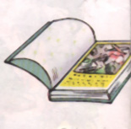
6. —Now open your , please.
—All right, Miss Li.
七、对话配对。(10%)
( ) 1 .Whose gloves are they? A. Thank you.
( ) 2. Look at my new pencil box. B. It’s in your bedroom.
( ) 3. What’s the matter? C. At eleven thirty.
( ) 4. What time do you have lunch? D. I’m hungry.
( ) 5. Where’s my scarf? E. How nice!
( ) 6. Here are some crayons for you. F. They’re Yang Ling’s.
( ) 7. This jacket is too big. G. Sorry, Helen.
( ) 8. You look happy. H. Bye, Mr Green.
( ) 9. See you in the afternoon. I. Try this one on.
( ) 10. You’re late, Wang Ling. J. Yes. I’ve got a toy bear.
八、认真想一想，下面句中填上什么最合适？将序号填入题前的括号内。(15%)
( ) 1. —May I have a copybook ________ Nancy? She’s ill.
— Sure. Here you are.
A. to B. for C. in
( ) 2. —Happy _________ Day! Miss Li. Here’s a card for you.
—Thank you.
A. Teacher’s B. Teachers C. Teachers’
( ) 3. —Whose umbrella is it?
—It is ______ umbrella. My father give it to me.
A. my B. his C. your
( ) 4. —I love dolls. Do you like dolls?
— _______________.
A. Yes, I am. B. Yes, I do. C. Yes, you do.
( ) 5. —_________ ruler is this?
—It’s Su Yang’s.
A. Who’ s B. whose C. Whose
( ) 6. —The jeans are too long.
—Try this ______ on.
A. one B. pair C. a
( ) 7. —_______ draw in your book.
—Sorry, Mr Green.
A. Not B. No C. Don’t
( )8. —_________ is my ruler?
—It’s in your pencil case.
A. Where B. What C. Whose
( )9. —What’s this ________ English?
—It’s a bookmark.
A. on B. in C. at
( )10. _________ a nice little book! I like it very much.
A. How B. What C. Why
( )11. —Look! What is _______ over there?
—It’s a kite.
A. this B. that C. those
( )12. —I’m sorry.
—
A. Yes. B. Thank you. C. That’s OK.
( )13. —It’s eight thirty five!
—It’s time to .
A. go to school B. have lunch C. go to bed
( )14. —Do you like ?
—Yes, I do.
A. puppet B. puppets C. a puppet
( )15. —I’m .
—Here’s a fan for you.
—Thank you.
A. hot B. thirsty C. tired
九、将下列对话排序。 (5%)
A. Let me have a look.
B. Oh, dear. I’m late.
C. Excuse me.
D. What’s the time?
E. Oh, it’s seven thirty.
F. I go to school at seven thirty-five.
G. Don’t worry. You can go by bus.
1 | 2 | 3 | 4 | 5 | 6 | 7
C |  |  |  |  | F
十、看图，选出与图意相符的句子抄在图后的四线格上。(10%)
A. Please draw some pictures for me.
B. Perhaps your book is on the desk.
C. Don’t drink the juice, please.
D. The shorts are Mike’s.
E. This pencil case is for you.
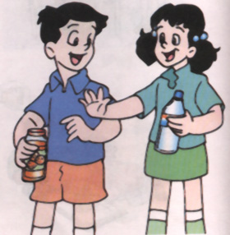
1

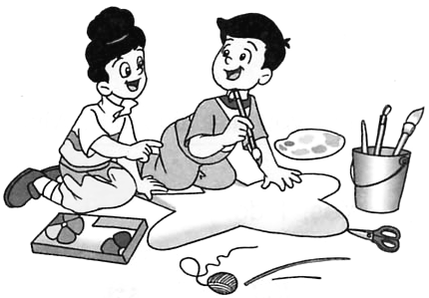

2

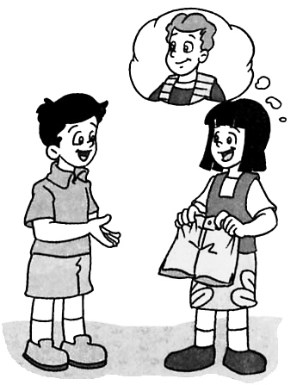

3

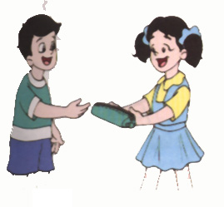

4

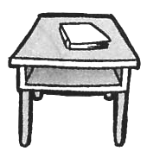

5

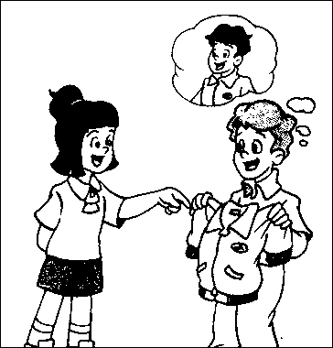
十一、根据图意，试着把对话中所缺单词补充完整。(13%)

1. A: Whose ________ is this?
B: It’s _____________. (图1)
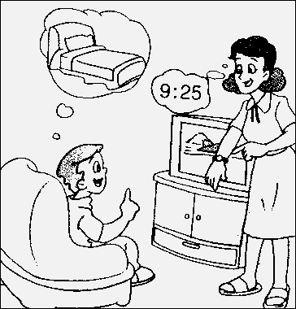
2. A: What’s the ________, please?
B: It’s ________twenty-five. (图2)
A: It’s time to to .
B: Yes, Mum.
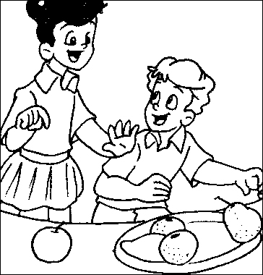
3. A: ________ eat the pear.
B: the _______ , please. (图3)

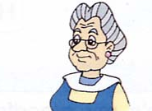
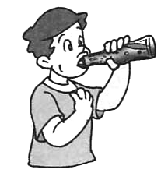
4. A: What’s the , dear?
B: I’m , Grandma. (图4)
A: some juice.
B: Thank you.
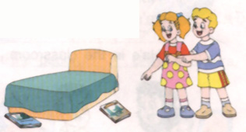
5. A: my storybook?
B: Look, it’s over there. (图5)
A: Thank you.

十二、阅读短文判断正误，正确的用T表示，错误的用F表示。(10%)
I have (有) two friends (朋友). They are Tom and Jim. We go to school at seven in the morning. We have lunch at twelve o’clock. We go home at five in the afternoon.
I have a clock. It’s on the desk. Tom has (有) an old watch (手表), and Jim has a new watch. Well, What’s the time? It’s four fifty-five. We can go home now.
( ) 1. Tom and Jim are my friends.
( ) 2. We go to school at seven in the afternoon..
( ) 3. My clock is on the desk.
( ) 4. Jim has an old watch.
( ) 5. It’s 4:35 now.

2006年《牛津小学英语4A》期末试题听力内容及参考答案
听力部分
一、听录音，选出所听到的内容，将代号填在题前括号中(听两遍)
1. Here’s a rubber for Su Yang.
2. I’d like this toy dog.
3. My purse is on the sofa.
4. His socks are too small.
5. Write the words in your notebook.
6. —What’s the matter?
—I’m tired.
7. It’s seven fifteen. Shall we go to school now?
答案： B A B C C B A
二、听问句，选答句(听两遍)
1. What’s this in English?
2. Can I have a look?
3. Do you like puzzles?
4. What time do you go to school?
5. Whose socks are they?
答案： A C B B A
三、看图，根据你所听到的对话内容给每幅图编号。
1. It’s time to go to bed .
2. A: Look, It’s my mother’s scarf.
B: Oh, the scarf is too long.
3. Close the book, please.
4. A: I’m hungry.
B: Have a hamburger, please.
5. A: I’ve got a new bed. I like it.
B: How lovely!
答案：5 2 1 3 4
四、你能根据所听到的时间给相应的钟面标上序号1、2、3、4、5吗？
1. —What’s the time?
—It’s eight fifteen.
2. It’s five fifty.
3. It’s seven thirty. It’s time to go to school.
4. It’s ten forty-five.
5. It’s two o’clock .
答案：5 3 1 4 2
五、听对话，判断图片与所听内容是否相符。相符的用“”表示，不符的用“”表示。
1. A: What can you see on the car? B: I can see a puzzle.
2. A: Whose sweater is it? B: It’s Miss Li’s.
3. A: What’s the matter? B: I’m hot.
4. A: Don’t draw on the desk. B: Sorry, Mr Green.
5. A: What’s the time? B: It’s nine fifty.
6. A: It’s twelve o’clock. B: Time to have lunch.
7. A: Shall we watch TV? B: All right.
8. A: Read the new words, please. B: OK.
答案：
笔试部分
六、看图选词完成句子。
1. rubber 2. pen 3. bedroom 4. sweater 5. seven ten 6. storybook
七、对话配对。
1. F 2. E 3. D 4. C .5. B 6. A 7. I 8. J 9. H 10. G
八、认真想一想，下面句中填上什么最合适？将序号填入题前的括号内。
1.B 2. C 3. A 4. B .5. C 6. B 7. C 8. A 9. B 10. B
11. B 12. C 13. C 14. B 15. A
九、将下列对话排序。
2. D 3. A 4. E 5. B 7. G
十、看图，选出与图意相符的句子抄在图后的四线格上。
1. Don’t drink the juice, please.
2. Please draw some pictures for me.
3. The shorts are Mike’s.
4. This pencil case is for you.
5. Perhaps your book is on the desk.
十一、根据图意，试着把对话中所缺单词补充完整。
1. jacket, Lao Tao’s 2. time, nine, go, bed 3. Don’t, Eat, apple
4. matter, thirsty, Have/Drink 5. Where’s
十二、阅读短文判断正误，正确的用T表示，错误的用F表示。
1. T 2. F 3. T 4. F 5. F

