牛津小学英语3BUnit1~2单元检测
听力部分（略）
笔试部分
六、从A栏中找出B栏的正确答语，把序号填在括号内。10’
A B
( )May I come in? 1.Sure.Here you are.
( )Can I have a look? 2.Yes,it is.
( )What’s this in English? 3.Thank you.
( )Is this telephone? 4.It’s a copybook
( )What a nice watch! 5.Come in,please.
七、写出下列所给字母的邻居。(注意区分大小写)10’
D G
m s j
八、将下列所给单词的大写变成小写,小写变成大写。10’
COMPUTER CLOCK RADIO COPYBOOK WATCH

crayon storybook cinema knife fridge

九、根据情景，选择填空。14’
（ ）1、当你去拜见朋友，想进房间时，应说：
A.May I come in? B. Come in, please. C. Oh, I see.
（ ）2、看见一个漂亮的照相机，你会说：
A. How old are you? B. Thank you. C. How nice!
（ ）3、询问某件东西是否是电脑，别人应答：
A. Is this a computer? B. Yes, it is . C. How pretty!
（ ）4、你想看一看某件东西，别人会说：
A. Can I have a look? B. No, it isn’t. C. sure.
（ ）5、在打扰别人时，你应说：
A. Here you are. B. Excuse me. C. Hello!
（ ）6、别人告诉你桌上是蜡笔时,你可以说:
A. Thank you . B. How are you? C.This is a crayon.
（ ）7、Is that your tape?
A. Yes, it isn’t. B. No, it isn’t. C. Yes, it is.
（ ）8—Can I have a ? — Sure
A.book B.look C.good
（ ）9、May I come in?
A. Yes. B. Come in, please C. Sure.
（ ）10、What’s that in English?
A zebra. B. Yes, it is a stapler. C. It’s a sharpener.
（ ）11、当别人叫你过来，他要说：
A. Come in ,please . B. Come here ,please. C.May I come in?
（ ）12、当你想知道远处桌上的物体是什么时，你会问：
A. What’s this on the desk ? B. What’s that on the desk ?
C. What’s that in the desk ?
（ ）13、当别人问你这是什么，你回答：
A. It’s a ….. B . Yes , it is . C. No, it isn’t.
（ ）14、你想说朋友的手表好看，可以说：（ ）
A. How a nice watch ! B. What a nice clock ! C. What a nice watch !
十、根据所给中文写出相应单词。6’
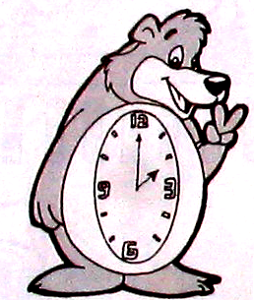
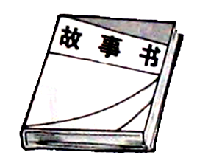
1. 2. 3 .
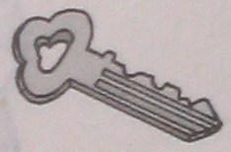

4 . 5. 6.
