2010年全国小学生英语竞赛(NECPS)四年级组竞赛样题
听力部分（共四大题，计40分）
I．听辨单词（Words）（共10小题，计10分）
A） 听音，选出你所听到的单词所代表的图片。每个单词只读一遍。（答案涂在答题纸上）
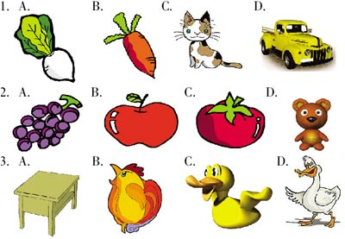
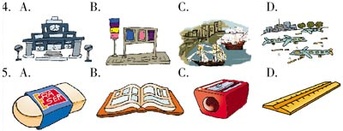
B）听音，选出你所听到单词。每个单词读两遍。（答案涂在答题纸上）
6. A. large B. more C. big D. small
7. A. short B. long C. high D. good
8. A. bad B. tall C. thin D. fat
9. A. blue B. black C. right D. white
10. A. son B. daughter C. mother D. sister
II. 句子理解（Sentences）（共10小题，计10分）
A)听音，判断所给图片与所听句子是（T）否（F）相符。每小题读两遍。（答案涂在答题纸上）
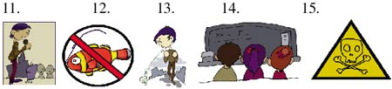
B)听音，选择所听句子含有的一项。每小题读两遍。（答案涂在答题纸上）
16. A. eraser B. chalk C. pencil case D. pen
17. A. come B. home C. climb D. catch
18. A. go B. to C. going D. girl
19. A. kite B. cat C. Kate D. bat
20. A. hay B. day C. way D. gay
III. 对话理解（Dialogues） （共10小题，计10分）
A) 听音，看图，选择与所听内容相符的图片。每个对话读两遍。（答案涂在答题纸上）
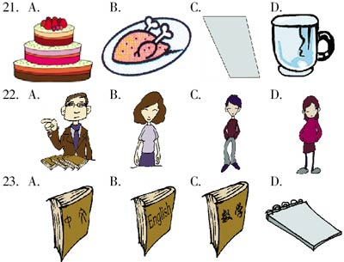
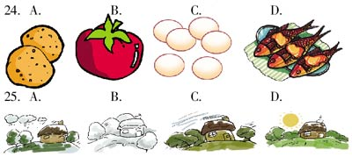
B) 听音，根据你所听到的内容为相关的图片按英文字母（A，B，C，D，E）的顺序标号。每个对话读两遍。（答案涂在答题纸上）
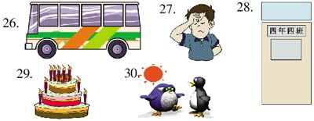
IV. 短文理解（Passages）（共10小题，计10分）
A） 听音，填单词，补全短文。短文读两遍。(答案写在答题纸上)
Hello, I am Mike. I have a happy family. There are five people in my family. I'm a 31 . I'm in Class 4, Grade 4. My grandfather is a 32 . My grandmother is a 33 . My father is a 34 . My mother is a 35 .
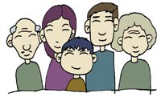
B) 听音，根据所听短文内容回答文后问题。短文读两遍。(答案涂在答题纸上)
36._________ 37._________ 38._________ 39._________ 40._________
笔试部分（共六大题，计60分）
I. 单词(Words)（共10 小题，计10分）
A)根据所给字母和句子提示写单词。（答案写在答题纸上）
1. earY Happy New _________!
2. uMm Good night, _________. Good night, Dad.
3. ckne Touch your _________, please.
4. ton She is _________ hungry now.
5. theer There is a bus stop over _________.
B) 看图，写身体部位名词。（答案写在答题纸上）
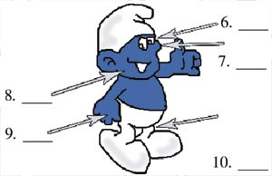
II. 句子（Sentences）（共10小题，计10分）
从A, B, C, D四个选项中选出下列各题的最佳答案。（答案涂在答题纸上）
11. _________ is a good girl. _________ is a bad boy.
A. He, She B. She, He
C. He, He D. She, She
12. There _________ a dog in the room.
A. is B. am C. are D. has
13. Let's go _________, shall we?
A. swim B. swims
C. swimming D. to swimming
14. The cap is _________. The hat is _________.
A. his, her B. her, his
C. his, hers D. hers, him
15. _________ a fine day it is!
A. How B. What
C. It's D. Its
16. It's is _________ orange. It's under _________ coat in my _________ room.
A. a, an, the B. an, the, 不填
C. an, a, the D. a, an, 不填
17. —_________ you see the bird in the sky?
—_________, I can't.
A. Are, No B. Do, OK
C. Can, Yes D. Can, No
18. I can count. One, two, three, _________ five.
A. six B. seven C. four D. eight
19. How _________ the jacket is!
A. much B. many C. oftne D. nice
20. I am from ________. I am a _________.
A. American, Englishman
B. French, Chinese
C. England, Chinese
D. Japanese, Japan
III. 情景会话（Dialogues）（共10 小题，计10分）
A)根据所给情景，选择合适的句子完成下列各题。（答案涂在答题纸上）
21．当别人帮助你的时候，你可以说：
_____________________________________________
A. How are you? B. Thanks a lot.
C. That's all right.
22. 当你上学迟到时，你可以这样对老师说：_____________________________________________
A. It doesn't matter.
B. I'm sorry. I am late.
C. I go to school on foot.
23. 当你要睡觉的时候，你可以对爸爸、妈妈说：_____________________________________________
A. Goodbye! B. Good night.
C. See you.
24. 当你要回家的时候，你可以这样对老师说：_____________________________________________
A. May I go home now?
B. How are you? C. May I come in?
25. 当你要打扰别人的时候，你可以说：_____________________________________________
A. Excuse me. B. I am sorry.
C. Come on!
B) 根据所给的情景选择合适的一项完成对话。（答案涂在答题纸上）
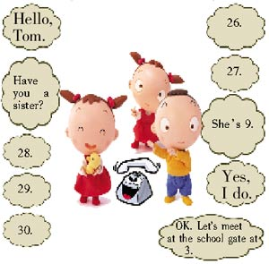
A. How do you do? B. Thanks a lot.
C. Do you have time tomorrow?
D. Let's go to see a film, shall we?
E. How old is she?
F. Yes, I have. G. Hello, Mary.
IV. 阅读理解（Reading comprehensions）（共10 小题，计10分）
A) 阅读短文，然后在图片上标出下面学生的位置。（答案涂在答题纸上，只写数字即可）
Hello, everyone! Where are John, Ray, Susan, Lisa and Carol sitting? Write their names on their seats in the diagram(图表).
There are two seats in front of John and two seats behind him. There is one seat on his right and one seat on his left. There is not any seat in front of Ray, and there is one seat on his left and one seat on his right. There are four seats in front of Susan, and there is one seat on her left and one seat on her right. There are three seats in front of Lisa, but only one seat behind her. There aren't any seats on her left, but there are two on her right. There are four seats in front of Carol, but there isn't any seat on her right.
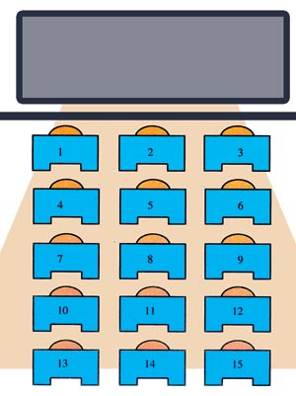
B) 阅读短文, 然后回答文后问题。（答案写在答题纸上）
Ben thinks he is clever, but he always does foolish things.
One day he sees a beautiful bell （门铃） at the top of a door. “Oh! How nice! I will take it home,” he thinks, “What can I do?” After a while he has a “good” idea. “Aha! I have an idea now. I can plug（堵） my ears. Then I will not hear the ring when I take off（拿掉）the bell.”
Then Ben does that. But as soon as he takes off the bell, the owner opens the door. “What are you doing?” the owner says angrily.
36. Is Ben a clever man?
__________________________________
37. Does Ben want the bell?
__________________________________
38. Where is the bell?
__________________________________
39. The bell rings as soon as Ben takes it off, right?
__________________________________
40. Who catches Ben while he is taking off the bell?
__________________________________
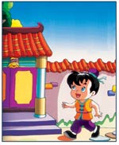
V. 智力测试（Intelligence test）（共5小题，计5分）
41. He likes to drink black tea. 中的“black tea”的中文翻译是：
__________________________________
A. 黑茶 B. 红茶 C. 绿茶
42. television的缩写形式是：
__________________________________
43. What letter is a kind of drink?
__________________________________
44. What number should replace the question mark? (什么数字能代替问号？)
__________________________________
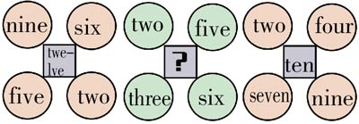
45. Which silhouette exactly matches thejellyfish?(哪个影子是章鱼的？)
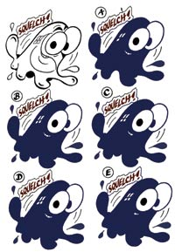
VI. 小作文（Composition）（共1小题，计15分）
提示：以“My Pet”为题写一篇小作文。
要求：1. 条理清楚，意思连贯，语句通顺，标点正确，书写清晰、规范； 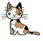
2. 可根据所给的图片作适当地发挥；
3. 不得少于50个单词；
4. 将作文写在答题纸上。

