四年级第一学期英语期末知识抽查模拟题
班别：___________姓名：___________成绩：______________
听力部分
一 听音选图。(12)
1 ( )( ) 2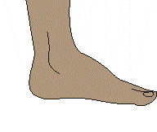( ) 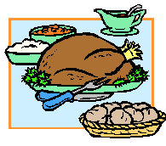( )
3( ) 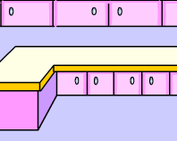 ( ) 4( )( ) 5( ) 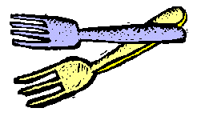 ( ) 6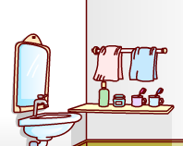 ( ) ( )
二 听音判断图的正确与否。(10)
1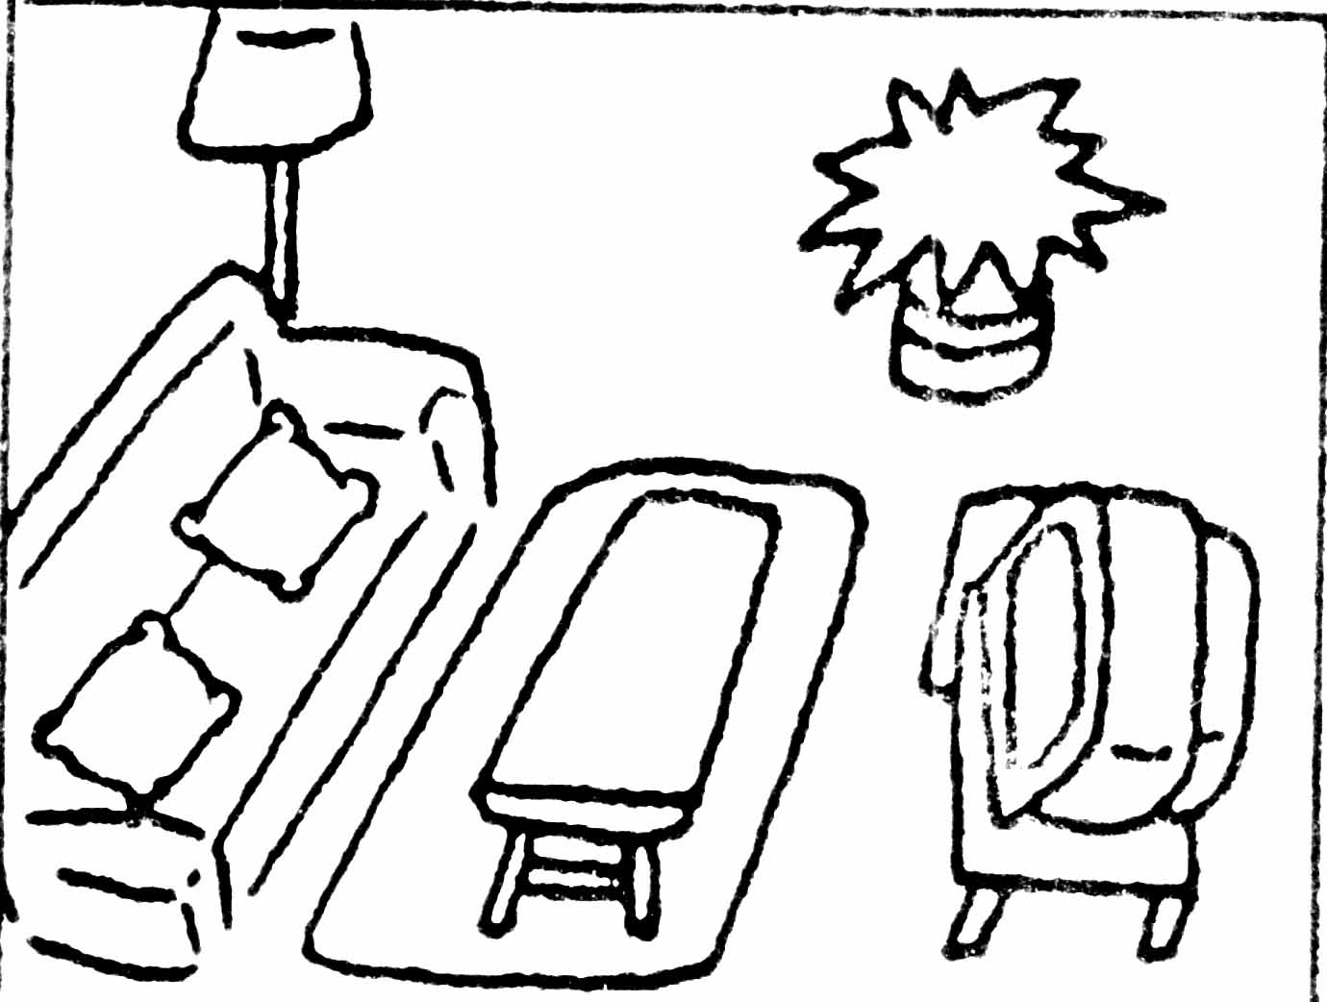( )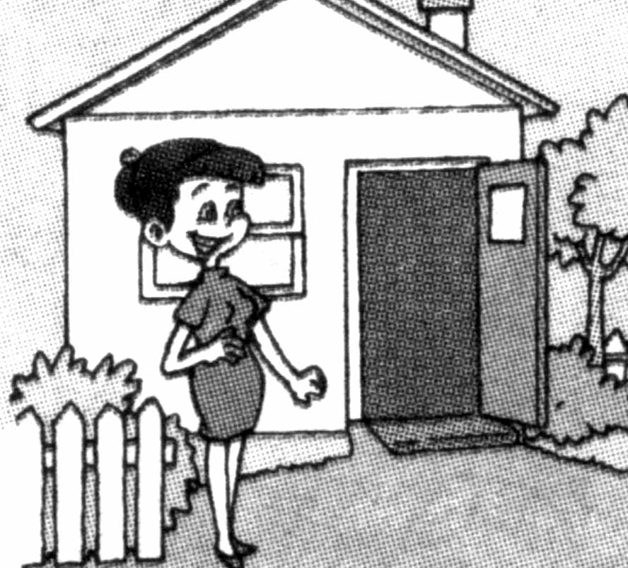 ( ) 2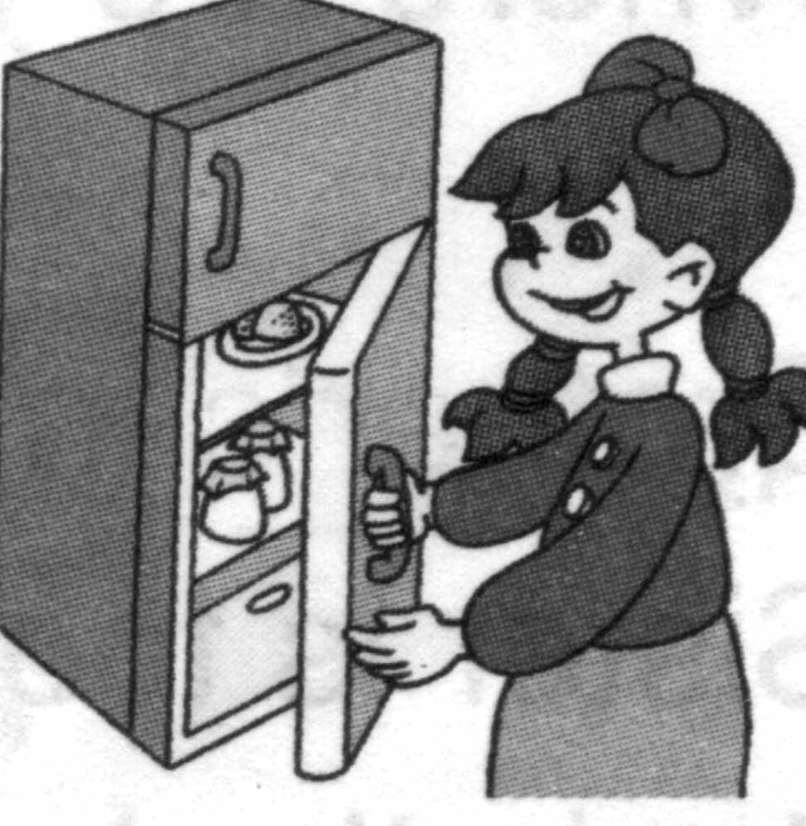( )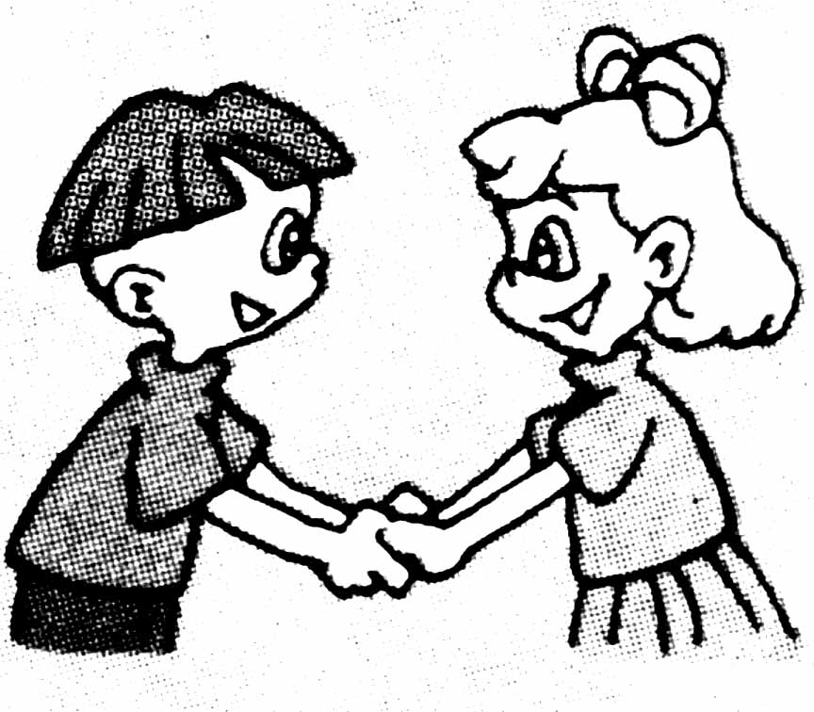( )
3.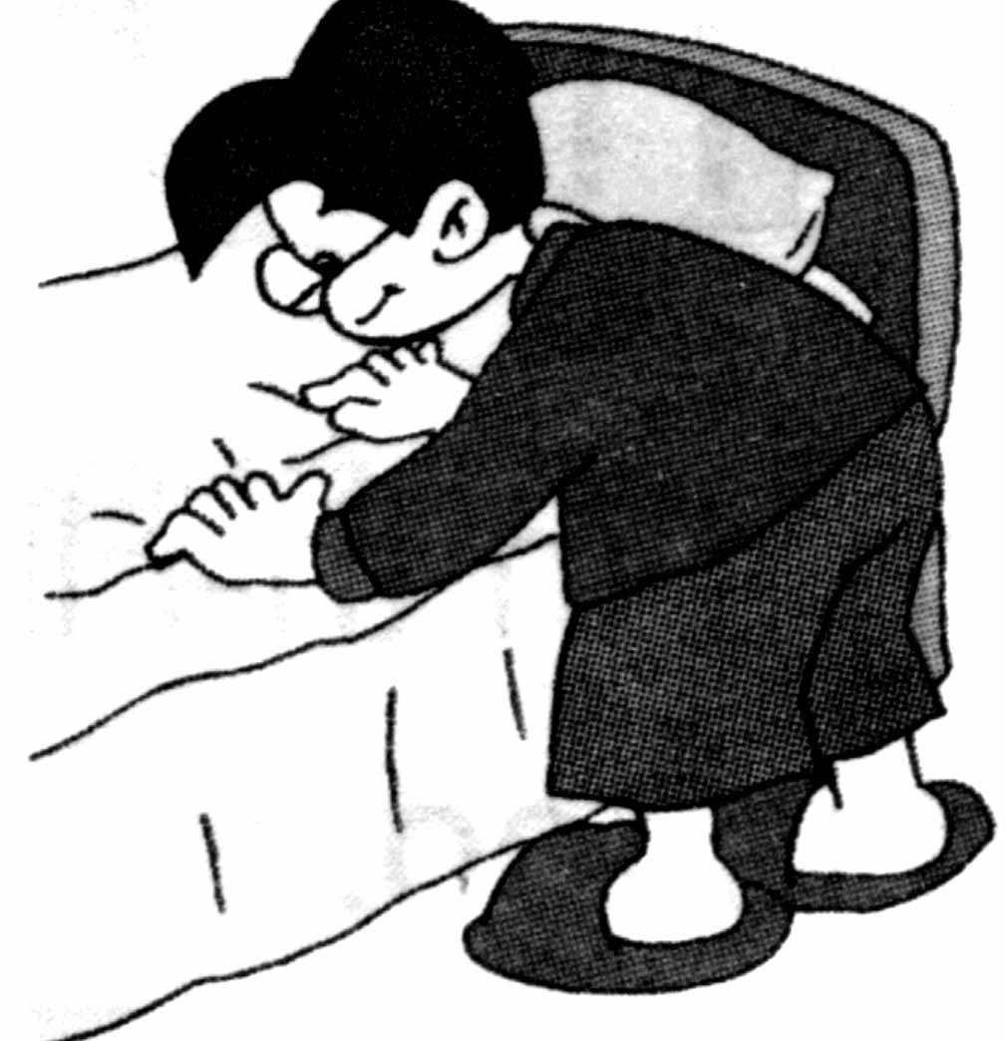 ( )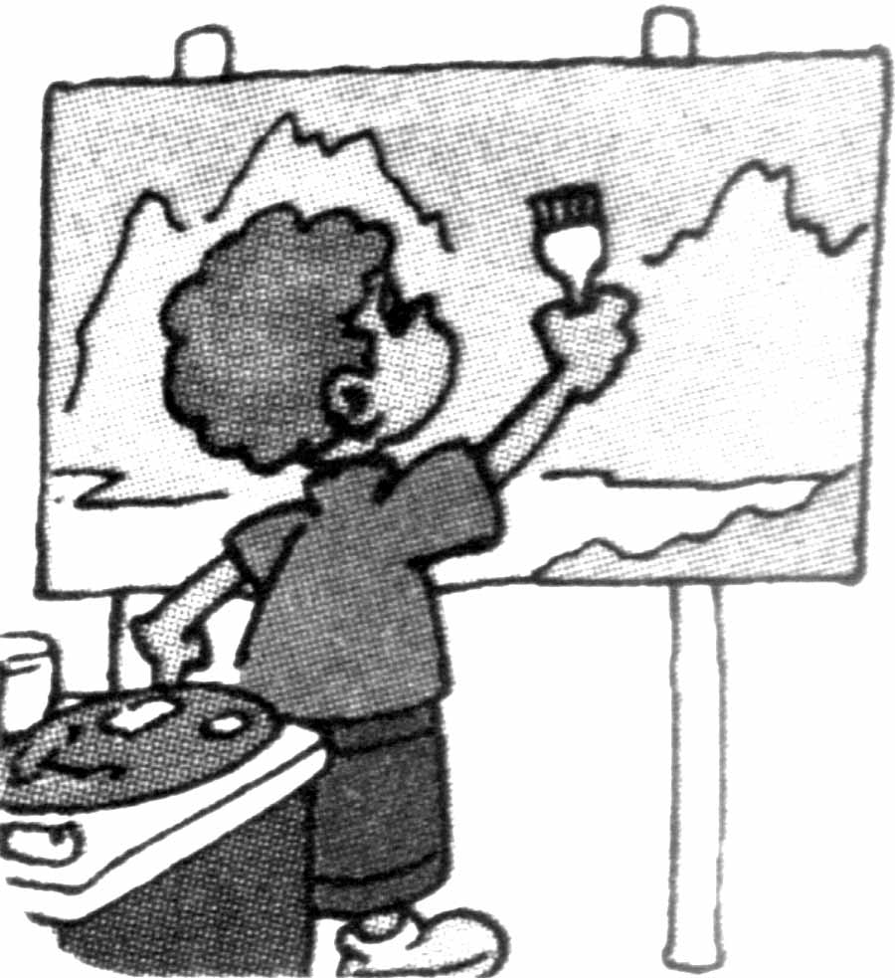( )4.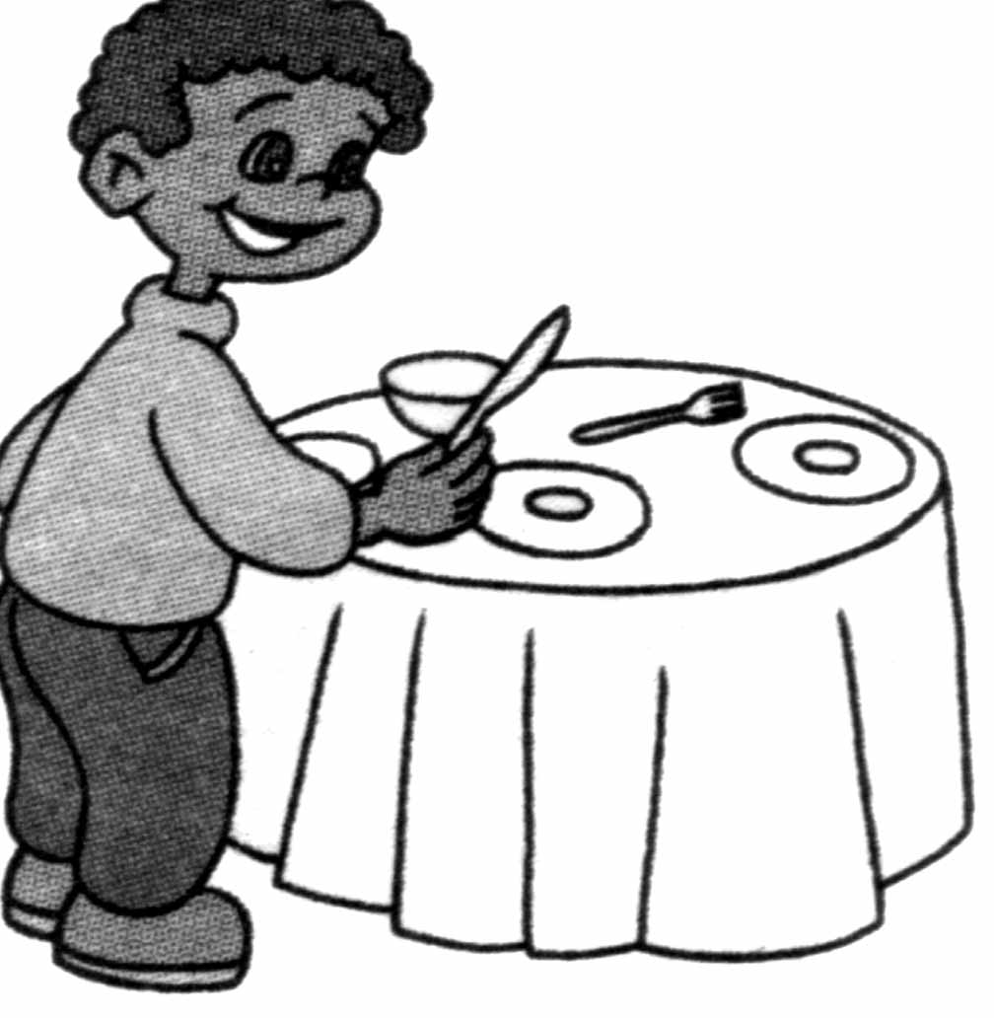 ( )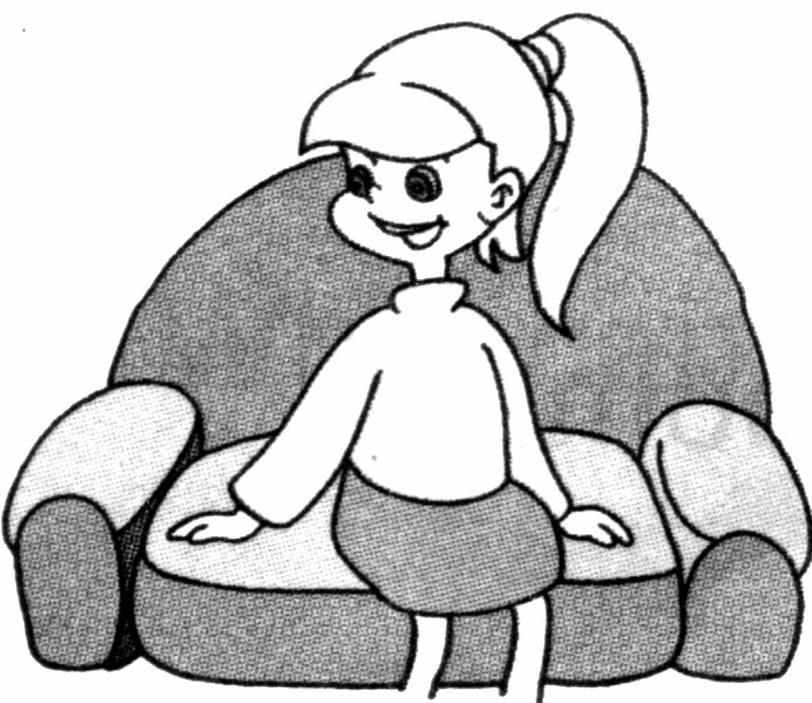 ( )
5.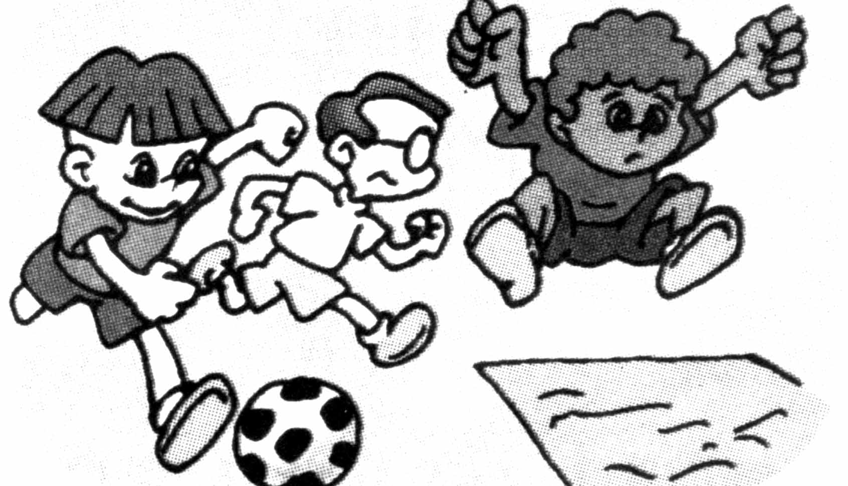 ( )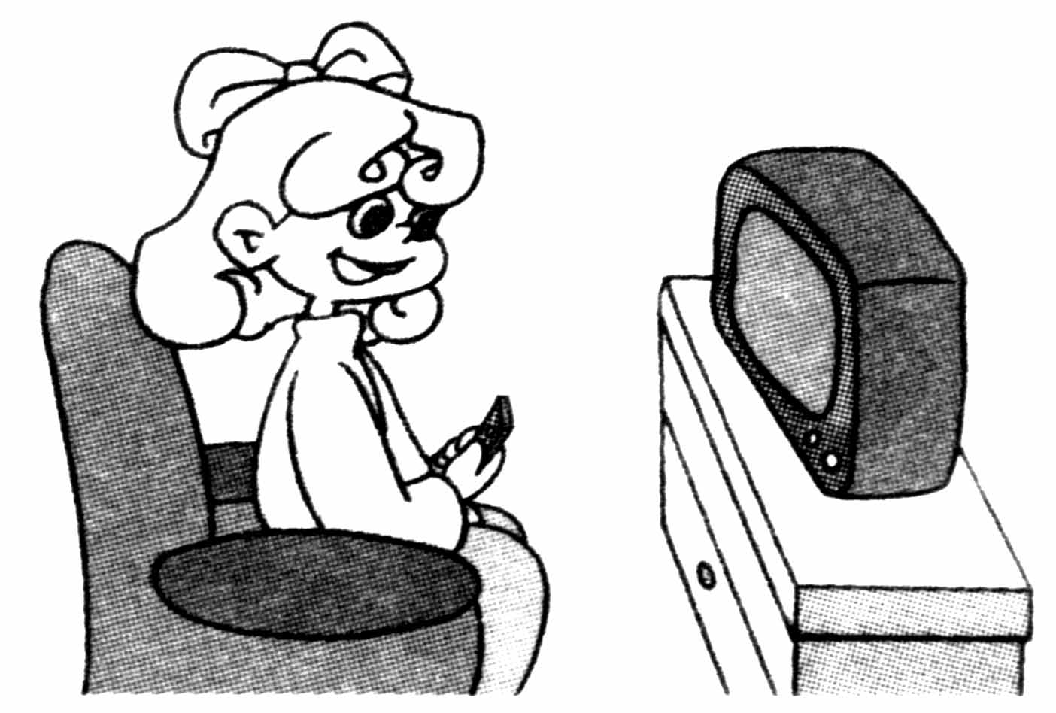 ( )
三 听句子选单词。(12)
1 ( ) A door B board C floor
- ( ) A teacher B picture C finger
- ( ) A short B sport C strong
- ( ) A forty B thirty C twenty
- ( ) A wall B ball C tall
- ( ) A knife B kite C nine
四 听问题，选答案。(8)
1 ( ) A Miss Green is. B Yes, she is . C She’s a teacher.
2 ( ) A Yes ,it is . B Two pencils. C It’s a bag.
3 ( ) A It’s my ruler. B I have a ruler. C It’s blue.
4 ( ) A Yes, I do. B Yes, it is . C Yes ,I can.
五 听一段话，填写单词。（一空一词）(10)
Welcome to my _________. This is my ________. I like reading books in it. I like reading books. I have many books in my study. You can see ______ story-books,_______ picture-books and _______ English books.
笔试部分
六 看图补充句子。(22)
A: What would you like for breakfast, Alice?
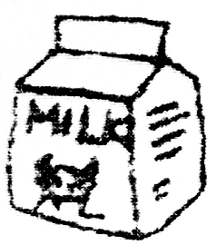
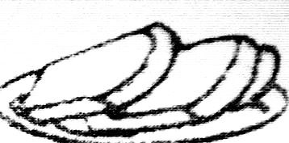
B: I’d like some _____ , some ______

and some _____ .
A: Wow! What a nice breakfast! And what about your dinner?
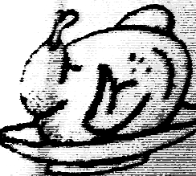
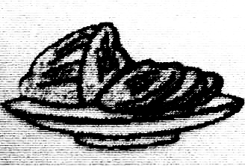

B: I’d like some _____ , some _______
and some _____ .
七 看图回答问题。(10)
- A: Where are my keys ?
B: Are they on the sofa ?
C:______,they________.
- A: Where are my pencils ?
B: They’re on the __________.
- A: Where are the books ?
B: Are they in the __________?
A:______, they _______.
- A: Where’s the phone ?
B: It’s on the _______.
- A: Can you see a fridge in the picture ?
B: ______, _______ _______.
八、补充对话完整。(8)
A: Hi, come and meet my f______. Look, this is my m________.
She’s nice.
B: What’s your m_________?
A: She’s a n________.
B: Is this your f________?
A: Yes, he is. He’s a d________.
B: Who’s that g_______. She has long hair.
A: She’s my s________. She likes music. This is my u_______.
He’s cool and strong.
九 阅读理解。(10)
Look at my family photo. This is my father. He’s a teacher. He’s tall. He likes sports. This is my mother. She’s a teacher, too. She likes reading. This is my brother. He’s a baseball player. He’s strong. I love my family.
1.( )My parents are teachers.
2.( )My father likes sports.
3.( )My brother likes music.
4.( )My brother is tall and strong.
5.( )There are four people in my family.

