四年级英语第一学期期末试卷
Class Name Number
听力部分（60 %）
一．Listen and choose. ( 根据听到的内容选择正确答案。)
( ) 1. A. uw B. qw C. uq ( ) 4. A. 30 B. 13 C. 31
( ) 2. A. air B. iar C. rai ( ) 5. A. 345 B. 543 C. 645
( ) 3. A. SXY B. FXS C. FSX ( ) 6. A. 9871 B. 9781 C. 6789
( )7. A.MNOP B. NMOP C.MNQP
( ) 8. A. 6349 B. 6579 C. 6538
( ) 9. A. AJHK B. HJKA C. HGKA
( ) 10. A. 7458 B. 9548 C. 7549

二．Listen and draw.（判断听到的内容与图片是否相符合，用 或 来表示。）
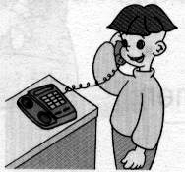
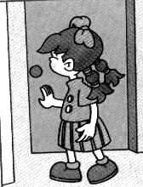
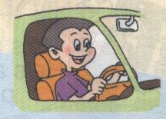

( ) ( ) ( )
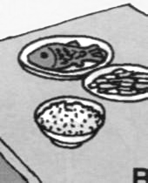
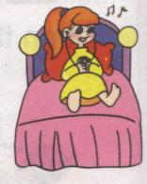
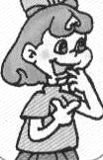
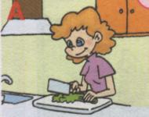

( ) ( ) ( ) ( )
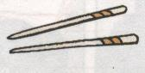
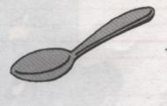
三．Listen and choose. ( 根据听到的内容，选择正确的图片完成句子。)
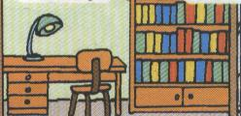
( ) 1. I can use . A. B.
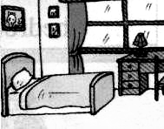
( ) 2. This is my . A. B.

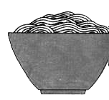
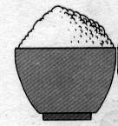
( ) 3. I’d like some . A. B.

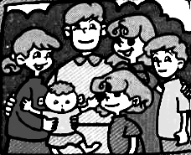
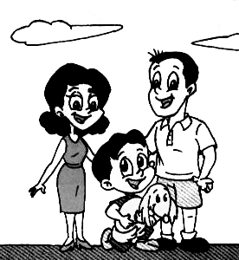
( ) 4. My family has members. A. B.
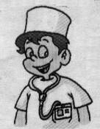
( ) 5. My father is a . A. B.

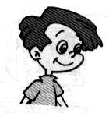
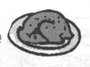
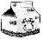
四．Listen and match. ( 根据听到的内容连线。)
1. tall

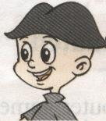
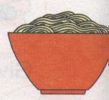

2. strong


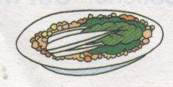
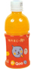
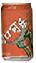
3. thin

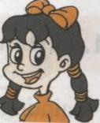
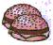
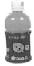
4. short

五．Listen and match. (按听到的内容把人与所在房间连起来。)
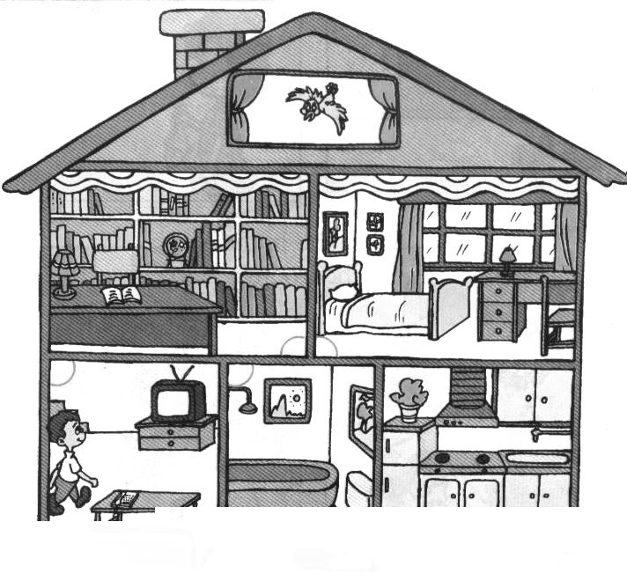



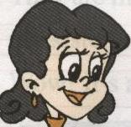

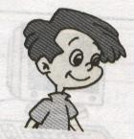

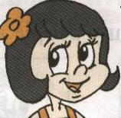

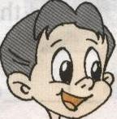

笔试部分 (40%)
- 填上所缺的字母，使单词完整，并与相应的图片连起来。

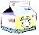
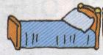
n __ __ se

b __ d
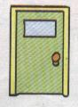
d __ __ r
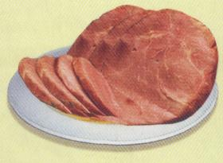
b __ __f
m __ lk

二．把相对应的问句与答句连起来。

Yes, they are.
What would you like?

Are they on the desk?
They’re under the desk.

Where are my books?
He’s a driver.

What’s your father?
I’d like some noodles.

She’s my teacher.
Who is she?

三．将单词进行分类，并把它们抄写在四写格上，
knife sister farmer doctor sofa
anut fork rice beef shelf

PEP 小学英语第三册期末试卷听力稿
Listen and choose. (10%)
  - qw 2.rai 3. FXS 4. 13 5. 345
6. 9871 7. NMOP 8. 6538 9. HGKA 10. 7458
- Listen and draw. (14%)
    - My father is a driver.
    - Answer the phone.
    - Close the door.
    - I’d like some noodles, beef and vegetable
    - –Where’s my mother? ---She’s in the living room.
    - Have a snack.
    - Sarah likes reading.
三．Listen and choose. (10%)
- I can use chopsticks.
- This is my study.
- I’d like some rice.
- My family has three members.
- My father is a doctor.
- Listen and match.( 12%)
⒈ I have a friend. He’s Mike. He’s thin. He likes hamburgers and juice.
⒉ This is my brother, Zhang Peng. He’s strong. He likes chicken and milk.
⒊ I’m Amy. I’m short. I’d like vegetables and coffee.
⒋ My name is Cheng Jie. I’m tall. I’d like noodles and water.
五．Listen and match. (14%)
- ---Where is my mother? ---She’s in the kitchen.
- ---Where is my father? ---He’s in the living room.
- My brother is in the bathroom.
- My sister is in the study.
- Where am I? I’m in my bedroom.
- This is my friend , John. He’s in my bedroom, too.
- Mr Black is watching TV with my father.

笔试部分比分：一、（10%） 二、（10%） 三、（20%）

