五年级（上）英语期末测试题
（满分100分，40分钟内完成）
题 号 | 一 | 二 | 三 | 四 | 五 | 总 分
得 分

得 分 |  | 一、书写检查。（30%）

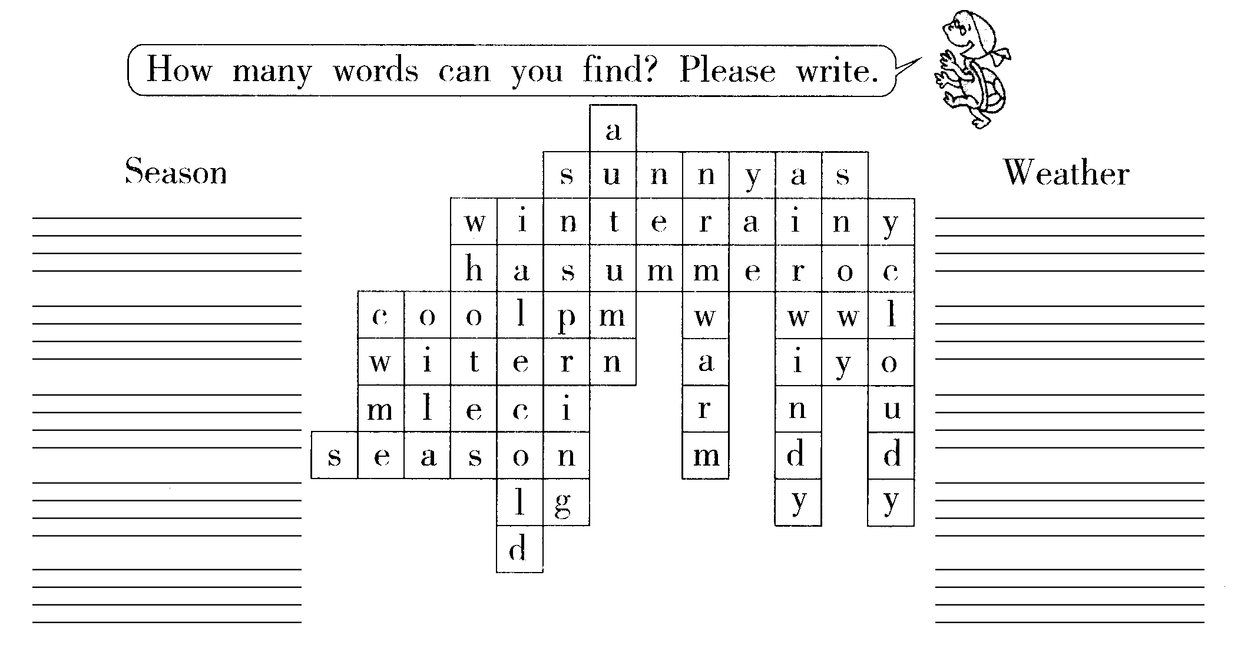
1、找出隐藏中的单词，按要求归类，并写在四线格中。（10分）

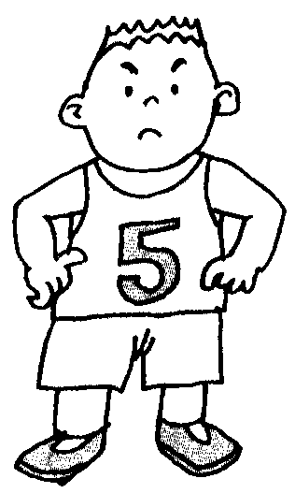
2、根据图示，将下列单词丢失的字母补充完整。（10分）
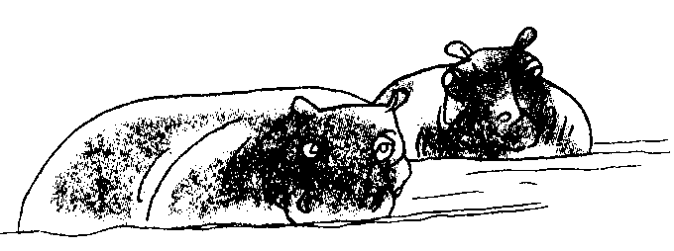
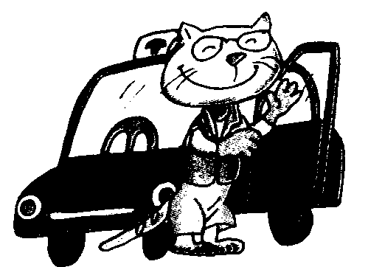
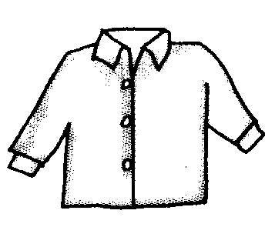
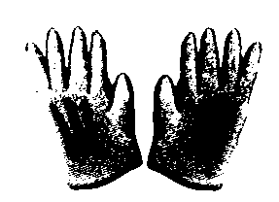

h___pp___ dr___v___r sh___ ___t gl___v___s str___ ___g
3、将下列单词重新排列成完整的一句话，写在四线格上，注意标点及大小写。（10分）
listen the report let’s to weather .

you like red do skirt this ?

like my look mother I .

ball are with playing a they .

I shall what wear ?

得 分 |  | 二、单词、词组辨认。（20%）
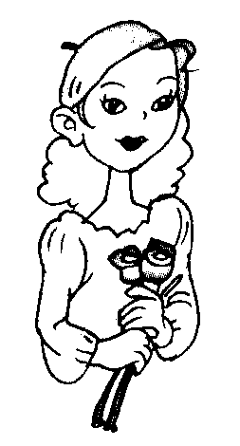
1、如图示，选择正确的单词，写在横线处。（10分）
She’s__________. （pretty friend girl）
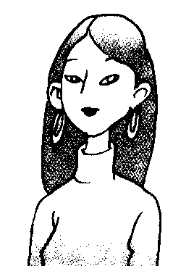
She’s__________. （old young fat）
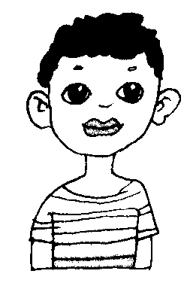
He’s my_____________.（teacher friend mother）
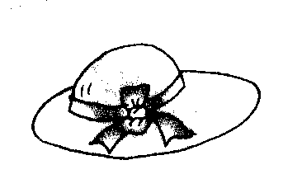
It’s_____________.（new young short）
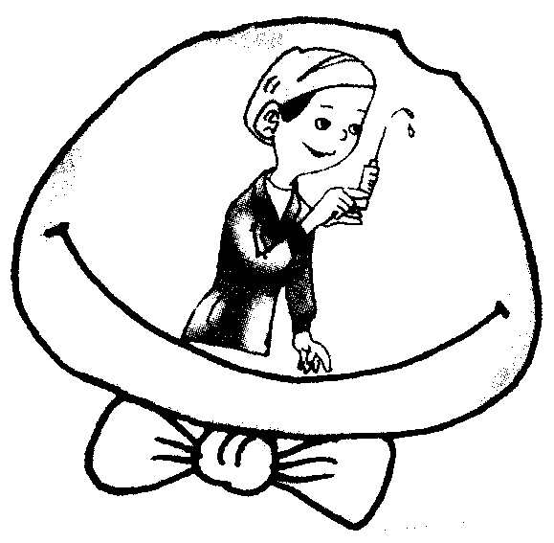
She’s a____________.（worker nurse engineer）

2、请看图片，选择恰当的短语将其序号填入图片下面的括号中。（10分）
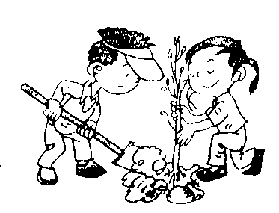
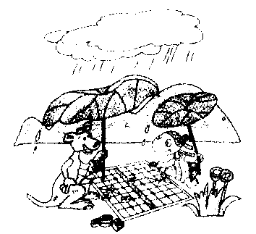
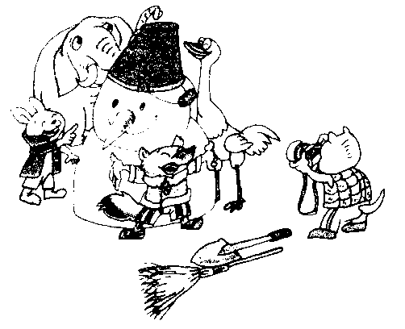
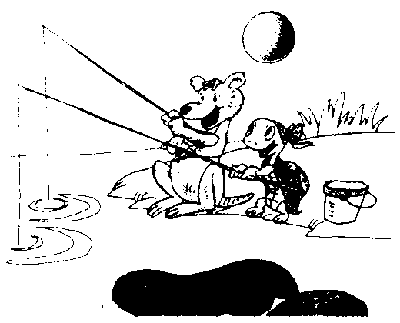
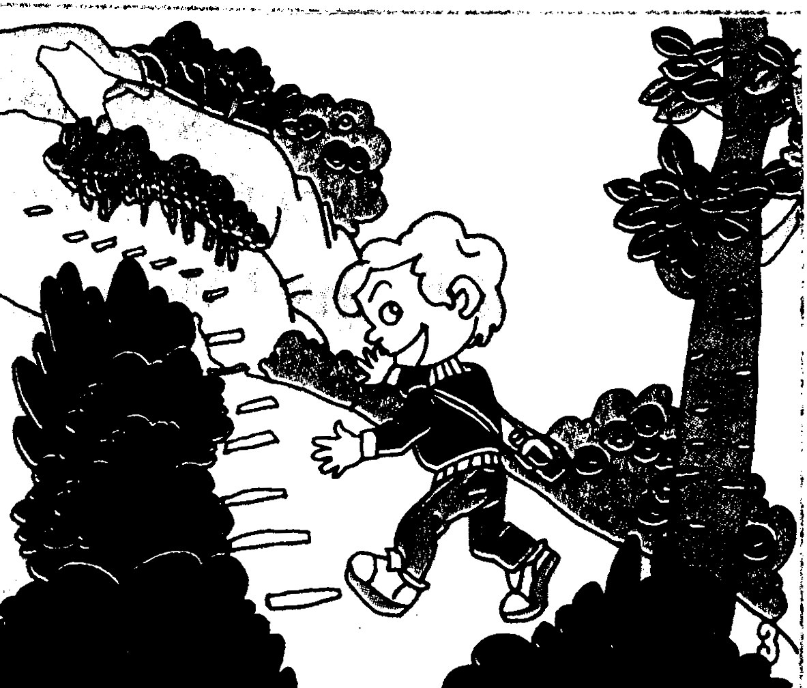

（ ） （ ） （ ） （ ） （ ）
(1) make a snowman. (2) play chess (5) go fishing
(3) phant trees (4) climb the mountain
得 分 |  | 三、将下列问句与对应答句连线。（10%）
1、Who are they? A、It’s snowy.
2、What’s he like? B、I want to wear my sweater.
3、What’s his hobby? C、He’s tall.
4、What do you want to wear? D、They are my parents.
5、What’s the weather like tiday? E、Collecting stamps.

得 分 |  | 四、能力检测。（15分）
1、将下列句子重新排序。（5分）
（1）Oh, good. I like it.
（2）Ok! Let me help you. Do you like this blue T-shirt?
（3）Dad, we have a party this evening. What shall I wear?
（4）No. It’s too big.
（5）How about this red one?
A：
B：
A：
B：
A：
2、阅读理解。（10分）
阅读，判断下列句子对（√），错（×）。
My name is LiFang. I have a new friend. Her name is Linda. She lives in New York. Linda is eleven years. She likes playing chess. My hobby is playing chess,too. She often goes to school by bus. Her mother is a doctor. She goes to work on foot. Her father is a teacher. He goes to work by car. Every evening Linda does her homework. Her mother watches TVand her father reads newspapers. Linda will come to China soon. She is in England now. I’m excited.
（ ）1、Lindia is a Chinese girl.
（ ）2、Linda’s father is a doctor.
（ ）3、Linda’s father reads newspapers in the evening.
（ ）4、Linda’s mother goes to work by bus.
（ ）5、LiFang likes playing chess.
得 分 |  | 五、根据本册书学过的知识填空，并把他（她）画出来。（15%）
（1）He has______hair, big____, _____ears, a_____nose and a ____mouth, ______he like?
（2）He____long____, ____eyes, small ______, a big _____and a small_____.
What’s she______?

六、请先圈出对话中的错误，并改正过来。（10%）
A、How many people is there in your family? 1. __________________________
B、Five.
A、Where are they? 2. __________________________
B、They’re my grandfother, grandmother, mother and me. 3.___________________
A、What do they do?
B、My grandfather is a work. 4.___________________________
My grandmother is a English teacher. 5.__________________________
My father and my mother are all doctors.
A、We are happy.

2006——2007学年度小学五年级（上）英语期末测试题答案及评分标准
一、1、winter summer autumn spring sunny cloudy snowy windy warm
cold cool (每单词一分，共10分)
2、hippo driver shirt gloves strong (每空一分，共10分)
3、Let’s listen to the weather report. Do you like this red skirt? I look like my mother.
They are playing with a ball. What shall we wear? (每句子二分标点或字母大小写错误扣一分10分)
二、1、pretty young friend new nurse (每题二分，共10分)
2、4 3 2 1 5 (每题二分，共10分)
三、1——D 2——C 3——E 4——B 5——A (每题二分，共10分)
四、A:Dad,we have a party this evening.What shall I wear?

B:Ok!Let me help you.Do you like this blue T-shirt? A:No.It’s too big.
B:How about this red one? A:Oh,good.I like it. (共5分)
2、× × √ × √ (每题二分，共10分)
五、根据学生画图来判断其填空的正确性。一空一分，画图各一分，共15分
六、1、is——are 2、Where——Who 3、grandfother——grandfather
4、work——worker 5、a——an (先圈出，再改正，每题2分，共10分)

