五年级英语第二学期期中自查题
Class:__________ Name:____________ Mark:___________
听力部分
一、根据录音内容，将下面每组中你认为符合录音内容的图片下面的字母圈住。
1、 2、 3.

4. 5、

二、根据录音内容，辨别相应的图片内容是否相符，相符的在图片下面的括号里打“√”，不符的打“×”。（10分）
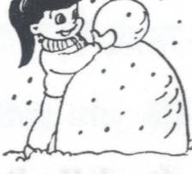
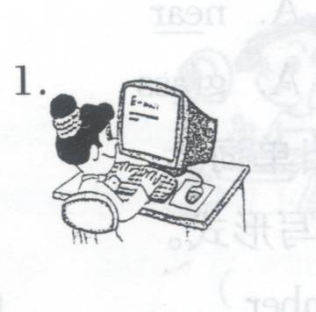
1、 2、 3、 4. 5. . 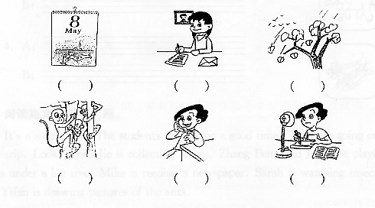 （ ） （ ） （ ）三、根据录音内容填空，在句子的空格中填上单词，将句子补充完整（每格一词。）(10分)
September
10th

1.When is your _______________? It’s in ___________________.
2.What’s the _________________? It’s ________________ 2nd.
3._________do you like summer? Because I can __________in the lake.
4.When do you _____________up? At _________________.
5.Which ________________ do you like best? I like_________________ best.
四、根据你在录音中听到的问题，将下面每组答句中最合适的答案选出来，并将其字母编号填到题前的括号里。（10分）
( ) 1.A. His birthday is in August. B. Her birthday is in May. C. My birthday is in April.
( ) 2.A. She likes fall best. B. Because it’s cool in fall. C. I like winter best.
( ) 3.A. No, I can’t. B. Yes, I do. C. Yes, I do.
( ) 4.A. It’s March 8th. B. It’s Spetember 10th C. It’s October.
( ) 5.A. Yes, I am. B. Yes, I do. C. Yes, it is.
五、听一段对话，并根据录音内容判断下列句子的正误，对的打“√”，错的打“×”。（10分）
( ) 1. There are six people in Ben’s family.
( ) 2. Ben’s birthday is in spring.
( ) 3. Lucy likes dancing.
( ) 4. Ben and his friends eat birthday cakes on Ben’s birthday.
( ) 5. Ben likes winter best.
笔试部分
六、短文填空：（根据短文意思，在所给的词中选择合适的填在相应的空格中，使短文完整，每格一词。）（10分）
(June 1st, school, cool, October 1st , work, happy , kites, spring, parents, take, climb, favourite)
Today is ____________. It’s National Day. The ____________ is windy and ____________. I don’t go to ______________ and my ______________ don’t go to ______________.We ___________ mountains, fly ____________ and ____________ photos(照相).We’re very tired, but we are very ________________.
七、根据所给图片书面回答所提出的问题。（答案需完整）（10分）
1.What can you do in spring?
_______________________________________________
2.When is your birthday?
_______________________________________________
3.Is your father’s birthday on National Day?
__________________________________________________
4.What’s your favourite season?
__________________________________________________
5.What’s the date today?
__________________________________________________
八、请用几句英语，写出你的城市夏天的天气及你的活动。（10分）
There are _____________ seasons in my city. They’re _____________, summer, ________ and ______________. I like summer ____________. The weather is_________and________. I usually __________ in the lake. I often __________ mountains, too. I like to __________ice-cream in summer.
九、补全对话：根据上下文的意思在下面对话的空格中填上适当的词，将对话补充完整。（10分）
A: ____________ your birthday ___________ March,Helen?
B: No, it’s not.
A:_____________ is your ______________?
B: It’s in April.
A:______________ has a _______________ in March?
B: My grandma.
A: _______________ the _______________?
B: It’s March 13th . Let’s make a _______________ card for her.
A: _____________ idea.
十、阅读短文,判断下列句子是否符合短文意思,如符合请打√,否则打×.(10分)
Today is February 3rd. The weather is windy and cold. I get many cards today. They’re birthday cards. They’re from my friends. Can you guess why? I wear my new red coat and blue jeans. They’re very pretty. My mother take me to the zoo.I can see many animals. I’m very happy today.
( ) 1.My birthday is February 3rd.
( ) 2.It’s windy and snowy today.
( ) 3.I can see many trees at the zoo.
( ) 4.I have a new coat. It’s blue.
( ) 5.I have many birthday cards.
2007—2008学年度
第二学期五年级英语期中自查题听力材料及参考答案
一、根据录音内容，将下面每组中你认为符合录音内容的图片下面的字母圈住。
1.plant trees 2.eat dinner 3.fly kites 4. December 12th 5.play sports
( A B B A B )
二、根据录音内容，辨别相应的图片内容是否相符，相符的在图片下面的括号里打“√”，不符的打“×”。（10分）
1.What’s your favourite season? I like spring.
2. What’s the date today? It’s September 10th. It’s Teachers’Day.
3.When is your mother’s birthday? It’s March 8th .
4.What can you do in winter? I can skate.
5.What do you do on the weekend? I usually play with the computer.
(× √ × × √ )
三、根据录音内容填空，在句子的空格中填上单词，将句子补充完整（每格一词。）
1.When is your birthday? It’s in October.
2.What’s the date? It’s April 2nd .
3.Why do you like summer? Because I can swim in the lake.
4.When do you get up? At 7:10.
5.Which season do you like best? I like winter best.
四、根据你在录音中听到的问题，将下面每组答句中最合适的答案选出来，并将其字母编号填到题前的括号里。（10分）
1.When is your mother’s birthday?
2.Which season do you like best?
3.Can you make a snowman in spring?
4.When is Teachers’Day?
5.Is your birthday in March?
( B C A B C )
五、听一段对话，并根据录音内容判断下列句子的正误，对的打“√”，错的打“×”。（10分）
Hi! I’m Ben. My favourite season is winter. The weather is usually very cold and windy in winter. But I like it. Beacause my birthday is in January. It’s in winter,too. I can play with snow. We usually have a party on my birthday. Many friends come to my house. We eat birthday cake and sing birthday songs together. I like dancing,too. My friend Lucy dances well. I often dance with her. On that day, my father , my mother ,my grandpa, my grandma, my uncle and my aunt often give me many birthday gifts. I have a lot of fun on my birthday.
( × ) 1. There are six people in Ben’s family.
( × ) 2. Ben’s birthday is in spring.
( × ) 3. Lucy likes dancing.
( √ ) 4. Ben and his friends eat birthday cake on Ben’s birthday.
( √ ) 5. Ben likes winter best.

