2007~2008学年度第二学期
学校： 班级： 姓名： 座号：
==============================密==================封==================线===================================
PEP五年级英语期中自查题
听力部分
一、听录音，选出每组中你所听到的内容。（10分）
( ) 1. A. class B. climb C. clean
( ) 2. A. winter B. window C. windy
( ) 3. A.June B. Jan. C. July
( ) 4. A. 4th B. 8 th C. 5th
( ) 5. A. At 12:40. B. At 11:50 C. At 7:15
( ) 6. A. May 7th B. Mar. 7th C. Aug. 6th
( ) 7. A. eat dinner B. eat lunch C. eat breakfast
( ) 8. A. do morning exercises B. do the dishes C. do my homework
( ) 9. A. National Day is Oct. 1st. B. Christmas Day is Dec. 25th.
C. Teachers’ Day is Sept. 10th.
( ) 10. A. I like spring best. B. I like summer best. C. I love sports .
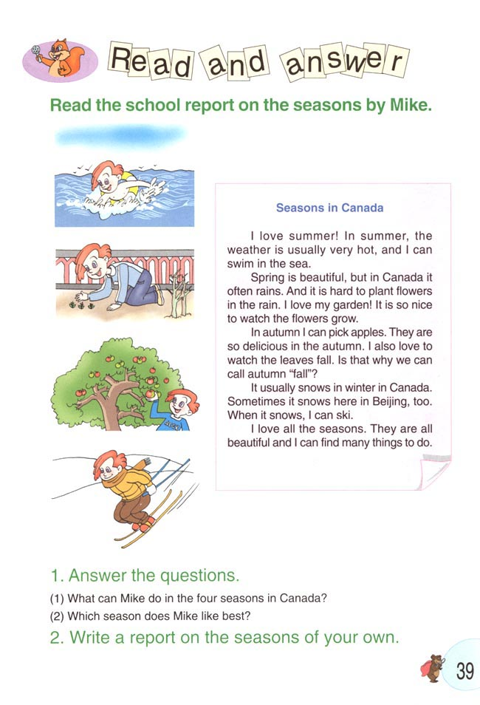
二、听录音，判断对错，对的打√，错的打×。（10分）
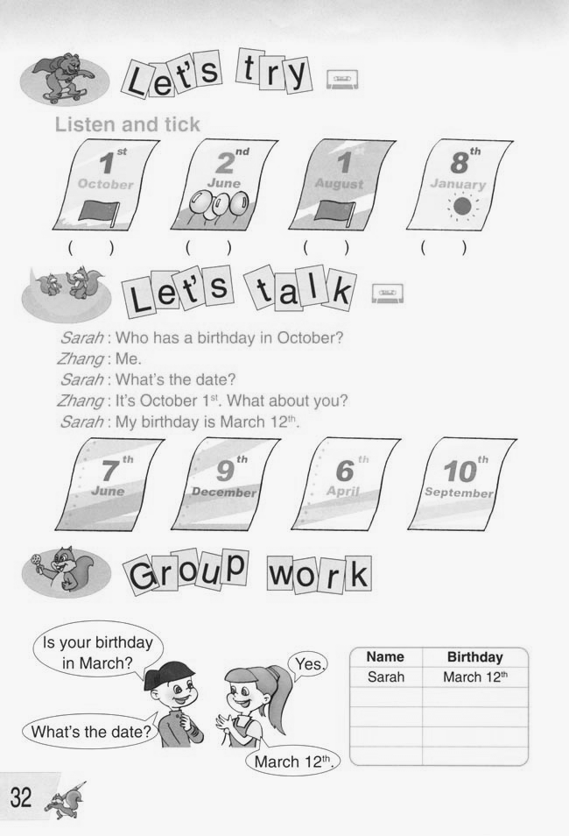
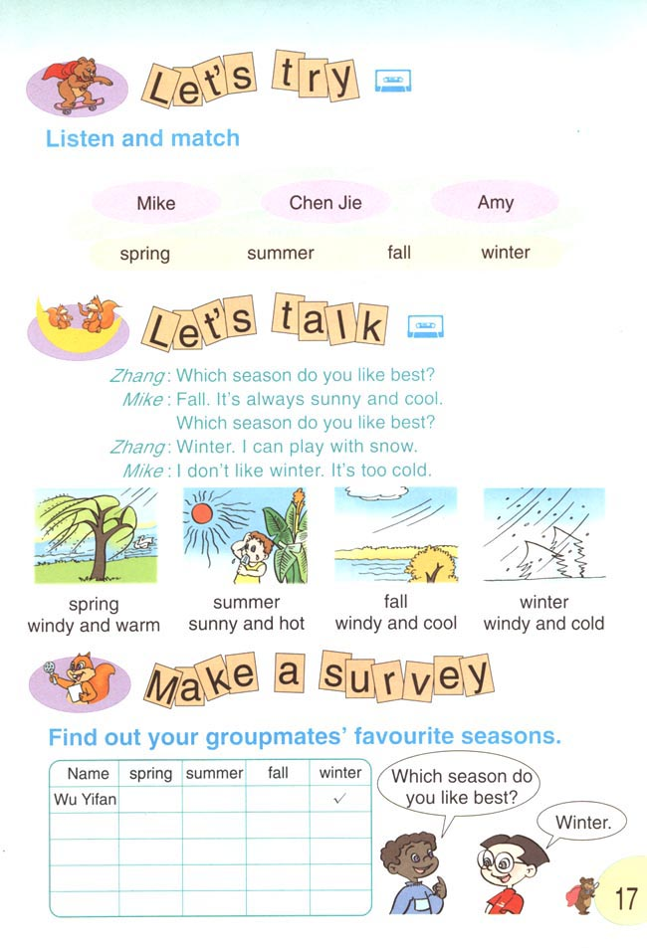
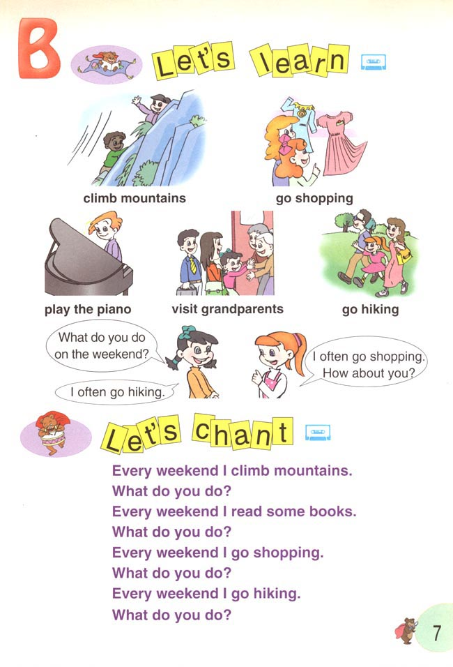
1. 2. 3. 4. 5.

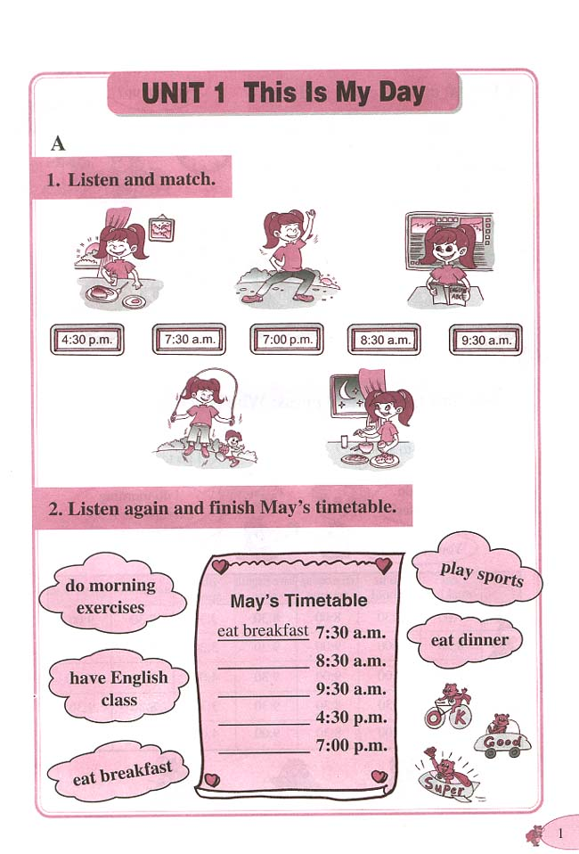
( ) ( ) ( ) ( ) ( )
7:00
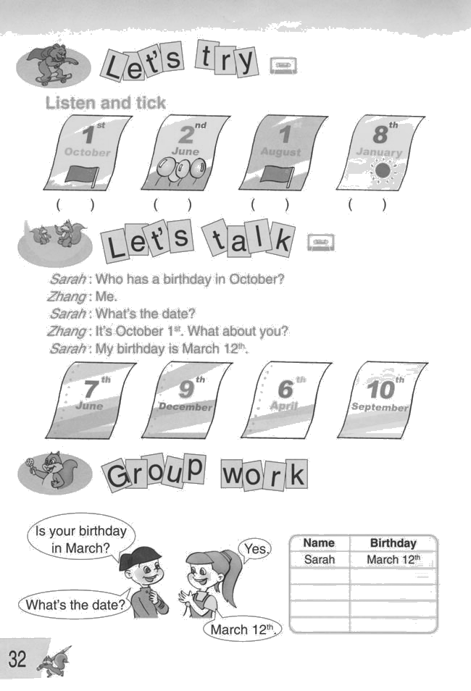
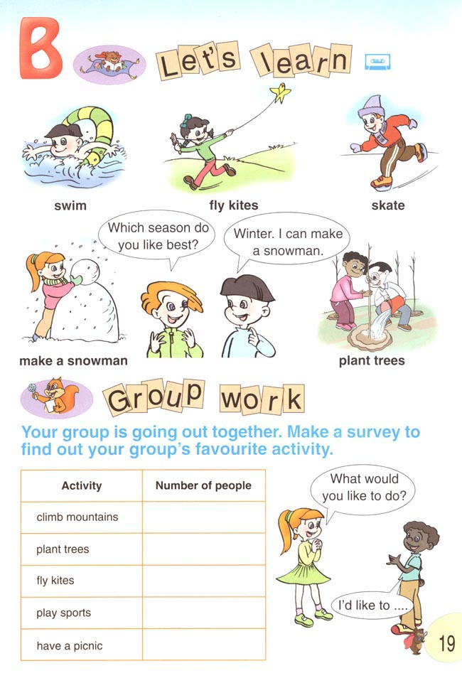
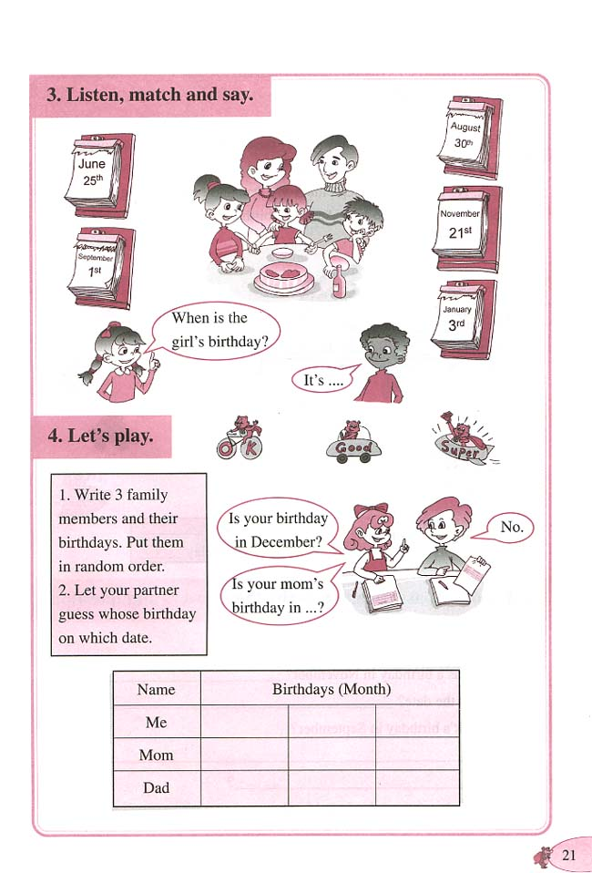

6. 7. 8. 9. 10.

( ) ( ) ( ) ( ) ( )

三、听问题，选答句。（10分）
( ) 1. A. I like spring. B. I like English. C. I like tomatoes.
( ) 2. A. It’s hot. B. It’s winter. C. It’s cold.
( ) 3. A. Because I can plant trees. C. Because it’s sunny and hot.
B. Because I can make a snowman.
( ) 4. A. It’s Aug. 1st. B. It’s July 1st. C. It’s June 1st.
( ) 5. A. Usually I play sports at 5:00pm.
B. I often play football at 4:30pm.
C. I have P.E. class at 3:15pm.
四、听录音，在横线上填写缺少的单词，每空一词。（10分）
1. I at 6:30.
2. My favourite is .
3. Lily’s birthday is .
4. A: do you like summer ? B: Because I can .
5. A: is Amy’s birthday ? B: birthday is in Jan..
五、听一段短文，判断句子的对错，对的打√，错的打×。（10分）
( ) 1. Liu Ying’s birthday is in February.
( ) 2. Liu Ming’s birthday is in March.
( ) 3. They have a birthday party every year.
( ) 4. They are twins(双胞胎).
( ) 5. Liu Ying likes summer. But Liu Ming likes fall.

笔试部分
六、补全对话：根据上下文的意思，把句子的数字编号写在横线上。（10分）
- Sometimes I clean my room. ②What can you do ? ③What’s the date ?
④What do you do on the weekend? ⑤What time is it ?
⑥What about you ? ⑦Which season do you like best ?
A: ?
B: I often go shopping with my parents. .
A: Oh, you are helpful at home. ?
B: Summer. Because I can swim in the lake. ?
A: Me too. Because my birthday is in summer.
B: ?
A: It’s June the first. It’s Children’s Day ,too.
八、选词填空，使短文完整，每空一词。（10分）
it’s, happy, sing, weekend, don’t, birthday, friends, swim, July, get, home, eat
Hello, I am Sally.My birthday is 20th. I usually up early. I am very . My parents and give me many presents(礼物). I go to school on my birthday because
summer holiday. Usually I have a birthday party at . We have a big dinner and a birthday cake. We and dance at the party. I have a good time on my .

九、根据答句写出问题。（10分）
1. A: ?
B: I eat dinner at 7:00 in the evening.
2. A: ?
B: My favourite season is spring.
3. A: ?
B: I can make a snowman in winter.
4. A: ?
B: Yes, my birthday is in March.
5. A: ?
B: Chen Jie has a birthday in October.
十、根据提示写几句话，说说你的生日在哪个季节，这个季节的天气情况如何，你是否喜欢这个季节，在这个季节里你可以做些什么事情，你的心情怎样，等等。（不少于五句话）（10分）

