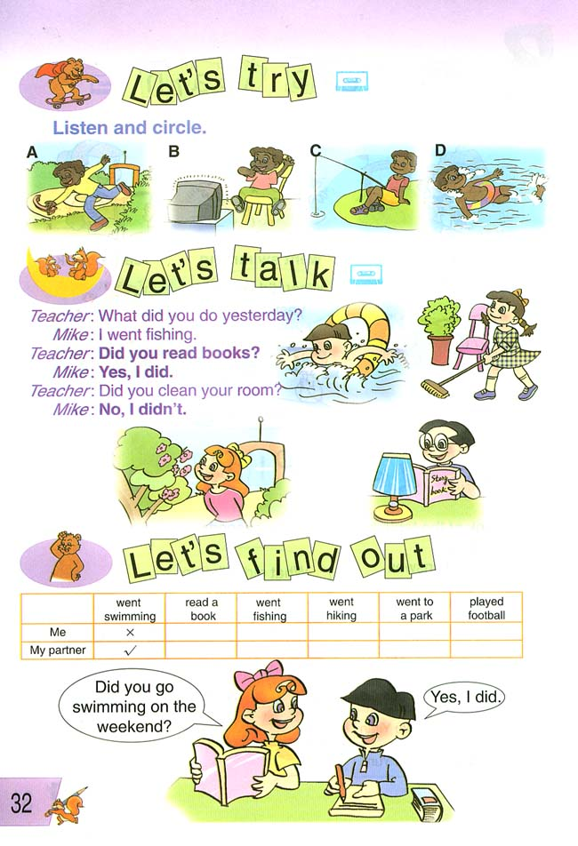
阳光三小五年级第二学期英语期中试卷Unit 1- 3
班级 姓名 分数
听力部分
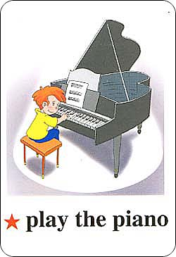
- 根据录音内容，将下面每题中你认为符合的选项的字母编号圈住。（10分）
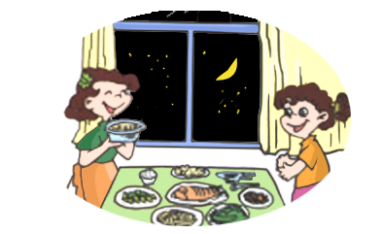

1、 2、

A B A B
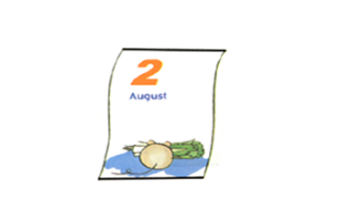
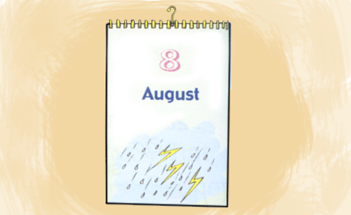
3、 4、 5、
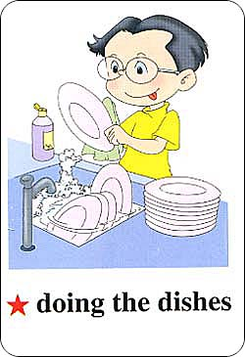
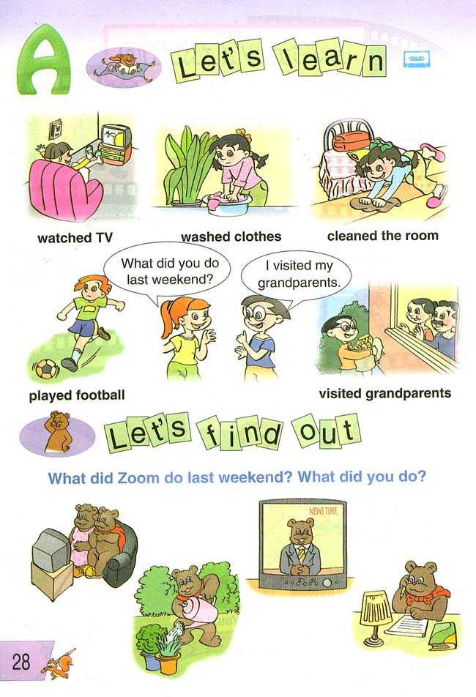

A B A B A B
6、 A fine B five C fifth
7、 A December B November C September
8、 A brother B weather C mother
9、 A Wednesday B Thursday C Tuesday
10、 A windy B cloudy C sunny

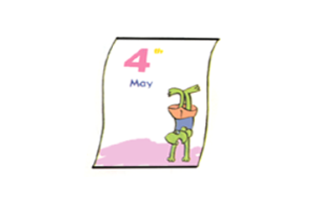

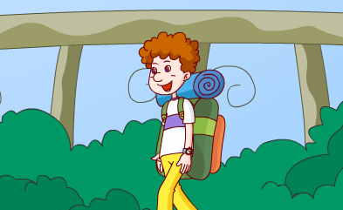
二、根据录音内容判断下列图片或句子是否相符，用√或×表示（10分）

1、（ ） 2、（ ） 3、（ ） 4、（ ） 5（ ）
6（ ） I usually read books in the morning.
7 ( ) Today is June 3rd .
8 ( ) Mike is active.
9 ( ) My uncle’s birthday isn’t in May.
10( ) Spring is Sarah’s favourite season.
三、根据录音内容，填写句子中所缺的单词，使句子完整。（10分）
1 _______ do you do on the weekend? I _______ my clothes.
2 ______ is Mike’s birthday? It’s in .
3 Do you ______ your grandparents on _________? Yes, I do.
4 Zhang Peng ________ plays the _________.
5 I get up at .
四、根据你在录音中听到的问题，把下面每题中最合适的答句选出来，将其编号写在题前括号里。（10分）
（ ）1、A、Yes, I do. B、 Yes, he is. C、Yes, I am.
（ ）2、A、She can sing. B、 She is tall. C、No, she isn’t.
（ ）3、A、I often go hiking. B、My birthday is in Sept..
C、October is her birthday.
（ ）4、A、At 10:00. B、At 7:30 . C、At 11:40.
（ ）5、A、It’s Saturday. B、It’s April 18th . C、It’s 8:oo.
五、听录音，根据录音内容，判断下列的句子是否与录音内容相符，相符的打“√ ”，不相符的打“ ×”。（10分）
( ) 1 Mike goes to school at 7:00.
( ) 2 Mike’s favourite class is English.
( ) 3 Mike likes playing ping-pong.
( ) 4 Mike has four or five classes every day.
( ) 5 Mike has painting class on the weekend.
笔试部分
六、根据答句写问句。（10分）
1 __________________________________？
Let me see. I go to bed at ten.
2 __________________________________？
Winter is my favourite season.
3 ___________________________________?
Yes, Uncle Bill’s birthday is in August.
4 ___________________________________?
No, I often go hiking on Sunday.
5 ____________________________________?
Oh, I see. Today is May 5th.

七、根据上下文的意思，补全下列对话。（10分）
(1) It is five. (2) It is sunny. (3) We play football. (4) We play computer games. (5) It is Sunday. (6) Yes, I do. (7) No, I don’t play football. (8) I am very happy.

A: What day is it today?
B: ________________________________________.
A: What is the weather like ?
B: ________________________________________.
A: What do you do on Sunday?
B: I go to a park with my classmates. _____________________ there.
A: Do you play games?
B: _________________________. _________________________.

八、选词填空。（10分）
（ computer, morning, breakfast, friend, get, school, music, lunch, afternoon, home, student, dinner ）
Hi, I’m Lisa. I’m a . I usually up at 6:50a.m.. Then I eat . I go to school with my best , Amy. After school we go at 4:30p.m.. We do our homework together. We have four classes in the and two classes in the . I like class, but Amy likes class. Because I often play computer. I have at 6:20p.m.. I watch TV at 7:50. Then I go to bed.

九、根据要求写短文：根据所给图片写出周末你的活动情况，不少于5句话。
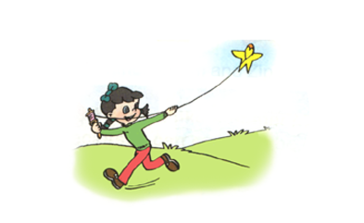
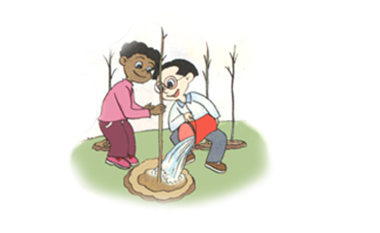


___________________________________________________________

十、阅读理解，选择正确的答案，把编号写在前面的括号里。
It is a sunny day this Sunday. I usually go shopping with my mother on Sunday. Sometimes I climb mountains. That’s fun. But not this Sunday. Because the weather report says it’s going to rain next Sunday. I can’t climb mountains in the rain. I can’t go shopping either. So I want to read books at home.

( ) 1 What is the weather like this Sunday?
A It is Sunday. B It is fine. C It is rainy.
( ) 2 What do you do on Sunday?
A I climb hills.
B I go hiking.
C I read books.
( ) 3 Can you climb mountains this Sunday?
A Yes, I can. B No, I can’t. C No, I’m not.
( ) 4 Do you go shopping on Sunday?
A Yes, I am. B Yes, I do. C No, I’m not.
( ) 5 What do you want to do next Sunday?
A I want to read books. B I want to watch TV. C I want to go shopping.
听力内容：
一、根据录音内容，将下面每题中你认为符合的选项的字母编号圈住。
- Do you play the violin on the weekend? Yes, I do.
- When do you eat dinner? At 7:10p.m..
- When is your birthday? It’s August 8th.
- What do you do on Saturday? I read books.
- Do you usually clean the room on Mondays? No. I often wash my clothes.
- fifth 7、 November 8、brother 9、Thursday 10、windy
- 根据录音内容判断下列图片或句子是否相符，用√或×表示
- What do you do on Sunday? I go hiking.
- Do you often play sports after school? Yes, I do.
- Summer is my favourite season. Because I usually swim.
- Which season do you like best? I like fall.
- Is your birthday in June? Yes. June 4th.
- Do you play the piano in the morning? No, I read books.
- What’s the date? June 1st.
- Is Mike quiet? No, he’s active.
- When is your uncle’s birthday? It’s in May.
- What’s your favourite season, Amy? I like spring. What about you, Sarah? Me too.
- 根据录音内容，填写句子中所缺的单词，使句子完整。
1、 What do you do on the weekend? I wash my clothes.
2、 When is Mike’s birthday? It’s in July .
3、 Do you visit your grandparents on Tuesday? Yes, I do.
4、 Zhang Peng often plays the piano.
5、 I usually get up at 6:30 .
- 根据你在录音中听到的问题，把下面每题中最合适的答句选出来，将其编号写在题前括号里。
- Do you make a snowman in winter?
- What can Chen Jie do?
- When is your mother’s birthday?
- When do you eat lunch?
- What time is it?
- 听录音，根据录音内容，判断下列的句子是否与录音内容相符，相符的打“√ ”，不相符的打“ ×”。
Hi, I’m Mike. I come to school at 7:30. I have five or six classes every day. I like math. After school I do homework. Sometimes I play ping-pong. On the weekend I usually play football and go to my painting class. That’s fun!

