小学五年级英语竞赛试题
笔试部分(共六大题,计60分)
I. 单词和短语 (Words and phrases) (共10小题,计10分)
A)根据图片写单词,首字母已给出.(答案写在答题纸上)
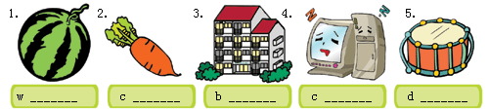
B)看图,选出每个图片所表示的短语.(答案涂在答题纸上)
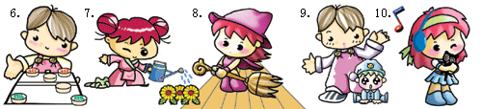
A. sweep the floor B. water the flowers C. look after a baby
D. play Chinese chess E. listen to music
II. 句子(Sentences) (共10小题,计10分)
A)请用括号中所给词的适当形式完成下列句子.(答案写在答题纸上)
11. There are three _______ (tomato) on the plate.
12. She can _______ (drive) a car.
13. Please _______ (not open) the door.
14. There _______ (be) some milk in the glass.
15. He is _______ (dance) now.
B)单项选择.(答案涂在答题纸上)
16. _______ is the first day of a week in America.
A. Monday B. Sunday C. Saturday D. Tuesday
17. My birthday is _______ 13th of August.
A. in B. on C. at D. of
18. These are _______ desks.
A. Ray or Lucy's B. Ray's and Lucy
C. Ray's and Lucy's D. Ray and Lucy
19. She often goes to _______ at nine, but now she is _______ .
A. sleeps, sleeping B. sleep, sleeping
C. sleep, sleep D. sleeping, sleeping
20.—How does your mother go to work?
— _______ .
A. By the bike B. On feet C. On foot D. Take bus
III. 情景会话(Dialogues) (共10小题,计10分)
A)根据所给情景,完成下列各题.(答案写或涂在答题纸上)
21. 当你有事需要打断别人的交谈时,常说的一句话是什么?
_____________________________________
22. 当你的好朋友考试没考好时,你应该怎样鼓励他(她)?
_____________________________________
23.
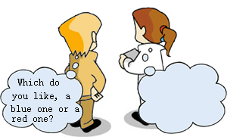
A. Yes, a blue one.
B. Yes, a red one.
C. A blue one.
D. No, a red one.
24.
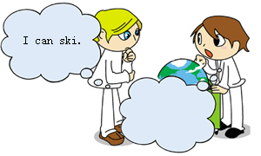
A. What can you do?
B. What are you doing?
C. What does she do?
D. What do you do?
25.
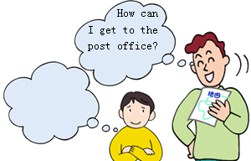
A. That's all right.
B. Sorry, I don't know.
C. I think so.
D. Not at all.
B)看图,从所给的选项中选择正确句子补全对话.(答案涂在答题纸上)

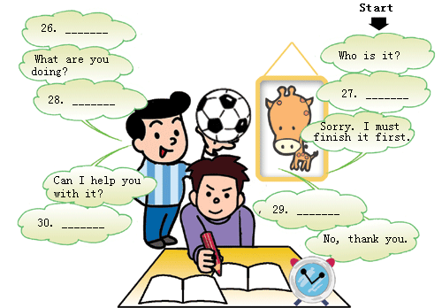
A. It's easy, “carry[`kri]”. Anything else?
B. It's Mike.
C. I'm Mike.
D. Yes, I don't know how to read the word "carry".
E. I'm learning English.
F. Let's go out and play football.
IV. 阅读理解 (Reading comprehension) (共10小题,计10分)
(A)
看图,根据图意判断下列句子正(T)误(F).(答案涂在答题纸上)
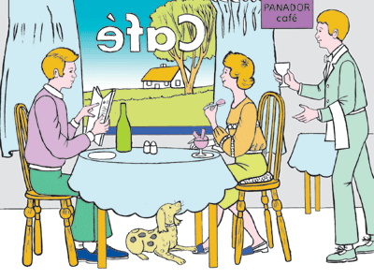
31. The people are in a PANADOR café.
32. The woman is eating bread.
33. There are two bottles on the table.
34. There is a dog under the table.
35. The waiter is holding a cup.
(B)
根据短文内容,回答下列问题.(答案写在答题纸上)
It is Julie's birthday. Uncle says he will take Julie and her cousins to see a film. They drive a car to the cinema. The children are very excited.
When they go to the cinema, they see a long queue(长列) at the ticket booth(售票厅). Uncle joins the queue to get the tickets for the film. He tells Julie and her cousins to go and buy some things to eat. They go to a stall(货摊) nearby. Julie buys a packet of popcorn(爆米花). Her cousins buy a bar of chocolate and some peanuts(坚果).
Soon, Uncle has the tickets and they go into the cinema. They find their seats and sit down. After a while, the lights go down and the film begins.
36. Whom does Uncle take to the cinema?
37. How do they all get to the cinema?
38. How do you know that many people want to watch the film?
39. Do the children buy some things to eat before or after the film?
40. What does Julie buy?
V. 智力测试(Intelligence test) (共5小题,计10分)
按要求完成下列各题.(答案写或涂在答题纸上)
41. What does “SARS” stand for(代表) in Chinese?
42. Lily is Mr. Black's girl Friday. She gives him a lot of help. What's the meaning of “girl Friday”?
A.女仆人 B.得力的女助手 C.女儿 D.女上司
43. Circle(圈出) at least (至少) five months of the year in this word box.
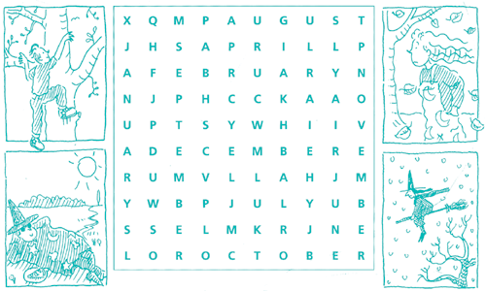
44. Which is the national flag(国旗) of New Zealand(新西兰)?

45. Look at these two pictures carefully(仔细地). There are seven differences between them. Please circle at least(至少) five differences.
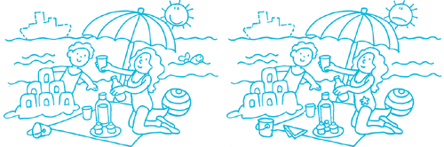
VI. 小作文(Composition) (计10分)
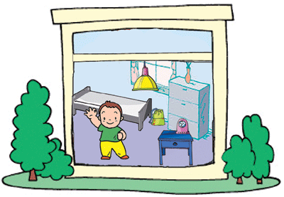
以"My Bedroom"为题,写一篇短文.(所给图片供参考)
要求:1. 条理清楚,意思连贯,语句通顺,标点正确,书写清晰、规范;
2. 不得少于60个单词;
3. 将作文写在答题纸上.
2004年全国小学生英语竞赛(NECPS)

笔试部分
I. 单词和短语(共10小题,每小题1分,计10分)
A)1. watermelon 2. carrot 3. building 4. computer 5. drum
B)6. D 7. B 8. A 9. C 10. E
II. 句子(共10小题,每小题1分,计10分)
A)11. tomatoes 12. drive 13. don't open 14. is 15. dancing
B)16. B 17. B 18. C 19. B 20. C
III. 情景会话 (共10小题,每小题1分,计10分)
A)21. Excuse me!
22. Don't lose heart.或Come on!(答案不唯一)
23. C 24. A 25. B
B)26. B 27. E 28. F 29. D 30. A
IV. 阅读理解 (共10小题,每小题1分,计10分)
A)31. T 32. F 33. F 34. T 35. F
B)36. Uncle takes Julie and her cousins to the cinema.
37. They get to the cinema by car.
38. There is a long queue of people at the ticket booth.
39. The children buy some things to eat before the film.
40. Julie buys a packet of popcorn.
V. 智力测试(共5小题,每小题2分,计10分)
41. 非典型性肺炎
42. B
43.
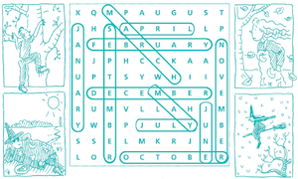

44. B
45.

VI. 小作文(计10分)
参考范文
My Bedroom
Look at this room. It's my bedroom. There is a map of China and a photo of me on the wall.
My bed is not very big but it is very nice. There is a lovely toy puppy on it. Every night I
sleep with it. Beside the bed, there is a desk. An alarm clock, a table lamp and some books
are on it.
I like my bedroom very much. How about your bedroom?(75 wrods)

