全国小学生英语竞赛(NECPS)五年级组竞赛样题
(时间:60分钟 总分:100分)
听力部分(共四大题,计40分)
I. 听辨单词(Words) (共10小题,计10分)
A) 听音,从A, B, C, D四个选项中选出你所听到的单词。每个单词只读一遍。(答案涂在答题纸上)
1. A. night B. light C. right D. fight
2. A. cut B. but C. cup D. put
3. A. cow B. now C. brown D. law
4. A. near B. beer C. here D. dear
5. A. seat B. meat C. feet D. neat
B) 听音,从A, B, C, D四个选项中选出你所听到的单词的图片。每个单词只读一遍。(答案涂在答题纸上)
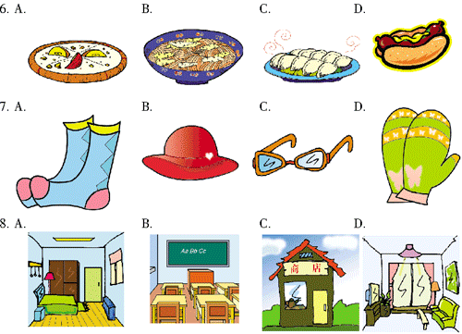
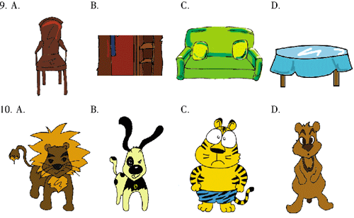
II. 句子理解(Sentences) (共10小题,计10分)
A) 听音,根据你所听到的句子,选出与其相对应的问句或答句。每个句子只读一遍。(答案涂在答题纸上)
11. A. I’m fine. B. I’m Susan.
C. I’m 11. D. I’m tall.
12. A. No, I’m not. B. No, I can’t.
C. Yes, I do. D. Yes, I am.
13. A. What fruit do you like? B. How about an apple?
C. Whose apple is it? D. Which one do you like?
14. A. Because you are lazy. B. Because you run fast.
C. Because I come early. D. Because I get up late.
15. A. Could I borrow your books?
B. Could you help me?
C. Could you lend me your eraser?
D. Could I learn from you?
B) 听音,根据你所听到的句子的意思,判断下列图片正(T)误(F)。每个句子只读一遍。(答案涂在答题纸上)
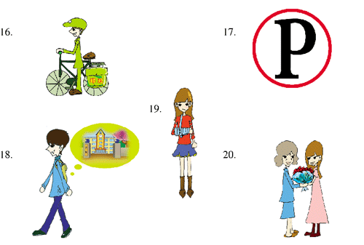
III. 对话理解(Dialogues) (共10小题,计10分)
A) 听音,根据你所听到的对话内容,选出正确的答案。每组对话读两遍。(答案涂在答题纸上)
21. What’s Jim’s telephone number?
A. 3941588. B. 3941578.
C. 3614578. D. 3614588.
22. Where does the dialogue take place (发生)?
A. In a toy store. B. In a restaurant.
C. In a bookshop. D. In a classroom.
23. What’s the man’s job?
A. He’s a doctor. B. He’s a worker.
C. He’s a student. D. He’s a teacher.
24. What does Tom want to drink?
A. A cup of tea. B. A glass of milk.
C. Neither A nor B. D. Both A and B.
25. What does the woman do on Sundays?
A. She usually goes out to play basketball.
B. She usually goes out to buy clothes.
C. She usually stays at home and watches TV.
D. She usually stays at home and reads books.
B) 听对话,判断下列句子与你所听到的对话内容是(Y)否(N)相符。每组对话读两遍。(答案涂在答题纸上)
26. Joan is ill.
27. The film begins at 6:45.
28. The man’s cup is blue.
29. The girl and Kate live in the same room.
30. The girl beside the house is the woman’s sister.
IV. 短文理解(Passages) (共10小题,计10分)
A) 听短文,按英文字母(A, B, C, D, E)的顺序为下列图片排序。短文读两遍。(答案写在答题纸上)
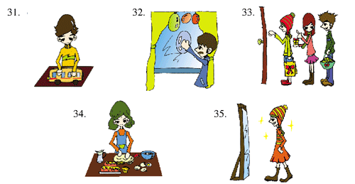
B) 听短文,根据所听内容补全短文(每空只填一词,注意单词首字母的大小写)。短文读两遍。(答案写在答题纸上)
36. . is coming. Where can you find it? Yes, it’s in the river. 37. are swimming happily. It’s in the forests. Leaves are 38. out. It’s on the earth. Grass 39. green and children put on their thin and 40. clothes.
笔试部分(共六大题,计60分)
I. 单词(Words) (共5小题,计5分)
填单词,补全句子,并使之能填在右面方格中(部分单词的首字母已给出)。(答案写在答题纸上)
1. Can you tell me ________ time?
2. This dress is Ann’s. It’s ________.
3. People ________ when they are happy.
4. They ________ some kites yesterday.
5. Jane is ________, so she doesn’t go to school.
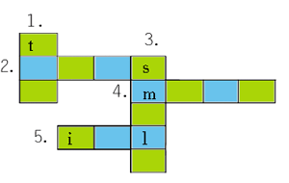
II. 句子(Sentences) (共10小题,计10分)
A) 用括号中所给词的适当形式填空,完成下列各句。(答案写在答题纸上)
6. It’s ________(sun) today.
7. She is good at ________(dance).
8. He often ________(write) letters to his parents.
9. May I ________(have) a new storybook, please?
10. Tree Planting Day is in the ________(three) month of a year.
B) 从A, B, C, D四个选项中选出最恰当的一项完成句子。(答案涂在答题纸上)
11. ________ coat is this?
A. Who B. Whom C. Whose D. Why
12. Don't ________ heart! You will win!
A. lose B. have C. losing D. has
13. He is ________ tallest ________ the three.
A. the; of B. /; of C. the; on D. /; in
14. She ________ for her classmates now.
A. waits B. waited C. waiting D. is waiting
15. I ________ to school, but my sister has to go to her school ________ bike.
A. walks; on B. walk; by C. go; ride D. goes; by
III. 情景会话(Dialogues)(共10小题,计10分)
A) 根据所给情景,选出恰当的一项完成对话。(答案涂在答题纸上)
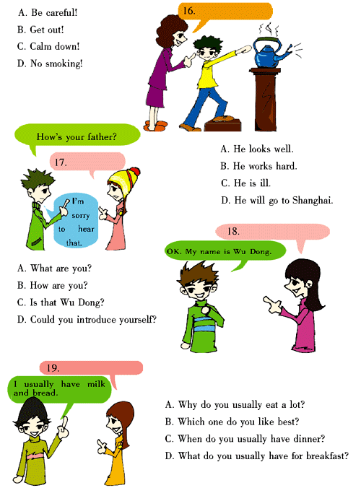
B) 从所给的选项中选择恰当的句子补全对话(此题有三个多余选项)。(答案写在答题纸上)
A. How’s that going? B. Would you like to come with us?
C. When and where shall we meet? D. See you then.
E. Where are you going to have it? F. We can go there by bike.
G. Why don’t we come early? H. We went there by plane.
Lina: We are going to have a picnic on Sunday.
Paul: Oh, really? ________21.________
Lina: By the river. ________22.________
Paul: OK. Why not? How can we get there?
Lina: ________23.________
Paul: Good idea. ________24.________
Lina: We will meet at my home at 8:30 in the morning.
Paul: OK. ________25.________
Lina: See you.
IV. 阅读理解(Reading comprehension) (共15小题,计15分)
A) 阅读短文,判断下列句子正(T)误(F)。(答案涂在答题纸上)
Here is a picture of my room. You see, how clean it is! There is a big window. I can see a beautiful mountain through it. Near the window there is a desk. On the desk there are many books, a clock and a lamp. In front of the desk there is a chair. Beside the desk is my little bed. I always make the bed by myself. Every morning, the clock rings at 6 o’clock. Then I get up quickly when I hear the sound.
26. My room is clean.
27. I can see a garden through my window.
28. There are many books, a clock and a lamp on the desk.
29. My mother often makes the bed for me.
30. I get up when I hear the clock ringing.
B) 阅读短文,完成文后各题。(答案涂在答题纸上)
His name is Alexander Forrest Roy William Jones. When he was born he was much smaller than most newborn babies(新生儿), and his mother wanted him to be big in the future, so his mother gave him the big name. Now he is five years old, but he is still shorter than most of the boys of his age. He is in a kindergarten. The children are at a zoo now. They wear nametags (名签) shaped like elephants. His nametag was made by his teacher. It says “Hello, my name is A. J.”
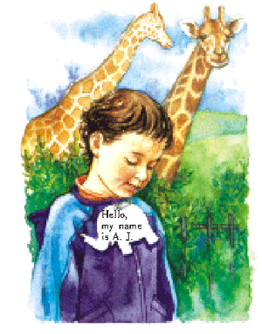
31. The boy in the picture has a ________ name.
A. big B. small C. short D. little
32. How old is he now?
A. Four. B. Fourteen. C. Five. D. Six.
33. Why did his mother give him that name?
A. Because his mother was clever.
B. Because he wanted that name.
C. Because he liked the name very much.
D. Because his mother hoped he would be big in the future.
34. The children’s nametags look like ________.
A. giraffes B. elephants C. tigers D. trees
35. Which one below is right?
A. He becomes as tall as other boys now.
B. He is still shorter than other boys.
C. His nametag is made by his mother.
D. His nametag is made by his friend.
C) 阅读短文,回答文后问题。(答案写在答题纸上)
Judy, Cathy and John are good friends. They all like fast food. Now they are in a fast food shop. Here is the menu.
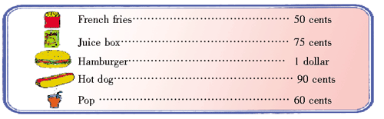
The food is cheap. The children buy the food they like.
36. What are the three children’s names?
37. What do the three children like?
38. Where are they now?
39. What is the most expensive food?
40. Judy wants to buy a hamburger and a box of juice. How much most she pay (付钱)?
V. 智力测试 (IQ test) (共5小题,计5分)
按要求完成下列各题。(答案涂或写在答题纸上)
41. What part of the computer do you look at when you are typing?
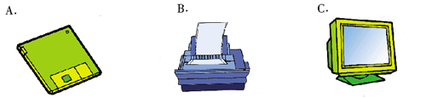
42. There are One hundred and twenty students in Grade 5. Seventy-eight of them walk to school. The rest (其余的) by bus. How many children go to school by bus?
43. Who is the shortest of the four? How tall is he / she?
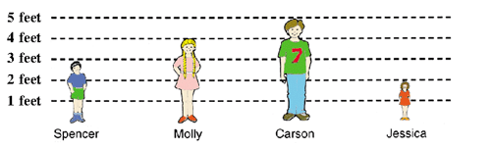
44. We all know a desk has 4 corners(角). If we cut one corner off, how many corners does the desk have?
45. Write the first letter of the pictures and use them to make a new word.
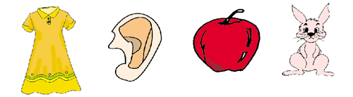
VI. 小作文(Composition) (计15分)
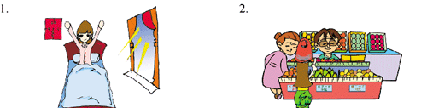
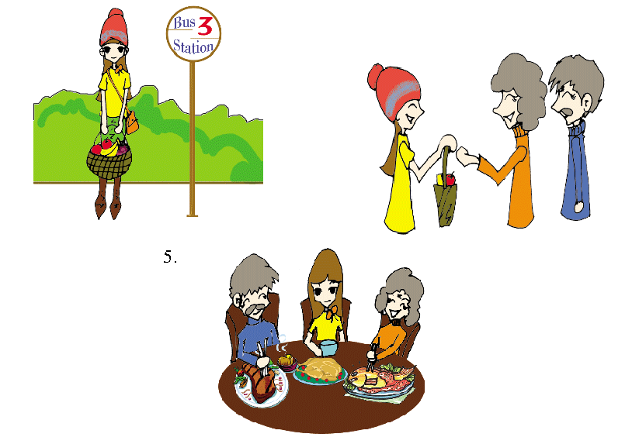
提示:看图,以“My Sunday”为题写一篇小作文。
要求:1. 条理清楚,意思连贯,语句通顺,标点正确,书写清晰、规范;
2. 以一般现在时写出图片中的内容,可作适当发挥;
3. 不得少于60个单词;
4. 将作文写在答题纸上。

