小学五年级上学期英语期末试卷
听 力 部 分
- Listen and choose.
(旅行即将拉开序幕，想赢取免费机票吗？只要把听到的正确图片选出来，就有机会哦!)
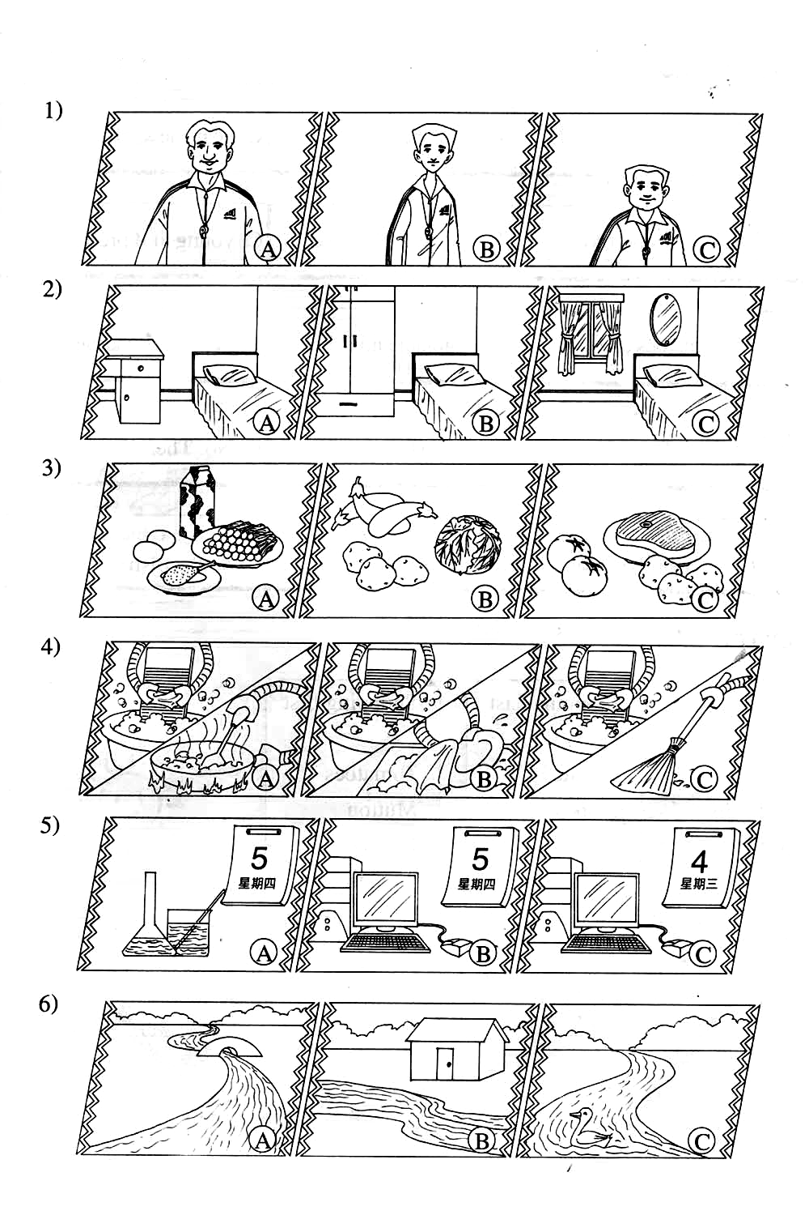
2． Listen and circle.
(登机啦！戴上“伸缩耳”，听听广播，把有用的信息圈出来!)
1）A. young and active B. strict and tall C．smart and active
2）A．over the bed B．near the closet C．over the end table
3）A．cabbage and fish B．potatoes and pork C．mutton and potatoes
4）A．make the bed B．clean the bedroom C．put away the clothes
5）A．There is a lake. B．There is a forest. C．There is a mountain.
3. Listen and tick.
（机长哈利`波特终于出现啦！他要宣布什么呢？仔细听，判断，记得用✓ 和✗表示。）
- I’m a university student.
- I don’t like Saturdays and Sundays.
- I do housework on Saturdays.
- I often do sports and watch TV on Sundays.
- My favorite food is green beans.
4. Listen and write.
（哈利`波特送你的第一件礼物是“魔杖”，赶快试试！把空中飞舞的单词定格在纸上。）

thin tree meals cook eggplants
Tuesday funny tomatoes flowers read

Hello! I’m Kitty. I’m _______ and _______. My favorite day is _______ ,because we have _______ and _______ for lunch that day. I often _______ books at home. I’m helpful at home .I can _______ the _______ . Look! There is a big _______ and many colorful(色彩缤纷的) _______ near my house ! How nice!
笔 试 部 分
- Read and choose.
(“魔法石”是第二件礼物，它能帮你照出下面哪些单词是同族哦！)
Chinese grass closet math curtain cloud air-conditioner P.E. forest

1）English : _______ _______ _______ 2) sky: _____
3) mirror : _______ _______ _______________
- Read and write.
(没有了魔法石的指点，这回看你的真本事了！看图写单词。Come on!)
1) There is a new _ _ a _ _ bin behind the desk.
2) My Chinese teacher is very o _ _ and k _ _ _. 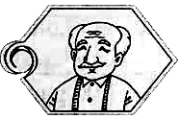
3) We have  t _ _ _ for dinner on Thursdays.
4) There is a small 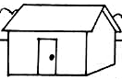 h _ _se in the forest.
5) It’s 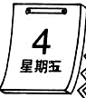 _ _ _day today .
- Read and tick or cross.
(幻影显形！判断下面的图片与句子是否相符。真真假假，画“☺”或“☹”。)
1）——Is there a chair in front of the desk ?
—— Yes ,there is.
2) ——What’s your principal like ? 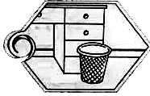
—— He is young and tall .
3) ——What do you have on Tuesday ? 
—— We have music class.
4) —— Are there any mountains in the picture ? 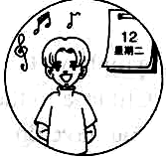
—— Yes, there are.
5) —— What do you do on Mondays ? 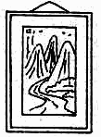
—— I often do the dishes.
- Arrange the sentences. 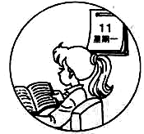
(哈利`波特玩咒语了，单词乱飞，你有本事把他们放回原位置，恢复原句吗？)

1） set you Can table the ?

2) English What’s like teacher your ?

3) day is What today it ?

4) Is a village there river in the ?

5) your favorite What’s food ?

- Read and tick.
(飞机终于到达目的地啦！究竟是哪块神奇的领域呢？一起去看看吧！正确的打“T”,错误的打“F”)
Hi! My name is Linda. I am 12 years old. I study at Brighton Primary School. I go to school from Monday to Friday .My favorite day is Friday. We have art and P.E. class and we have beef for lunch. Beef is my favorite food. It’s tasty and healthy. My favorite teacher is Miss White. She is our English teacher. She is tall and pretty. Her class is so much fun.
I’m very helpful at home. I can sweep the floor and wash my clothes. I live in a small village. The sky is blue. The air is fresh. There is a river in my village. There is a path near the river. There are no ducks in the river .But you can see many fish .
1) I go to school five days in a week. ( )
2) We have art and science class on Friday. ( )
3) My favorite teacher is tall and pretty . ( )
4) Mutton is my favorite food. ( )
5) I’m very helpful at home. ( )
6)There are many ducks in the river. ( )
哈哈！喜欢这次奇异之旅吗？测试都过了吗？那就欢迎你下学期到霍格沃茨魔法学校学习！

备注：（1）听力题第四题为一题1.5分，笔试题第一题为1分，其他均为一题2分。
总分为100分。
（2）现试卷为A4纸格式，最好在第一份打印后整体缩小复印。若直接在电脑上排版会变乱。
听力材料
1．Listen and choose.
1) Look! This is my P.E. teacher . He is tall and thin .
2) This is my bedroom. There is a big closet near the bed.
3) I have eggplants, cabbage, tomatoes for lunch .They are tasty and healthy.
4)I’m a robot. I can wash my clothes and cook the meals .
5) It’s Wednesday today. We have computer class.
6)Look! There is a house near the river.
2． Listen and circle.
!)----- What’s your computer teacher like ?
He is young and active.
2)-----Where is the mirror ?
It’s near the closet.
3)-----What do you have for lunch today ?
I have cabbage and fish today.
4)-----Are you helpful at home ?
Yes. I can make the bed.
5)-----Is there a mountain in the park ?
No, there isn’t . But there is a forest.
3. Listen and tick.
Dear Ben!
My name is Herry. I’m a university student. I like Saturday and Sunday very much. I do my homework and play computer on. On Sunday I often do sports with my friends and watch TV. We often have fish and tofu for lunch on Saturday. Fish is my favorite food. What about you ? Can you tell me ?
4. Listen and write.
Hello! I’m Kitty. I’m thin and funny. My favorite day is Tuesday, because we have tomatoes and eggplants for lunch that day. I often read books at home. I’m helpful at home .I can cook the meals. Look! There is a big tree and many colorful flowers near my home ! How nice!

