小学五年级英语第一学期期中测试题
一、听录音，判断是否与图片相符，对的打“√”，错的打“×”。

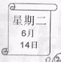

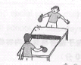

( ) ( ) ( )
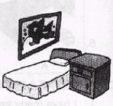
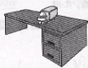

( ) ( )

二、听录音，找出与其相应的图片，并圈出其字母编号。

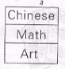

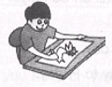
1. 2.

A B A B


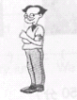
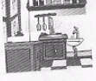
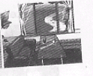
3. 4.

A B A B
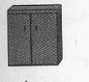
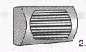
5.

A B
三、听音，写出句子所缺的单词，每空只填一词。（10分）
1．Is your English teacher ?
No, she’s .
2. I have and on Thursdays.
3. Today is , I often do my .
4. Is this your ?
No, it .
5. What’s in your ?
There are two and a .
四、听问句，找出合适的答句，并写出字母编号。
（ ）1．A. Yes, he is tall.
B. He is young and kind.
C. She is funny but strict.
（ ）2. A. Yes, I am. B. Yes, it isn’t . C. No, it isn’t.
（ ）3. A. There is an end table, a bed and a closet.
B. There are a trash bin and a light.
C. Yes, we are.
（ ）4. A. I go to school.
B. We do homework and read books.
C. My mother often watches TV.
（ ）5. A. She’s Mr Chen.
B. He’s tall and kind.
C. He’s Mr Li.

五、根据录音内容，为下列图片标号。（10分）
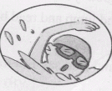

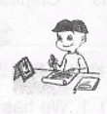

( ) ( ) ( )
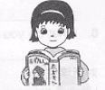
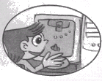

( ) ( )
六、选词填空。（10分）
(in, on, am, are, like, to, and, don’t, often, happy, funny, too, have, has, for)
I a student. I go to school from Monday Friday. We English, math and computer Tuesdays. I
computer. On Saturdays Sundays, we go to school. I watch TV. Sometimes I do sports. I do my homework, . I am on weekends.
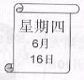
七、看图回答问题。（10分） 1.
- Is today Tuesday?


(2) What’s the boy like? 2. 2

(3) What do they have on Tuesdays? 3. 3.
科学
数学
美术


(4) Where do you go on weekends? 4. 4.

PARK

(5) Is the man old?
5.

八、根据要求完成下列短文。（10分）
（我有一间新房子。衣柜上面有一部空调机，墙上有一面镜子，在床的旁边放有两张床头柜。门后有一个小垃圾篓，有黄色的窗帘。）
I a new room. There is air-conditioner over the . a mirror the wall. The two end tables are the bed. There is a trash bin the door. There yellow . I like my room.
九、补全对话。
Tom: Hello, Mary! ________________ ______________?
Mary: It’s Thursday.
Tom: ___________________________ _________?
Mary: I have Chinese, art and math on Thursdays.
__________________________ _______?
Tom: I have English, math and P.E .I like P.E very much.
Mary: ________________ _______________?
Tom: Miss Chen is my P.E teacher.
Mary: ____________________ _____________?
Tom: Yes, she is strict but she is very kind.
十、阅读短文，对的打“√”，错的打“×”。
Welcome to my new room. There are 3 bedrooms, a living room, a washroom and a kitchen. The living room is big. There is a TV, a table, 5 chairs and a sofa in it. The curtains are yellow and new. In my bedroom, there is a bed, a shelf, a desk and a chair. I clean my bedroom everyday.
( )1、There are six rooms in my new home.
( )2、My bedroom is big.
( )3、There are two tables in my living room.
( )4、The curtains are green and new.
( )5、I clean my washroom everyday.
五年级期中测验听力稿
一、听录音，判断是否与图片相符，对的打“√”，错的打“×”。
(√)1.Look at the old woman. She’s my grandma.
(×)2. What day is it today?
It’s Thursday.
(√)3. What do you do on weekends?
I often do sports.
(×)4. There are two end tables and a bed in the bedroom.
(×)5. There is a car over the desk.
二、听录音，找出与其相应的图片，并圈出其字母编号。
（ B ）1．What do you have on Wednesdays?
I have music, art and Chinese.
（ B ）2. Do you often do sports on Saturdays?
No, I don’t. I often draw pictures.
（ A ）3. Is your Chinese teacher tall?
No, he is strong and short.
（ B ）4. What do you often do on weekends?
I often cook in the kitchen.
（ B ）5. There is an air-conditioner in my room.
三、听音，写出句子所缺的单词，每空只填一词。（10分）
1．Is your English teacher quiet ?
No, she’s active .
2. I have science and English on Thursdays.
3. Today is Sunday , I often do my homework .
4. Is this your bathroom ?
No, it isn’t .
5. What’s in your bedroom ?
There are two curtains and a mirror .
四、听问句，找出合适的答句，并写出字母编号。
（ C ）1．What’s your mother like?
( C ) 2. Is your living room big ?
( A ) 3. What’s your bedroom like?
( B ) 4. What do you often do on weekends?
( C ) 5. Who’s your Chinese teacher?
五、根据录音内容，为下列图片标号。（10分）
A：What do you do on weekends?
B: On Saturday morning, I often do homework; in the afternoon, I often play football with my friends.
A: What about Sundays?
B: On Sunday morning, I often play computer games, then, I go swimming in the afternoon. In the evening I read books.
A: Are you happy?
B: Sure.

