小学五年级英语Unit3单元测试题
- 听音，根据你听到的内容给下面各人写出早午晚餐相应食物的编号。

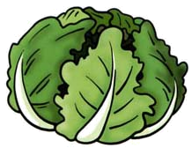
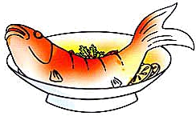
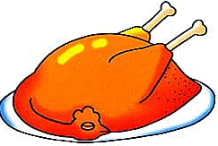


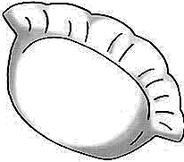

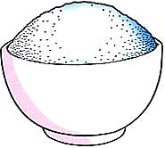



A B C D E F

G H I J K L
Name | Breakfast | Lunch | Dinner
Amy
Chen Jie
- 听音，选出你听到的单词。
( ) 1. A. window B. yellow C. snow D. grow
( ) 2. A. coat B. road C. boat D. goat
( ) 3. A. floor B. flower C. flag D. flow
( ) 4. A. fruit B. frog C. from D. fridge
( ) 5. A. how B. now C. town D. brown

- 听音，根据听到的内容写出下面句子缺少的单词。
Chen: What’s your food?
Sarah: .
Chen: Me too. It’s .
Sarah: I like .
Chen: I don’t like . They’re .
- 听音，标号。
圆白菜 茄子 西红杮 土豆 青豆

- 选出下面各单词缺少了的字母，把序号写在括号里。
( ) 1. sw t A. ee B. ea C. ae
( ) 2. fr t A. iu B. ue C. ou
( ) 3. s A. our B. ore C. oue
( ) 4. to to A. ta B. ma C. pa
( ) 5. eggpl t A. en B. ea C. an
- 按要求完成下面的句子。
1．what, have, do, breakfast, for, you, today (?) （连词成句）

2．What would you like for dinner? （写出中文意思）

3．I’m have to eat vegetables. （改错句）

4．I like carrot juice. （改为否定句）

5．迈克喜欢新鲜的水果。 （译成英文）

- 情景对话。给左边的问句选择正确的答语，把其编号写到左边的括号里。
( ) 1. What do you have for lunch? A. Grapes.
( ) 2. What’s your favourite food? B. Tofu.
( ) 3. What’s your favourite fruit? C. I’d like some beans.
( ) 4. What would you like? D. I have some tomatoes.
( ) 5. Do you like mutton? E. Yes, I do.
- 阅读理解。根据对话内容判断下面句子的对错，正确的写“T”，不正确的写“F”。
Cook: Oh, it’s time for lunch. Look! This is the school menu. On Mondays we have onions and noodles. On Tuesdays we have mutton and potatoes. On Wednesdays we have vegetables and pork. On Thursdays we have chicken and tofu. On Fridays we have green beans and beef. What do you like, Amy?
Amy: I like mutton. I like Tuesdays.
Cook: What about you, Chen Jie?
Chen Jie: I like beef. I like Fridays!
( ) 1. The children have lunch at school.
( ) 2. They have mutton on Thursdays.
( ) 3. They have chicken on Tuesdays.
( ) 4. Amy likes Mondays.
( ) 5. Chen Jie likes Fridays.
第一题，听音，根据听到的内容给下面各人写出早午晚餐相应食物的编号。
1. Hello! I’m Sarah. I have hamburgers for breakfast, chicken and cabbages for lunch, fish, egg and bread for dinner. What about you?
2. Hi! I’m Chen Jie. I have noodles for breakfast, chicken and soup for lunch, dumplings , pork and rice for dinner. Oh, they’re tasty and yummy!

第二题，听音，选出所听到的单词。
1. yellow 2. goat 3. flower 4. fruit 5. brown

第三题，听音，给下面的小动物选出它们吃的东西，用线连起来。
1. I’m Bear. I like pork. Oh, it’s yummy!
2. Hi! I’m monkey. I like bananas. They’re sweet!
3. I’m Mr Pig. The tofu is fresh. I like it.
4. Hello! I’m a mouse. I like potatoes. They’re salty!
5. I’m Miss Panda. The grapes are healthy for me. I’d like the grapes.

第四题，听音，根据听到的内容写出下面句子缺少的单词。
Chen: What’s your favourite food?
Sarah: Fish.
Chen: Me too. It’s tasty.
Sarah: I like grapes.
Chen: I don’t like grapes. They’re sour.

第五题，听音，标号。
1. ptoato 2. green beans 3. tomato 4. cabbage 5. eggplant

