小学五年级英语5B综合测试题
听力部分
一、Listen and judge 听音判断，正确用“T”，错误用“F”(8%)
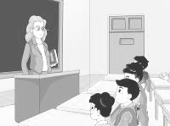
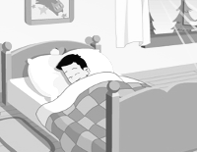

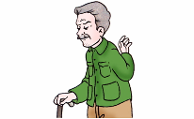

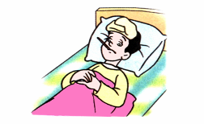

1. ( ) 2. ( ) 3. ( ) 4. ( )
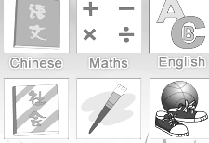
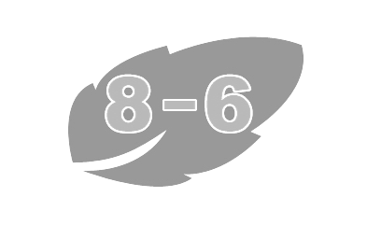
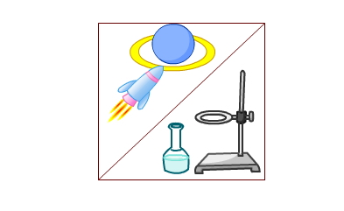
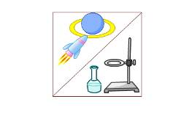

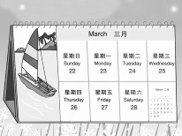

5. ( ) 6. ( ) 7. ( ) 8. ( )
二、Listen and choose根据问句选答句。（8%）
1.（ ）A．This is Mary speaking. B. I’m Mary.
C. Yes, I am.
2. ( ）A．We have Chinese and PE. B. It’s interesting.
C. I like Chinese.
3.（ ）A．It’s March. B. It’s tuesday.
C. It’s Thursday.
4.（ ）A．Yes, I do. B. No, I don’t.
C. Yes, I am.
5.（ ）A．She’s got a headache.
B. She has got a earache.
C. She feels a headache.
三、Listen and write听录音,填空。(14%)
Today is ________. In Class 2, Grade 5, everyone is here. But David is____________. He_______ got a ________ ___________.There are four ________ in the morning and one in the _____________.
Classes are _________, Mike calls David. David feels better. He doesn’t know the homework. So Mike goes to tell him and ________ some ________ for him, too.
笔试部分
一、按要求写出下列单词（10%）
1. do(第三人称单数)__________ 2. listen (近义词) __________
3. they(所有格) __________ 4. hot(反意词) __________
5. take(现在分词) __________ 6. she(宾格) __________
7. class(复数形式) __________ 8. good (比较级) __________
9.plus(反意词) ___________ 10. right(反意词) __________
二、根据单词首字母和句子意思，将对话中的单词补充完整(15%)
A: Welcome b________ to school, Ben.
B: Nice to m________ you, Mr Green.
A: There is a n__________ subject this t_______, do you know?
B: Yes. It’s S________ S________.
A: Do you l________ it?
B: Yes, it’s an i_________ s_________.
A: What time do you h________ this lesson? On M________?
B: No. It’s on F________.
三、填入适当的介词（8%）
1. How many Art lessons do you have ________ a week?
2. We have a Computer Studies lesson ________ Friday.
3. Draw some flowers ________ the paper.
4. She goes to school ________ seven o’clock.
5. Can you come and help me ________ my Maths?
6. Here’s a new copybook ________ Nancy.
7. May I speak_______ Nancy?
8. Boys and girls, this is the first day ________ the new term.
四、英汉互译（10%）
1. 这学期 ___________________ 2. 在星期一早晨 ________________
3. 第一节课 __________________ 4. 午饭后 ______________________
5. 立即、马上 ________________ 6. 两个星期 ____________________
7. 转好 ______________________ 8. 吃药 ________________________
9. 告诉我_____________________ 10. 呆在床上____________________
五、选择。
（ ）1．Look at ___________ numbers.
A. these. B. this C. that
（ ）2. We have five _______________ a week.
A. English lesson. B. Englishes lessons C. English lessons
（ ）3.Open your_________ and _______ “Ah”.
A. mouth, say. B. mouse, say C. mouth, speak
（ ）4. --What’s 531 ________200? --It’s 731.
A. pluses. B. minus C. plus
（ ）5. Take___________medicine and have________rest.
A. some, a lot . B. some, a lot of C. any, a lot
（ ）6. --________ that in the basket? --A basketball
A. Where’s. B. Whose C. What’s
（ ）7. --What lessons ______ Mary have in the morning?
--She ________ two English lessons and two Chinese lessons.
A. does, has. B. do, have C. does, have
（ ）8. __________ any medicine near the cup?
A. There are. B. Are there C. Is there
www.2xxyy.com 江苏省中小学英语教学提供
六、按要求写出下列句子(5%)
1. I have Chinese，English and Art in the morning. (改为第三人称单数形式)
___________________________________________________________
2. There are four English lessons in a week.( 对划线部分提问)
___________________________________________________________
3. I feel ill.(根据答句，写问句)
___________________________________________________________？
4. There are some English lessons today.(改为一般疑问句)
___________________________________________________________？
5. I’ve got a bad cough.(对划线部分提问)
___________________________________________________________
七、阅读理解，选择. (7%)
A
Jane is a schoolgirl. She is fifteen. She lives with her parents and her grandfather. Her grandfather is seventy years old. He has got a backache. He needs to see a doctor. But Jane’s parents are very busy. Her father is a policeman. Her mother is a teacher. So Jane wants to go to hospital with her grandfather after school. She hopes her grandfather gets better soon.
（ ）1. What’s Jane’s job?
A. A teacher B. A policewoman C. A student
（ ）2. --What’s wrong with her grandfather? --He’s got _____.
A. a toothache B. a backache C. an earache
（ ）3. Who needs to see a doctor?
A. Jane B. Jane’s parents C. Jane’s grandfather

B
Liu Tao: Hi, Mike. Nice to see you.
Mike: Nice to see you, too. Liu Tao.
Liu Tao: What day is it today?
Mike: It’s Thursday. What lessons do you have in this morning?
Liu Tao: We have Maths, Chinese, Art, and Science.
Mike: Oh, I like PE very much. But we don’t have PE today.
Liu Tao: We have PE and Computer Studies this afternoon.
Mike: Great! Do you like PE?
Liu Tao: No, I don’t. I like English very much. Tomorrow we will have an English lesson in the morning.
Mike: It’s time for class. Let’s go!
阅读理解，并判断。
( )1. Liu Tao has PE in the afternoon.
( )2. Liu Tao has six lessons today.
( )3. Liu Tao doesn’t like English.
( )4. Liu Tao will have English lesson on Friday morning.

