牛津小学英语六年级6A教学质量调研试卷
- 语音：10%
  - 找出划线部分发音与其余三个不同的那个单词，将其序号填入题前括号内：5%
( ) 1. A. grass B. pass C. match D. ask
( ) 2. A. ago B. costume C. over D. photo
( ) 3. A. head B. clean C. breakfast D. sweater
( ) 4. A. her B. driver C. November D. brother
( ) 5. A. near B. dear C. hear D. bear
  - 找出与所给例词划线部分读音相同的单词，将其序号填入题前括号内：5%
( ) 1. cage A. as B. candle C. race
( ) 2. win A. milk B. sign C. mobile
( ) 3. too A. look B. shoot C. good
( ) 4. blow A. town B. now C. grow
( ) 5. cousin A. ground B. touch C. house

- 词汇和句子：20%
  - 译出下列词组和句子：15%
1. 把球传给我 2. 所有的学生
3. 拍照 4. 紧靠在公园隔壁
5. 迈克的生日礼物 6. 在四月一日
7. 在黑板前面 8. 刚才
9. 观看一场激动人心的比赛 10. 禁止乱扔垃圾。
11. three rolls of film 12. blow out the candles
13. go out of the football field
14. Keep off the grass.
15. Different public signs mean different things.
  - 根据所给单词首字母及句意完成单词，使句子意思完整正确：5%
1. M is the third month (月份) of a year (一年).
2. Look, Wang Bing is s David. He’s in front of David.
3. —Where’s your handkerchief? —It’s in my p .
4. —What does this sign mean? —It means “D ”. We shouldn’t touch it.
5. Today is the Children’s Day. Everyone is very e .
- 选择填空：10%
( ) 1. —Where you just now? —I in the library.
A. was;were B. was;was C. were;was D. are;am
( ) 2. I’m tall than(比) Wang Bing. So I sit Wang Bing in the classroom.
A. in front of B. behind C. next D. between
( ) 3. —What’s in the box? —There a pair of glasses.
A. am B. is C. are D. be
( ) 4. —What is Su Hai doing? —She’s her camera.
A. look for B. is looking for C. looking for D. looks for
( ) 5. “ ” means we shouldn’t make noise here.
A. Keep quiet B. Keep off the grass C. No smoking D. No parking
( ) 6. walk on the grass , please.
A. No B. Not C. Doesn’t D. Don’t
( ) 7. The Teacher’s Day is on September 10th. September 10th reads .
A. tenth of September B. the tenth of September
C. tenth of the September D. ten of September
( ) 8. Tom, the ball to .
A. kick;he B. kicks;him C. kick;him D. kicks;he
( ) 9. Oh, my earphones are on the floor. Can you for me,please?
A. pick it up B. pick up them C. pick them up D. pick they up
( ) 10. —What is it today? —It’s Thursday.
A. date B. weather C. day D. time

- 从Ⅱ栏中选出能对Ⅰ栏中句子作出正确反映的答语：10%
(A) Ⅰ Ⅱ
( ) 1. Throw the ball to me, please. A. Yes, I do.
( ) 2. Can you take a photo for us? B. Here it is.
( ) 3. Do you usually have a birthday party? C. Sure.
( ) 4. Where’s my CD Walkman? D. Yes, I am.
( ) 5. Can’t you see a sing on the grass? E. OK. Catch.
F. Let me see. Oh, yes, it is.

(B) Ⅰ Ⅱ
( ) 1. Can I watch TV? A. It’s three all now.
( ) 2. Is David a goalkeeper? B. It’s the thirty-first of October.
( ) 3. What’s the score? C. Gao Shan ’s got a goal.
( ) 4. Who’s got a goal? D. No, he isn’t.
( ) 5. What date is it today? E. No, he doesn’t..
F. No, you can’t. You should do your homework
- 连词成句：10%
1. Gao Shan, goal, is, to, the, look, kicking, the, ball (.)

2. diary, a, Mike’s, was, ago, in, moment, bag, the (.)

3. cage, interesting, is, sign, bird’s, the, on, the (.)

4. when, TV, can, we, watch(?)

5. come, to, would, like, you, to, birthday, my, party (?)

- 根据实际情况回答问题，要求答句完整：10%
1. Would you like a VCD of Japanese cartoons as your present?

2. Can we play football in the classroom?

3. Do you often ask any questions in class?

4. Is your English book in your bag now?

5. What does “No cycling.” mean?

- 看图完成对话：25%
1. A: What is it today?
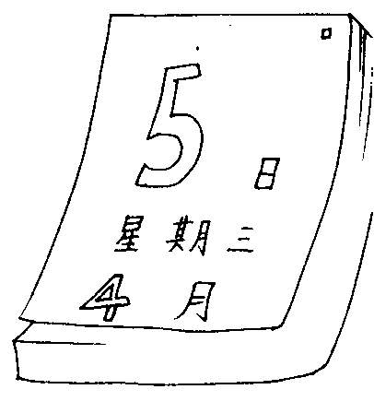
B: It’s the of .
A: And what day is it today?
B: It’s .

2. A: Look at the sign. What does it mean?

B: It “ ”.
A: What does that mean?
B: It we our car here.

3. A: your guitar?
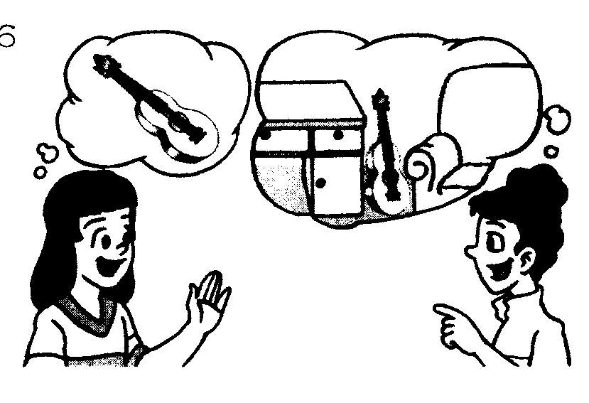
B: It’s the sofa the .
A: It isn’t there now.
B: It just now.
4. A: When’s your birthday?
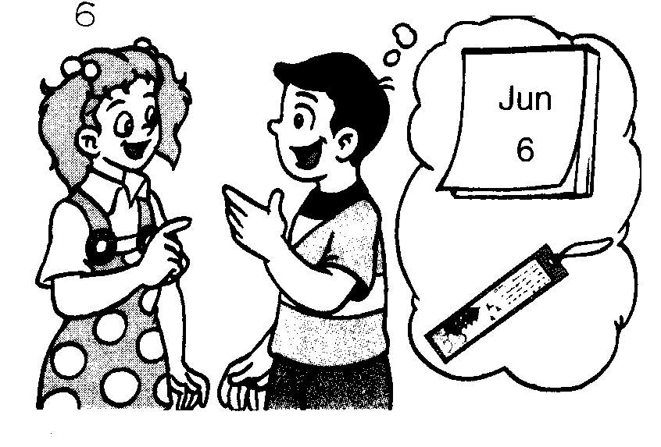
B: My birthday’s the of .
A: What would you like as a ?
B: I’d like .

5. A: Look, Mike is the ball to Liu Tao.
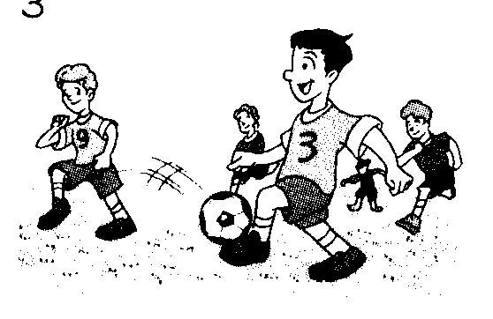
B: Liu Tao’s the ball now.

- 阅读下面的短文，判断所给句子是否与短文内容相符，相符的用“T”表示，不符的用“F”表示：5%
Today is Sunday. Some students are playing basketball in the playground. They are having a match. Wang Bing, Liu Tao, Ben, Kate and Su Hai are in the Tiger Team. David, Gao Shan, Jack, Su Yang and Nancy are in the Lion Team. The score is ten (the Tiger Team)to eight (the Lion Team)now. Look, Liu Tao is over there in the corner with the ball. Gao Shan and Jack are next to him. Now, Liu Tao is passing the ball to Su Hai, but Jack stops it. Oh, Jack is shooting. The ball is flying to the goal. He’s got a goal.
( ) 1. The students are having a football match now.
( ) 2. Wang Bing, Liu Tao, Kate and Su Yang are in the same team.
( ) 3. Liu Tao passes the ball to Su Hai, Su Hai’s got the ball and shoots it to the goal.
( ) 4. Jack’s got a goal for the Lion Team.
( ) 5. At last(最后) the score is still(仍旧)ten to eight.

北塘区小学六年级英语教学质量调研试卷
参 考 答 案 及 评 分 标 准
- 每题1分。
  - 1. C 2. B 3. B 4. A 5. D
  - 1. C 2. A 3. B 4. C 5. B
- 每题1分， 1~10题每错1处扣0.5分，错满2处全扣。
A.
1. pass the ball to me 2. all the students
3. take photos 4. next to the park
5. Mike’s birthday present 6. on the first of April
7. in front of the blackboard 8. just now/a moment ago
9. watch an exciting race 10. No littering.
11. 三卷胶卷 12. 吹灭蜡烛
13. 出界 14.禁止践踏草坪。
15. 不同的公共标识具有不同的含义。
B. 1. March 2. stopping 3. pocket 4. Danger 5. excited
- 每题1分。
1. C 2. B 3. B 4. C 5. A 6. D 7. B 8. C 9. C 10. C
- 每题1分。
A. 1. E 2. C 3. A 4. B 5. F
B. 1. F 2. D 3. A 4. C 5. B
- 每题2分，语序错全扣，抄错单词或漏词每处扣1分。
1. Look, Gao Shan is kicking the ball to the goal.
2. Mike’s diary was in the bag a moment ago.
3. The sign on the bird’s cage is interesting.
4. When can you watch TV?
5. Would you like to come to my birthday party?
- 每题2分， 回答不完整扣1分。答案略。
- 每空1分。
1. date; fifth; May; Wednesday
2. means; No parking; means; shouldn’t park
3. Where’s; between; and; desk; was there
4. on; sixth/6th ; June; birthday present; a bookmark
5. passing; got
- 每题1分。
1. F 2. F 3. F 4. T 5. F

